1. **SYNOPSIS**

Clothing Store with Source Code is a PHP project that can buy clothes through online services. This program was developed by using PHP, HTML, MySQLi, and Javascript. The system is basically easier to understand, the customer should create an account first to order some clothes. Then the user will choose their preferable clothe and add them to the shopping cart in order to check out the product. The admin has an important role here, he manages all the daily transactions, adding new clothes, setting up the product offers, and monitoring customer information.

**2. SYSTEM CONFIGURATION**

In here, the system specification tells that what the requirements that we used in here. The specification tells us about the hardware requirements and the software requirements that we are used to develop the project.

**2.1 HARDWARE SPECIFICATION**

Processor : Pentium Dual core

Ram : 2 GB

Monitor : acer

Hard Disk : 250 GB

Mouse : Logitech

Keyboard : Logitech

**2.2 SOFTWARE SPECIFICATION**

The software used for the development of the project is

Operating system : Windows 7

Environment : Macromedia DreamWeaver 8

.NET Framework : Version 4.0

Language : C#

Front End : CSS, JAVASCRIPT,HTML

Back End : PHP & MYSQL

**3. SOFTWARE DESCRIPTION**

**3.1 INTRODUCTION TO PHP**

PHP is a serve-side scripting language designed specifically for web development. It is open source which means it is free to download and use. It is very simple to learn and use. It is an interpreted language and it does not require a compiler. PHP codes are first executed on the server and then the result is returned to the browser. PHP can actually do anything related to server-side scripting or more popularly known as the backend of the website. PHP allows using wide range of databases.

**BENIFITS OF PHP:**

PHP is available free of change on the Internet, for a variety of platforms and architectures, including UNIX, Microsoft Windows, and Mac OS, as well as for most web servers. It enables to perform incremental, interactive development and testing without going through a compile-test-debug cycle each time change the code. This can speed the development cycle drastically. A variety of data types, a powerful object oriented engine, an extensive library of built-in functions , and support for most current web technologies and protocols complete the picture.

**ARCHITECTURE OF PHP:**

Linux provides the base operating system and environment. The apache web server intercepts HTTP requests and either serves them directly or passes them on to the PHP interpreter for execution. The PHP interpreter parses and executes PHP code, and returns the results to the web server.

**ADVANTAGES OF PHP:**

1. Most important advantages of PHP is that it's open source and free from cost. It can be downloaded at anywhere and readily available to use for event of web application.

2. It is platform independent. PHP based applications can run on any OS like Linux, UNIX and Windows, etc.

3. Application can easily be located which are based on PHP and connected to database. It's mainly used due to its faster rate of loading over slow internet speed than another programming language.

4. It has less learning curve, because it is simple and straightforward to use. Someone familiar with C programming can easily work on PHP.

5. It is more stable from a few years with assistance of providing continuous support to various versions.

6. It helps in reusing an equivalent code and no got to write lengthy code and sophisticated structure for event of web applications.

**DISADVANTAGES OF PHP:**

1. It is not that secure due to its open-source, because the ASCII text files are often easily available.

2. It is not suitable for content-based web applications. 3. It has a week type, which can cause incorrect data and knowledge to user.

**3.2.INTRODUCTION TO MYSQL:**

MYSQL is an open source, fast reliable, and flexible relational database management system, typically used with PHP. MYSQL server design is Multilayered with independent modules. It is fully Multithreaded by using kernel threads. It can handle multiple CPUs if they are available. It provides transactional and non-transactional engines.

**Tables**

A table is used to organize data in the form of rows and columns and used for both storing and displaying records in the structure format.

**Database**

A database is used to store the collection of records in an organized form. It allows us to hold the data into tables, rows, columns and indexes to find the relevant information frequently. We can access and manage the records through the database very easily.

**Queries**

A list of commonly used MYSQL queries to create database, use database, create table, insert record, update record, delete record, select record, truncate table and drop table.

**Forms**

The HTML d ata entry form in Notepad or in your PHP editor is created and then need to create a form with a "POST" method to pass the data to PHP for processing. Place the name of the PHP in the "ACTION" section form.

**Reports**

MYSQL shell enables to set up and run reports to display live information from a MYSQL server, such as status and performance information. MYSQL Shell's reporting facility supports both built-in reports and user-defined reports.

**Pages**

The page is the fundamental unit of data storage in SQL server. An extend is a collection of eight physically contiguous pages. Extends help efficiently manage pages.

**Module**

The MYSQL Module collets and parses the slow logs and error logs created by MYSQL. When run the Module, it performs a few tasks that is to set the default paths to the log files and make sure each multiline log event gets sent as a single event.

**ADVANTAGES OF MYSQL:**

1. MYSQL is a Relational Database Management System or RDBMS which means that it stores and presents data in tabular form, organized in rows and columns.

2. MYSQL is more secure as it consists of a solid data security layer to protect sensitive data from intruders and passwords in MYSQL are encrypted.

3. MYSQL is available for free to download and use from the official site of MYSQL.

4. MYSQL is compatible with most of the operating system, including Windows, Linux, NetWare, Novell, Solaris and other variations of UNIX.

**DISADVANTAGES OF MYSQL:**

1. MYSQL is not very efficient in handling very large databases.

2. MYSQL doesn't have as good a developing and debugging tool as compared to paid databases.

3. MYSQL version less than 5.0 do not support COMMIT, stored procedure and ROLE.

**3.3.INTRODUCTION TO HTML**

**4. SYSTEM ANALYSIS**

**4.1 Existing System**

Traditional brick-and-mortar retail stores are limited by geographic location,store hours,and physical inventory space.Customers must visit physical stores to browse roducts,check sizes,and make purchases,which can be time-consuming and inconvenient,Retailers,in turn,have to deal with high operational costs,including rent,utilities,and staffing.The existing system may also struggle with providing personalized shopping experiences,as it lacks the data-driven insights that online platforms offer.By shifting to an online clothing stores can overcome these limitations.

**4.2 Proposed System**

Our online clothing store is designed to provide a seamless shopping experience with a wide range of fashionable apparel for all styles and occasions. With user-friendly navigation, customers can easily browse through categories and view detailed product descryptions and images. Customers can explore our collections through detailed product pages that include high-quality images, size guides, and styling suggestions. while user reviews and fashion tips foster a vibrant community for style inspiration. With a focus on delivering engaging content, our platform ensures a seamless and enjoyable fashion discovery experience. The system also helping customers discover new styles they'll love.

**5. PROJECT DESCRIPTION**

The Online Clothing Store Project is a web-based platform designed to simplify and enhance the shopping experience for customers while providing businesses with an efficient and scalable way to manage and sell clothing products. The platform enables users to browse a wide range of clothing items, including men’s, women’s, and children’s apparel.

The primary objective of this project is to create a user-friendly interface that allows customers to easily search for products, view detailed descriptions and images, select sizes and colors, and make secure purchases. The platform supports a range of features such as personalized recommendations and customer reviews to help shoppers make informed decisions..

Overall, the online clothing store project aims to offer a seamless shopping experience for users while helping businesses expand their reach, optimize operations, and grow their brand in the competitive fashion industry.

**SCOPE:**

The scope of an Online clothing store project encompasses various essential components aimed at creating a seamless shopping experience for users.It includes the development of a user-friendly website andor mobile application that is responsive across different devices,ensuring accessibility for all customers.The project involves implementing user management features,such as registration and login options,allowing customers to create accounts,view order history.

**5.1 Module Description :**

**Login:**

The system's Login Module serves as the gateway, ensuring secure access to authorized users. Users are required to enter their username and password, and the system grants access based on different authorization levels, including admin, customer.

**Admin:**

The Admin module is the backbone of the application. Admin functionalities include registration the customer details, create category details, create product and create offers,view feedbacks and also view the order list of the customers

**Home:**

The Home Module serves as the entry point for customers, showcasing the online clothing store's featured products, categories, and promotions. The Home Module aims to provide an engaging and user-friendly experience, encouraging customers to explore the website further.

**Category:**

The Category Module organizes products into hierarchical categories and subcategories, enabling customers to easily browse and discover products.

**Product:**

The Product Module presents the online clothing store's product catalog, allowing customers to browse and search for specific items. Each product details page includes essential information such as description, images, pricing, size and color options. This module helps customers make informed purchasing decisions.

**Offer:**

The Offers Module enables administrators to create and manage promotions, discounts, and special offers to drive sales and customer engagement.

**Register:**

The Register Module enables new customers to create an account, providing a seamless and secure registration process.

**Contact:**

The Contact Module provides cust omers with a secure and convenient way to contact the online clothing store's support team.

**Cart:**

The Shopping Cart Module enables customers to manage their selected products, displaying items added to their cart. This module allows customers to adjust quantities, remove items, calculate totals and proceed to ch eck out.

**Order:**

The Order Management Module streamlines order processing, fulfillment, and shipping. Administrators can update order status, integrate shipping carriers. This module optimizes order fulfillment efficiency.

**Feedback:**

The Feedback Module allows users to post feedback and reviews related to products, focusing on aspects such as quality and cost. This feature promotes transparency and continuous improvement within the organization.

**6. SYSTEM DESIGN**

System design is the process of new system or replace or complement an existing system.

**6.1 Logical Design**

The symbol used in the dataflow diagram

**- Data Flow**

**_ Source and Destination**

**_ Process**

**_ Data Source**

**6.1.1 BLOCK DIAGRAM**

Home

ONLINE CLOTHING STORE

Admin

End User

View without login

Customer

Login

Register

Log Out

Provide

Feeddback

Add and View Cart

View Offers

View Products

View Category

Login

Log Out

View FeedbackDetails

View Order Details

Create Offers

Create

Category

Details

Insert new admin

View Offers

View products

View Category

**6.1.2 DATA FLOW DIAGRAM**

Admin

View Feedbacks

View Orders

Create Offers

Create Category

Create new admin

Database

**Fig 6.1 Admin Flow Diagram**

Customer

Provide Feedback

Add item to Cart

View Offer Details

View Products

View Category

Database

**Fig 6.2 Customer Flow Diagram**

**6.2 PHYSICAL DESIGN**

**6.2.1 Needed PHP Files**

|  |  |
| --- | --- |
| Index.php | Display the Home Page |
| Register.php | Display the Registration Page |
| Header.php | Display the Header Section |
| Footer.php | Display the Footer Section |
| Login.php | Display the Login Page |
| Category.php | Display the Category Details |
| Products.php | Display the Products Details |
| Offers.php | Display the Offers Details |
| Contact.php | Display the Contact Details |
| Right.php | Display the Details |
| InsertUser.php | Display the Inserted User Details |
| InsertProduct.php | Display the Inserted Product Details |
| InsertOffer.php | Display the Inserted Offer Details |
| Insertcategory.php | Display the Inserted Category Details |
| Feedback.php | Display the Feedback Page |
| Cart.php | Display the Cart Details |
| Checkout.php | Display the Checkout Details |

|  |  |
| --- | --- |
| DeleteCart.php | Display the Deleted Cart Message |
| History.php | Display the Shopping History Page |
| DeleteUser.php | Display the Deleted User Message |
| DeleteOffer.php | Display the Deleted Offer Message |
| DeleteFeedback.php | Display the Deleted Feedback Message |
| DeleteCategory.php | Display the Deleted Category Message |
| Logout.php | Display the Logout Page |

**6.2.2 NEEDED DATABASE TABLE**

**Table: SSignup Table**

|  |  |
| --- | --- |
| **Name** | **Data Type** |
| Student Id | int |
| Student Name | nvarchar(50) |
| Address | nvarchar(50) |
| Phone No | nvarchar(50) |
| Password | nvarchar(50) |
| Mail | nvarchar(50) |
| RegNumber | nvarchar(50) |
| Department | nvarchar(50) |
| Status | nvarchar(50) |
| Department Id | nvarchar(50) |

**Table: Staff Details Upload Table**

|  |  |
| --- | --- |
| **Name** | **Data Type** |
| Staff Id | int |
| Staff Name | nvarchar(50) |
| Address | nvarchar(50) |
| Phone No | nvarchar(50) |
| Password | nvarchar(50) |
| Mail | nvarchar(50) |
| Designation | nvarchar(50) |
| Department | nvarchar(50) |
| Department Id | nvarchar(50) |

**Table: Meeting Details Upload Table**

|  |  |
| --- | --- |
| **Name** | **Data Type** |
| AlumniRegNumber | nvarchar(50) |
| Alumni Name | nvarchar(50) |
| Department | nvarchar(50) |
| Meeting Date | nvarchar(50) |
| Meeting Time | nvarchar(50) |
| Place | nvarchar(50) |
| Organized | nvarchar(50) |
| Passout | nvarchar(50) |
| StaffMail | nvarchar(50) |
| Department Id | nvarchar(50) |

**Table: Seminar Details Upload Table**

|  |  |
| --- | --- |
| **Name** | **Data Type** |
| AlumniRegNumber | nvarchar(50) |
| Alumni Name | nvarchar(50) |
| Department | nvarchar(50) |
| Seminar Date | nvarchar(50) |
| Seminar Topic | nvarchar(50) |
| Organzied | nvarchar(50) |
| College Block | nvarchar(50) |
| Staff Mail | nvarchar(50) |
| Department Id | nvarchar(50) |

**Table: Alumni Update Details Upload Table**

|  |  |
| --- | --- |
| **Name** | **Data Type** |
| AlumniRegNumber | nvarchar(50) |
| Name | nvarchar(50) |
| Department | nvarchar(50) |
| Address | nvarchar(50) |
| Position | nvarchar(50) |
| Company Name | nvarchar(50) |
| Passout | nvarchar(50) |

**Table: Jobs Details Upload Table**

|  |  |
| --- | --- |
| **Name** | **Data Type** |
| Job Name | nvarchar(50) |
| OpenFor | nvarchar(50) |
| JobFor | nvarchar(50) |
| Currentrequired | nvarchar(50) |
| CompanyName | nvarchar(50) |
| Company Mail | nvarchar(50) |

**Table: Payment Details Upload Table**

|  |  |
| --- | --- |
| **Name** | **Data Type** |
| FundFor | nvarchar(50) |
| Fund | nvarchar(50) |
| Card | nvarchar(50) |
| Cvv | nvarchar(50) |
| Name | nvarchar(50) |
| Experience | nvarchar(50) |
| FundBy | nvarchar(50) |

**Table: Feedback Details Upload Table**

|  |  |
| --- | --- |
| **Name** | **Data Type** |
| Student Name | nvarchar(50) |
| Department | nvarchar(50) |
| Feed | nvarchar(50) |

**7. SYSTEM TESTING**

System testing is a critical element of software quality assurance and represents the ultimate reviews of specification, design and coding. Testing represents an interesting anomaly for the software. During earlier definition and development phases, it was attempted to build software from an abstract concept to a tangible implementation. No system is error free because it is so till the next error drops up during any phase of the development or usage of the product. A sincere effort however needs to be put to bring out a product that is satisfactory.

The testing phase involves the testing of development system using various data. Preparation of the test data plays a vital role in system testing. After preparing the test data, the system under study was tested using those data. While testing the system, by using the test data, errors were found and corrected by using the following testing steps and corrections were also noted for future use. Thus, a series of testing is performed on the proposed system before the system is ready for implementation.

**Test plan**

The importance of system testing and its implications cannot be overemphasized. System testing is a critical element of Software Quality Assurance and represents the ultimate review of the specifications, design and coding.

* .**Unit Testing**

The first level of testing is called unit testing. Here different modules are tested against the specification produced running the design of the modules. Unit testing is done to test the working of individual modules with test oracles. Unit testing comprises a set of tests performed by an individual programmer prior to integration of the units into a large system. A program unit is usually small enough that the programmer who developed it can test it in a great detail. Unit testing focuses first on the modules to locate errors. These errors are verified and corrected so that the unit perfectly fits to the project.

* **System Testing**

The next level of testing is system testing. This testing is done to check if the system has met its requirements and to find the external behavior of the system. System testing involves two kinds of activities.

* **Acceptance testing**

The next level of testing is called the Acceptance testing. In this many tested modules are combined into subsystems, which were then tested. Test case data is prepared to check the control flow of all the modules and to exhaust all possible inputs to the program. Situations like treating the modules when there is no data entered in the test box is also tested.

This testing strategy dictates the order in which modules must be available, and exerts strong influence on the order in which the modules must be written, debugged and unit tested. In acceptance testing, all modules on which unit testing\g is performed are integrated together and tested.

**Test Case**

Name of the Test Case: **Login Page**

|  |  |  |  |  |
| --- | --- | --- | --- | --- |
| **Test Case #** | **Test Case Description** | **Expected Results** | **Pass / Fail** | **Actual Results** |
| 01 | Enter Email and password | It should Fill Correct and login | Pass | It Should fill correct and login correctly. |

**8. SOURCE CODE**

**Home.aspx**

<%@ Page Language="C#" AutoEventWireup="true" CodeFile="Home.aspx.cs" Inherits="_Default" %>

<!DOCTYPE html PUBLIC "-//W3C//DTD XHTML 1.0 Transitional//EN" "http://www.w3.org/TR/xhtml1/DTD/xhtml1-transitional.dtd">

<html xmlns="http://www.w3.org/1999/xhtml">

<head>

<title>Alumni Management</title>

<meta http-equiv="Content-Type" content="text/html; charset=iso-8859-1" />

<link href="style.css" rel="stylesheet" type="text/css" />

<script language="javascript" type="text/javascript">

// <!CDATA[

function IMG1_onclick() {

}

// ]]>

</script>

</head>

<body style ="width :100%; background:url(BGIMG/g1.PNG)">

<form id="form1" runat="server">

<div id="box" style="width:80%; margin :0px auto;">

<div id="topPan" style=" vertical-align: text-top; letter-spacing: normal; text-align: justify"><a href="#"></a>

<ul>

<li><a href="Home.aspx">HOME</a></li>

<li><a href="Adminlog.aspx">ADMIN</a></li>

<li><a href="Stafflog.aspx">STAFF</a></li>

<li><a href="Studentlog.aspx">STUDENT</a></li>

<li><a href="Alumnilog.aspx">ALUMNI</a></li>

</ul>

<p class="MsoNormal" style="margin: 0in 0in 10pt">

<b><span style="font-size: 30pt; color: white; font-family: Calibri; mso-themecolor: background1">

</span></b></p>

<p class="MsoNormal" style="margin: 0in 0in 10pt">

<b><span style="font-size: 30pt;

color: white; font-family: Calibri; mso-themecolor: background1">ALUMNI MANAGEMENT

SYSTEM</span></b><span style="color: white; mso-themecolor: background1"><?xml namespace=""

ns="urn:schemas-microsoft-com:office:office" prefix="o" ?><o:p></o:p></span></p>

</div>

<div id="bodytopmainPan">

<asp:Image ID="Image1" runat="server" Height="234px" ImageUrl="~/BGIMG/maxresdefault.jpg"

Style="z-index: 100; left: 274px; position: absolute; top: 157px; width: 457px;" />

<h2>

<h2>

<br />

<br />

<br />

</h2>

<br />

</h2>

</div>

<div id="bodymainmiddlePan">

<div id="bodymiddlePan" style="left: 148px; top: -5px">

<div id="middleonePan">

<ul class="block">

<li><a href="AlumniSer.aspx">ALUMNI<br />

SEARCH</a></li>

</ul>

<p class="more">

&nbsp;</p>

</div>

<div id="middletwoPan">

<ul class="block">

<li><a href="Alumnitrain.aspx">ALUMNI<br />

TRAINING</a></li>

</ul>

<p class="more">

&nbsp;</p>

</div>

<div id="middlethreePan">

<ul class="block">

<li><a href="Alumnifeed.aspx">&nbsp; ALUMNI

<br />

FEEDBACK</a></li>

</ul>

<p class="more">

&nbsp;</p>

</div>

</div>

<asp:Image ID="Image3" runat="server" Height="199px" ImageUrl="~/BGIMG/a17.jpg"

Width="661px" style="z-index:100;margin-left:70px;" />

</div>

<div id="footermainPan" style="height: 80px">

<div id="footerPan">

<a href="#"></a>&nbsp;<ul class="templateworld">

</div>

</div>

</div>

</form>

</body>

</html>

**Home.aspx.cs**

using System;

using System.Data;

using System.Configuration;

using System.Web;

using System.Web.Security;

using System.Web.UI;

using System.Web.UI.WebControls;

using System.Web.UI.WebControls.WebParts;

using System.Web.UI.HtmlControls;

public partial class _Default : System.Web.UI.Page

{

protected void Page_Load(object sender, EventArgs e)

{

}

}

**Adminlog.aspx**

<%@ Page Language="C#" AutoEventWireup="true" CodeFile="Adminlog.aspx.cs" Inherits="Adminlog" %>

<!DOCTYPE html PUBLIC "-//W3C//DTD XHTML 1.0 Transitional//EN" "http://www.w3.org/TR/xhtml1/DTD/xhtml1-transitional.dtd">

<html xmlns="http://www.w3.org/1999/xhtml">

<head>

<title>Alumni Management</title>

<meta http-equiv="Content-Type" content="text/html; charset=iso-8859-1" />

<link href="style.css" rel="stylesheet" type="text/css" />

<script language="javascript" type="text/javascript">

// <!CDATA[

function IMG1_onclick() {

}

// ]]>

</script>

</head>

<body style ="width :100%; background:url(BGIMG/g1.PNG)">

<div id="box" style="width:80%; margin :0px auto; height: 904px;">

<div id="topPan" style="vertical-align: text-top; letter-spacing: normal; text-align: justify"><a href="#"></a>

<ul>

<li><a href="Home.aspx">HOME</a></li>

<li><a href="Adminlog.aspx">ADMIN</a></li>

<li><a href="Stafflog.aspx">STAFF</a></li>

<li><a href="Studentlog.aspx">STUDENT</a></li>

<li><a href="Alumnilog.aspx">ALUMNI</a></li>

</ul>

<p class="MsoNormal" style="margin: 0in 0in 10pt">

<b><span style="font-size: 30pt; color: white; font-family: Calibri; mso-themecolor: background1"></span></b></p>

<p class="MsoNormal" style="margin: 0in 0in 10pt">

<b>

<span style="font-size: 30pt;

color: white; font-family: Calibri; mso-themecolor: background1">ALUMNI MANAGEMENT

SYSTEM</span><ALUMNI

MANAGEMENT SYSTEM</span></b><span style="color: white; mso-themecolor: background1"><?xml namespace=""ns="urn:schemas-microsoft-com:office:office" prefix="o" ?><o:p></o:p></span></p>

</div>

<form id="form1" runat="server">

<div id="bodytopmainPan">

<asp:Image ID="Image1" runat="server" ImageUrl="~/BGIMG/maxresdefault.jpg"

Style="z-index: 100; left: 268px; position: absolute; top: 155px; height: 217px; width: 468px;"/>

<h2>

<h2>

<br />

<br />

<br />

</h2>

<br />

</h2>

</div>

<div id="bodymainmiddlePan">

<div id="bodymiddlePan"

style="left: 0px; width: 700px; top: -2px; height: 365px">

<br />

<br />

<asp:Image ID="Image2" runat="server" ImageUrl="~/BGIMG/z15.jpg"

Style="z-index: 100; left: 85px; position: absolute; top: 17px; height: 290px; width: 507px;" />

<asp:TextBox ID="TextBox2" runat="server" Style="z-index: 101; left: 351px;

position: absolute; top: 174px; width: 107px; bottom: 171px; height: 20px;"

Font-Size="Large" TabIndex="2" TextMode="Password" BackColor="#333333"

ForeColor="White"></asp:TextBox><asp:TextBox ID="TextBox1" runat="server" Style="z-index: 102; left: 351px;position: absolute; top: 149px; width: 107px; height: 20px; bottom

:196px;"Font-Size="Large" TabIndex="1" BackColor="#333333" ForeColor="White"></asp:TextBox>

<asp:ImageButton ID="ImageButton1" runat="server" ImageUrl="~/BGIMG/z12.jpg"

OnClick="ImageButton1_Click" Style="z-index: 104; left: 473px; position: absolute;

top: 152px; width: 59px; height: 27px; right: 168px;" TabIndex="3" />

</div>

</div>

</form>

<div id="footermainPan" style="height: 80px">

</div>

</div>

</body>

</html>

**Adminlog.aspx.cs**

using System;

using System.Data;

using System.Configuration;

using System.Collections;

using System.Web;

using System.Web.Security;

using System.Web.UI;

using System.Web.UI.WebControls;

using System.Web.UI.WebControls.WebParts;

using System.Web.UI.HtmlControls;

public partial class Adminlog : System.Web.UI.Page

{

string username = "admin";

string password = "admin";

protected void Page_Load(object sender, EventArgs e)

{

}

protected void ImageButton1_Click(object sender, ImageClickEventArgs e)

{

if (TextBox1.Text == username && TextBox2.Text == password)

{

Response.Redirect("Adminmain.aspx");

}

else

{

Page.ClientScript.RegisterStartupScript(this.GetType(), "AMS", "<script>alert('UserName And Password Not Valid..');</script>");

}

}}

**Adminmain.aspx**

<%@ Page Language="C#" AutoEventWireup="true" CodeFile="Adminmain.aspx.cs" Inherits="Adminmain" %>

<!DOCTYPE html PUBLIC "-//W3C//DTD XHTML 1.0 Transitional//EN" "http://www.w3.org/TR/xhtml1/DTD/xhtml1-transitional.dtd">

<html xmlns="http://www.w3.org/1999/xhtml">

<head>

<title>Alumni Management</title>

<meta http-equiv="Content-Type" content="text/html; charset=iso-8859-1" />

<link href="style.css" rel="stylesheet" type="text/css" />

<script language="javascript" type="text/javascript">

// <!CDATA[

function IMG1_onclick() {

}

// ]]>

</script>

<style type="text/css">

#form1

{

height: 1213px;

}

</style>

</head>

<body style ="width :100%; background:url(BGIMG/g1.PNG)">

<div id="box" style="width:80%; margin :0px auto;">

<div id="topPan" style="vertical-align: text-top; letter-spacing: normal; text-align: justify"><a href="#"></a>

<ul style="left: 128px; width: 591px; top: 76px">

<li><a href="Adminmain.aspx">STAFF</a></li>

<li><a href="Adminmain1.aspx">STUDENT</a></li>

<li><a href="Adminmain2.aspx">ALUMNI</a></li>

<li><a href="Adminmain3.aspx">MEETING</a></li>

<li><a href="Adminmain4.aspx">SEMINAR</a></li>

<li><a href="Adminmain5.aspx">FUND</a></li>

<li><a href="Alumnilog.aspx">LOGOUT</a></li>

</ul>

<p class="MsoNormal" style="margin: 0in 0in 10pt">

<b><span style="font-size: 30pt; color: white; font-family: Calibri; mso-themecolor: background1">&nbsp;</span></b></p>

<p class="MsoNormal" style="margin: 0in 0in 10pt">

<b>

<span style="font-size: 30pt;

color: white; font-family: Calibri; mso-themecolor: background1">ALUMNI

MANAGEMENT SYSTEM</span><ALUMNI MANAGEMENT SYSTEM</span></b><span style="color: white; mso-themecolor: background1"><?xml namespace=""

ns="urn:schemas-microsoft-com:office:office" prefix="o" ?><o:p></o:p></span></p>

</div>

<form id="form1" runat="server">

<div id="bodytopmainPan">

<asp:Image ID="Image1" runat="server" Height="234px" ImageUrl="~/BGIMG/maxresdefault.jpg"

Style="z-index: 100; left: 306px; position: absolute; top: 173px; width: 422px;" />

<h2>

<h2>

<br />

<br />

<br />

</h2>

<br />

</h2>

</div>

<div id="bodymainmiddlePan" style ="height :1000px;">

<div id="bodymiddlePan"

style="left: -2px; width: 701px; top: -261px; height: 348px">

<div id="Div1" style="z-index: 100; left: 33px; width: 902px; position: absolute;

top: -2147483648px; height: 619px;"Div1" style="z-index: 100; left: 33px; width: 902px; position: absolute;

top: -23px; height: 599px">

</div>

<div class="post_content" style="z-index: 123; left: 2px; width: 99%; position: absolute;

top: 0px">

</div>

<asp:RequiredFieldValidator ID="RequiredFieldValidator2" runat="server" ControlToValidate="TextBox3"

ErrorMessage="Enter Address ..." Style="z-index: 100; left: 508px; position: absolute;

top: 171px" ValidationGroup="A"></asp:RequiredFieldValidator>

<asp:Label ID="Label2" runat="server" ForeColor="Black" Style="z-index: 101; left: 245px;

position: absolute; top: 121px; height: 16px;" Text="Name"></asp:Label>

<asp:Image ID="Image2" runat="server" ImageUrl="~/BGIMG/staff.png"

Style="z-index: 102; left: 202px; position: absolute; top: -52px; width: 318px; height: 85px;" />

<br />

<asp:Label ID="Label1" runat="server" ForeColor="Black" Style="z-index: 103; left: 245px;

position: absolute; top: 86px; height: 17px;" Text="Staff ID"></asp:Label>

<asp:TextBox ID="TextBox2" runat="server"

OnTextChanged="TextBox1_TextChanged" Style="z-index: 104;

left: 367px; position: absolute; top: 125px" TabIndex="2"

Height="25px" Width="119px" required></asp:TextBox>

<asp:RequiredFieldValidator ID="RequiredFieldValidator1" runat="server" ControlToValidate="TextBox2"

ErrorMessage="Enter Name ..." Style="z-index: 105; left: 506px; position: absolute;

top: 128px" ValidationGroup="A"></asp:RequiredFieldValidator>

<br />

<asp:TextBox ID="TextBox3" runat="server" Height="25px" OnTextChanged="TextBox1_TextChanged"

Style="z-index: 106; left: 369px; position: absolute; top: 166px; width: 121px;" TabIndex="3"

TextMode="MultiLine" required></asp:TextBox>

<asp:TextBox ID="TextBox4" runat="server"

OnTextChanged="TextBox1_TextChanged" Style="z-index: 107;

left: 369px; position: absolute; top: 210px" TabIndex="4"

Height="25px" Width="119px" required></asp:TextBox>

<asp:DropDownList ID="DropDownList1" runat="server" Style="z-index: 108; left: 372px;

position: absolute; top: 390px; height: 29px; width: 121px;">

<asp:ListItem>Comp.Sci</asp:ListItem>

<asp:ListItem>MATHS</asp:ListItem>

<asp:ListItem>BCA</asp:ListItem>

<asp:ListItem>B.Com</asp:ListItem>

<asp:ListItem>TAMIL</asp:ListItem>

<asp:ListItem>ENGLISH</asp:ListItem>

</asp:DropDownList>

<asp:Label ID="Label4" runat="server" ForeColor="Black" Style="z-index: 109; left: 246px;

position: absolute; top: 161px" Text="Address"></asp:Label>

<asp:Label ID="Label8" runat="server" ForeColor="Black" Style="z-index: 110; left: 245px;

position: absolute; top: 393px" Text="Department"></asp:Label>

<asp:TextBox ID="TextBox7" runat="server"

OnTextChanged="TextBox1_TextChanged" Style="z-index: 111;

left: 370px; position: absolute; top: 349px; width: 119px;"

TabIndex="5" Height="25px" required></asp:TextBox>

<asp:Label ID="Label5" runat="server" ForeColor="Black" Style="z-index: 112; left: 245px;

position: absolute; top: 211px" Text="Phone no"></asp:Label>

<asp:Label ID="Label6" runat="server" ForeColor="Black" Style="z-index: 113; left: 246px;

position: absolute; top: 257px" Text="Password"></asp:Label>

<br />

<asp:TextBox ID="TextBox5" runat="server"

OnTextChanged="TextBox1_TextChanged" Style="z-index: 114;

left: 370px; position: absolute; top: 259px; width: 117px;"

TabIndex="5" TextMode="Password" Height="25px" required></asp:TextBox>

<asp:RegularExpressionValidator ID="RegularExpressionValidator1"

runat="server" ControlToValidate="TextBox4"

ErrorMessage="Enter Valid 10 Digit Mobile number !!!" Style="z-index: 115; left: 508px;

position: absolute; top: 203px" ValidationExpression="\d{10}"

ValidationGroup="A"></asp:RegularExpressionValidator>

<asp:RequiredFieldValidator ID="RequiredFieldValidator3" runat="server" ControlToValidate="TextBox5"

ErrorMessage="Enter Password ..." Style="z-index: 116; left: 510px; position: absolute;

top: 260px" ValidationGroup="A"></asp:RequiredFieldValidator>

<asp:TextBox ID="TextBox6" runat="server"

OnTextChanged="TextBox1_TextChanged" Style="z-index: 117;

left: 369px; position: absolute; top: 305px; width: 120px;"

TabIndex="5" Height="25px" required></asp:TextBox>

<asp:TextBox ID="TextBox1" runat="server"

OnTextChanged="TextBox1_TextChanged" Style="z-index: 118;

left: 367px; position: absolute; top: 82px" TabIndex="1" Height="25px"

Width="119px"></asp:TextBox>

<br />

<asp:Label ID="Label3" runat="server" ForeColor="Black" Style="z-index: 119; left: 247px;

position: absolute; top: 303px; height: 19px; width: 25px;"

Text="Mail"></asp:Label>

<asp:Label ID="Label7" runat="server" ForeColor="Black" Style="z-index: 120; left: 244px;

position: absolute; top: 347px" Text="Designation"></asp:Label>

<asp:Label ID="Label10" runat="server" ForeColor="Black" Style="z-index: 103; left: 244px;

position: absolute; top: 53px; height: 17px;" Text="DepartmentID"></asp:Label>

<asp:TextBox ID="TextBox9" runat="server"

OnTextChanged="TextBox1_TextChanged" Style="z-index: 118;

left: 367px; position: absolute; top: 48px" TabIndex="1" Height="25px"

Width="119px" required></asp:TextBox>

<asp:GridView ID="GridView1" runat="server" BackColor="#DEBA84" BorderColor="#DEBA84"

BorderStyle="None" BorderWidth="1px" CellPadding="3" CellSpacing="2" Style="z-index: 124;left: -48px; position: absolute; top: 513px; width: 776px; height: 142px;"

AutoGenerateColumns="False">

<RowStyle BackColor="#FFF7E7" ForeColor="#8C4510" />

<FooterStyle BackColor="#F7DFB5" ForeColor="#8C4510" />

<PagerStyle ForeColor="#8C4510" HorizontalAlign="Center" />

<SelectedRowStyle BackColor="#738A9C" Font-Bold="True" ForeColor="White" />

<HeaderStyle BackColor="#A55129" Font-Bold="True" ForeColor="White" />

<Columns>

<asp:BoundField DataField="Sid" HeaderText="SATFF ID" />

<asp:BoundField DataField="SName" HeaderText="SATFF NAME" />

<asp:BoundField DataField="desig" HeaderText="DESIGNATION" />

<asp:BoundField DataField="Dept" HeaderText="DEPARTMENT" />

<asp:BoundField DataField="Address" HeaderText="ADDRESS" />

<asp:BoundField DataField="Phoneno" HeaderText="NUMBER" />

<asp:BoundField DataField="mail" HeaderText="MAIL" />

<asp:BoundField DataField="password" HeaderText="PASSWORD" />

<asp:BoundField DataField="DeptId" HeaderText="DEPARTMENT ID" />

</Columns>

</asp:GridView>

<asp:ImageButton ID="ImageButton1" runat="server" ImageUrl="~/BGIMG/stbut.png"

OnClick="ImageButton1_Click" Style="z-index: 122; left: 332px; position: absolute;

top: 437px; height: 48px; width: 95px;" TabIndex="6"

ValidationGroup="A" />

</div>

<br />

</div>

</form>

<div id="footermainPan" style="height: 80px">

</div>

</div>

</body>

</html>

**Adminmain.aspx.cs**

using System;

using System.Data;

using System.Configuration;

using System.Collections;

using System.Web;

using System.Web.Security;

using System.Web.UI;

using System.Web.UI.WebControls;

using System.Web.UI.WebControls.WebParts;

using System.Web.UI.HtmlControls;

using System.Data.SqlClient;

public partial class Adminmain : System.Web.UI.Page

{

SqlConnection staffup = new SqlConnection("Data Source=PGCS11\\SQLEXPRESS;Initial Catalog=alumnimanage;Integrated Security=True");

SqlCommand sign;

SqlDataAdapter ad;

DataSet ds = new DataSet();

static DataTable dt = new DataTable();

protected void Page_Load(object sender, EventArgs e)

{

{

int a;

staffup.Open();

string query = "Select Max(Sid) from Staffdet";

SqlCommand cmd = new SqlCommand(query, staffup);

SqlDataReader dr = cmd.ExecuteReader();

if (dr.Read())

{

string val = dr[0].ToString();

if (val == "")

{

TextBox1.Text = "1";

}

else

{

a = Convert.ToInt32(dr[0].ToString());

a = a + 1;

TextBox1.Text = a.ToString();

}

}

staffup.Close();

}

{

ad = new SqlDataAdapter("select * from Staffdet ", staffup);

ad.Fill(ds, "r");

dt = ds.Tables["r"];

GridView1.DataSource = dt;

GridView1.DataBind();

}

}

protected void ImageButton1_Click(object sender, ImageClickEventArgs e)

{

staffup.Open();

sign = new SqlCommand("insert into Staffdet(Sid,SName,Address,Phoneno,Password,Mail,desig,Dept,DeptId)values('" + TextBox1.Text + "','" + TextBox2.Text + "','" + TextBox3.Text + "','" + TextBox4.Text + "','" + TextBox5.Text + "','" + TextBox6.Text + "','" + TextBox7.Text + "','" + DropDownList1.Text + "','" + TextBox9.Text + "')", staffup);

sign.ExecuteNonQuery();

staffup.Close();

Page.ClientScript.RegisterStartupScript(this.GetType(), "AMS", "<script>alert('New Staff Details Updated Successfully...');</script>");

TextBox1.Text = "";

TextBox2.Text = "";

TextBox3.Text = "";

TextBox4.Text = "";

TextBox5.Text = "";

TextBox6.Text = "";

TextBox7.Text = "";

TextBox9.Text = "";

}

protected void TextBox1_TextChanged(object sender, EventArgs e)

{

}

}

**Adminmain1.aspx**

<%@ Page Language="C#" AutoEventWireup="true" CodeFile="Adminmain1.aspx.cs" Inherits="Adminmain1" %>

<!DOCTYPE html PUBLIC "-//W3C//DTD XHTML 1.0 Transitional//EN" "http://www.w3.org/TR/xhtml1/DTD/xhtml1-transitional.dtd">

<html xmlns="http://www.w3.org/1999/xhtml">

<head>

<title>Alumni Management</title>

<meta http-equiv="Content-Type" content="text/html; charset=iso-8859-1" />

<link href="style.css" rel="stylesheet" type="text/css" />

<script language="javascript" type="text/javascript">

// <!CDATA[

function IMG1_onclick() {

}

// ]]>

</script>

</head>

<body style ="width :100%; background:url(BGIMG/g1.PNG)">

<div id="box" style="width:80%; margin :0px auto;">

<div id="topPan" style="vertical-align: text-top; letter-spacing: normal; text-align: justify"><a href="#"></a>

<ul style="left: 118px; width: 601px; top: 76px">

<li><a href="Adminmain.aspx">STAFF</a></li>

<li><a href="Adminmain1.aspx">STUDENT</a></li>

<li><a href="Adminmain2.aspx">ALUMNI</a></li>

<li><a href="Adminmain3.aspx">MEETING</a></li>

<li><a href="Adminmain4.aspx">SEMINAR</a></li>

<li><a href="Adminmain5.aspx">FUND</a></li>

<li><a href="Alumnilog.aspx">LOGOUT</a></li>

</ul>

<p class="MsoNormal" style="margin: 0in 0in 10pt">

<b><span style="font-size: 30pt; color: white; font-family: Calibri; mso-themecolor: background1"></span></b></p>

<p class="MsoNormal" style="margin: 0in 0in 10pt">

<b>

<span style="font-size: 30pt;

color: white; font-family: Calibri; mso-themecolor: background1">ALUMNI MANAGEMENT

SYSTEM</span></b><span style="color: white; mso-themecolor: background1"><?xml namespace=""ALUMNI

MANAGEMENT SYSTEM</span></b><span style="color: white; mso-themecolor: background1"><?xml namespace=""

ns="urn:schemas-microsoft-com:office:office" prefix="o" ?><o:p></o:p></span></p>

</div>

<form id="form1" runat="server">

<div id="bodytopmainPan">

<span style="color: white; mso-themecolor: background1">

<asp:Image ID="Image1" runat="server" Height="234px" ImageUrl="~/BGIMG/maxresdefault.jpg"

Style="z-index: 100; left: 247px; position: absolute; top: 169px; width: 512px;" />

</span>

<br />

<h2>

<h2>

<br />

<br />

<br />

</h2>

<br />

</h2>

</div>

<div id="bodymainmiddlePan">

<div id="bodymiddlePan"

style="left: 29px; width: 501px; top: -235px; height: 348px">

<div id="Div1" &nbsp; &nbsp;&nbsp;

<div id="Div1" style="z-index: 100; left: 22px; width: 762px; position: absolute;

top: 23px; height: 599px">

<span style="color: white; mso-themecolor: background1">

<asp:GridView ID="GridView1" runat="server" BackColor="#0000C0" BorderColor="#0000C0"

BorderStyle="None" BorderWidth="1px" CellPadding="3" CellSpacing="2" Style="z-index: 124;left: -168px; position: absolute; top: 100px; width: 688px; height: 92px;"

AutoGenerateColumns="False">

<RowStyle BackColor="White" ForeColor="Black" />

<FooterStyle BackColor="#F7DFB5" ForeColor="#8C4510" />

<PagerStyle ForeColor="#8C4510" HorizontalAlign="Center" />

<SelectedRowStyle BackColor="#738A9C" Font-Bold="True" ForeColor="White" />

<HeaderStyle BackColor="#0000C0" Font-Bold="True" ForeColor="White" />

<Columns>

<asp:BoundField DataField="RegNum" HeaderText="REG NO" />

<asp:BoundField DataField="SName" HeaderText="STUDENT NAME" />

<asp:BoundField DataField="Address" HeaderText="ADDRESS" />

<asp:BoundField DataField="Phoneno" HeaderText="PHONE" />

<asp:BoundField DataField="mail" HeaderText="MAIL" />

<asp:BoundField DataField="password" HeaderText="PASSWORD" />

<asp:BoundField DataField="Dept" HeaderText="DEPARTMENT" />

<asp:BoundField DataField="DeptId" HeaderText="DEPARTMENT ID" />

</Columns>

</asp:GridView>

</span>

</div>

<div class="post_content" style="z-index: 123; left: -43px; width: 125%; position: absolute;

top: -14px; height: 32px;">

</div>

<asp:Image ID="Image2" runat="server" Height="166px" ImageUrl="~/BGIMG/studdd.png"

Style="z-index: 102; left: 118px; position: absolute; top: -91px"

Width="165px" />

</div>

</div>

</form>

<div id="footermainPan" style="height: 80px">

</div>

</div>

</body>

</html>

**Adminmain1.aspx.cs**

using System;

using System.Data;

using System.Configuration;

using System.Collections;

using System.Web;

using System.Web.Security;

using System.Web.UI;

using System.Web.UI.WebControls;

using System.Web.UI.WebControls.WebParts;

using System.Web.UI.HtmlControls;

using System.Data.SqlClient;

public partial class Adminmain1 : System.Web.UI.Page

{

SqlConnection studreg = new SqlConnection("Data Source=PGCS11\\SQLEXPRESS;Initial Catalog=alumnimanage;Integrated Security=True");

SqlCommand sign;

SqlDataAdapter ad;

DataSet ds = new DataSet();

static DataTable dt = new DataTable();

string stu = "Current";

protected void Page_Load(object sender, EventArgs e)

{

ad = new SqlDataAdapter("select * from SSignup where Status='" + stu + "'", studreg);

ad.Fill(ds, "r");

dt = ds.Tables["r"];

GridView1.DataSource = dt;

GridView1.DataBind();

}

}

**Adminmain2.aspx**

<%@ Page Language="C#" AutoEventWireup="true" CodeFile="Adminmain2.aspx.cs" Inherits="Adminmain2" %>

<!DOCTYPE html PUBLIC "-//W3C//DTD XHTML 1.0 Transitional//EN" "http://www.w3.org/TR/xhtml1/DTD/xhtml1-transitional.dtd">

<html xmlns="http://www.w3.org/1999/xhtml">

<head>

<title>Alumni Management</title>

<meta http-equiv="Content-Type" content="text/html; charset=iso-8859-1" />

<link href="style.css" rel="stylesheet" type="text/css" />

<script language="javascript" type="text/javascript">

// <!CDATA[

function IMG1_onclick() {

}

// ]]>

</script>

</head>

<body style ="width :100%; background:url(BGIMG/g1.PNG)">

<div id="box" style="width:80%; margin :0px auto;">

<div id="topPan" style="vertical-align: text-top; letter-spacing: normal; text-align: justify"><a href="#"></a>

<ul style="left: 116px; width: 603px; top: 76px">

<li><a href="Adminmain.aspx">STAFF</a></li>

<li><a href="Adminmain1.aspx">STUDENT</a></li>

<li><a href="Adminmain2.aspx">ALUMNI</a></li>

<li><a href="Adminmain3.aspx">MEETING</a></li>

<li><a href="Adminmain4.aspx">SEMINAR</a></li>

<li><a href="Adminmain5.aspx">FUND</a></li>

<li><a href="Alumnilog.aspx">LOGOUT</a></li>

</ul>

<p class="MsoNormal" style="margin: 0in 0in 10pt">

<b><span style="font-size: 30pt; color: white; font-family: Calibri; mso-themecolor: background1">&nbsp;</span></b></p>

<p class="MsoNormal" style="margin: 0in 0in 10pt">

<b>

<span style="font-size: 30pt;

color: white; font-family: Calibri; mso-themecolor: background1">ALUMNI

MANAGEMENT SYSTEM</span></b><span style="color: white; mso-themecolor: background1"><?xml namespace=""

ns="urn:schemas-microsoft-com:office:office" prefix="o" ?><o:p></o:p></span></p>

</div>

<form id="form1" runat="server">

<div id="bodytopmainPan">

<asp:Image ID="Image1" runat="server" Height="234px" ImageUrl="~/BGIMG/maxresdefault.jpg"

Style="z-index: 100; left: 274px; position: absolute; top: 172px; width: 475px;" />

<h2>

<h2>

<br />

<br />

<br />

</h2>

<br />

</h2>

<br />

</div>

<div id="bodymainmiddlePan">

<div id="bodymiddlePan"

style="left: 39px; width: 586px; top: -210px; height: 348px">

<div id="Div1" style="z-index: 100; left: -219px; width: 792px; position: absolute;

top: -3px; height: 599px">

<asp:GridView ID="GridView1" runat="server" BackColor="White" BorderColor="#CCCCCC"

BorderStyle="None" BorderWidth="1px" CellPadding="3" Style="z-index: 124;

left: 110px; position: absolute; top: 106px; width: 661px; height: 182px;"

AutoGenerateColumns="False">

<RowStyle ForeColor="#000066" />

<FooterStyle BackColor="White" ForeColor="#000066" />

<PagerStyle ForeColor="#000066" HorizontalAlign="Left" BackColor="White" />

<SelectedRowStyle BackColor="#669999" Font-Bold="True" ForeColor="White" />

<HeaderStyle BackColor="#006699" Font-Bold="True" ForeColor="White" />

<Columns>

<asp:BoundField DataField="RegNum" HeaderText="REG NO" />

<asp:BoundField DataField="SName" HeaderText="STUDENT NAME" />

<asp:BoundField DataField="Address" HeaderText="ADDRESS" />

<asp:BoundField DataField="Phoneno" HeaderText="PHONE" />

<asp:BoundField DataField="mail" HeaderText="MAIL" />

<asp:BoundField DataField="password" HeaderText="PASSWORD" />

<asp:BoundField DataField="Dept" HeaderText="DEPARTMENT" />

<asp:BoundField DataField="DeptId" HeaderText="DEPARTMENTID" />

</Columns>

</asp:GridView>

</div>

<div class="post_content" style="z-index: 123; left: 0px; width: 99%; position: absolute;

top: 0px">

</div>

<asp:Image ID="Image2" runat="server" ImageUrl="~/BGIMG/alu logo.png"

Style="z-index: 102; left: 153px; position: absolute; top: -101px; height: 149px;"

Width="207px" />

</div>

</div>

</form>

<div id="footermainPan" style="height: 80px">

</div>

</div>

</body>

</html>

**Adminmain2.aspx.cs**

using System;

using System.Data;

using System.Configuration;

using System.Collections;

using System.Web;

using System.Web.Security;

using System.Web.UI;

using System.Web.UI.WebControls;

using System.Web.UI.WebControls.WebParts;

using System.Web.UI.HtmlControls;

using System.Data.SqlClient;

public partial class Adminmain2 : System.Web.UI.Page

{

SqlConnection studreg = new SqlConnection("Data Source=PGCS11\\SQLEXPRESS;Initial Catalog=alumnimanage;Integrated Security=True");

SqlCommand sign;

SqlDataAdapter ad;

DataSet ds = new DataSet();

static DataTable dt = new DataTable();

string stu = "Alumni";

protected void Page_Load(object sender, EventArgs e)

{

ad = new SqlDataAdapter("select * from SSignup where Status='"+stu +"'", studreg);

ad.Fill(ds, "r");

dt = ds.Tables["r"];

GridView1.DataSource = dt;

GridView1.DataBind();

}

}

**Adminmain3.aspx**

<%@ Page Language="C#" AutoEventWireup="true" CodeFile="Adminmain3.aspx.cs" Inherits="Adminmain3" %>

<!DOCTYPE html PUBLIC "-//W3C//DTD XHTML 1.0 Transitional//EN" "http://www.w3.org/TR/xhtml1/DTD/xhtml1-transitional.dtd">

<html xmlns="http://www.w3.org/1999/xhtml">

<head>

<title>Alumni Management</title>

<meta http-equiv="Content-Type" content="text/html; charset=iso-8859-1" />

<link href="style.css" rel="stylesheet" type="text/css" />

<script language="javascript" type="text/javascript">

// <!CDATA[

function IMG1_onclick() {

}

// ]]>

</script>

</head>

<body style ="width :100%; background:url(BGIMG/g1.PNG)">

<div id="box" style="width:80%; margin :0px auto;">

<div id="topPan" style="vertical-align: text-top; letter-spacing: normal; text-align: justify"><a href="#"></a>

<ul style="left: 117px; width: 602px; top: 76px">

<li><a href="Adminmain.aspx">STAFF</a></li>

<li><a href="Adminmain1.aspx">STUDENT</a></li>

<li><a href="Adminmain2.aspx">ALUMNI</a></li>

<li><a href="Adminmain3.aspx">MEETING</a></li>

<li><a href="Adminmain4.aspx">SEMINAR</a></li>

<li><a href="Adminmain5.aspx">FUND</a></li>

<li><a href="Alumnilog.aspx">LOGOUT</a></li>

</ul>

<p class="MsoNormal" style="margin: 0in 0in 10pt">

<b><span style="font-size: 30pt; color: white; font-family: Calibri; mso-themecolor: background1">

&nbsp; &nbsp; &nbsp; &nbsp; &nbsp; &nbsp; &nbsp; &nbsp; &nbsp;</span></b></p>

<p class="MsoNormal" style="margin: 0in 0in 10pt">

<b><span style="font-size: 30pt;

color: white; font-family: Calibri; mso-themecolor: background1">ALUMNI MANAGEMENT

SYSTEM</span><ALUMNI

MANAGEMENT SYSTEM</span></b><span style="color: white; mso-themecolor: background1"><?xml namespace=""

ns="urn:schemas-microsoft-com:office:office" prefix="o" ?><o:p></o:p></span></p>

</div>

<form id="form1" runat="server">

<div id="bodytopmainPan">

<asp:Image ID="Image1" runat="server" Height="234px" ImageUrl="~/BGIMG/maxresdefault.jpg"

Style="z-index: 100; left: 257px; position: absolute; top: 173px; width: 534px;" />

<h2>

<h2>

<br />

<br />

<br />

</h2>

<br />

</h2>

</div>

<div id="bodymainmiddlePan">

<div id="bodymiddlePan"

style="left: 10px; width: 634px; top: -272px; height: 362px">

<asp:GridView ID="GridView1" runat="server" CellPadding="4"Style="z-index: 124;

left: -6px; position: absolute; top: 128px; height: 149px; width: 632px;"

AutoGenerateColumns="False" ForeColor="#333333" GridLines="None">

<RowStyle ForeColor="#333333" BackColor="#FFFBD6" />

<FooterStyle BackColor="#990000" ForeColor="White" Font-Bold="True" />

<PagerStyle ForeColor="#333333" HorizontalAlign="Center" BackColor="#FFCC66" />

<SelectedRowStyle BackColor="#FFCC66" Font-Bold="True" ForeColor="Navy" />

<HeaderStyle BackColor="#990000" Font-Bold="True" ForeColor="White" />

<Columns>

<asp:BoundField DataField="Passout" HeaderText="ALUMNI PASSOUT YEAR" />

<asp:BoundField DataField="Dept" HeaderText="DEPARTMENT" />

<asp:BoundField DataField="Place" HeaderText="PLACE" />

<asp:BoundField DataField="MDate" HeaderText="MEETING DATE" />

<asp:BoundField DataField="MTime" HeaderText="MEETING TIME" />

<asp:BoundField DataField="Org" HeaderText="ORGANIZED BY" />

</Columns>

<AlternatingRowStyle BackColor="White" />

</asp:GridView>

<div id="Div1" style="z-index: 100; left: -190px; width: 902px; position: absolute;

top: -34px; height: 599px">

</div>

<div class="post_content" style="z-index: 123; left: 0px; width: 99%; position: absolute;

top: 0px">

</div>

<asp:Image ID="Image2" runat="server" ImageUrl="~/BGIMG/download.png"

Style="z-index: 102; left: 110px; position: absolute; top: -49px; width: 385px; height: 141px;" />

</div>

</div>

</form>

<div id="footermainPan" style="height: 80px">

</div>

</div>

</body>

</html>

**Adminmain3.aspx.cs**

using System;

using System.Data;

using System.Configuration;

using System.Collections;

using System.Web;

using System.Web.Security;

using System.Web.UI;

using System.Web.UI.WebControls;

using System.Web.UI.WebControls.WebParts;

using System.Web.UI.HtmlControls;

using System.Data.SqlClient;

public partial class Adminmain3 : System.Web.UI.Page

{

SqlConnection alumeet = new SqlConnection("Data Source=PGCS11\\SQLEXPRESS;Initial Catalog=alumnimanage;Integrated Security=True");

SqlCommand sign;

SqlDataAdapter ad;

DataSet ds = new DataSet();

static DataTable dt = new DataTable();

protected void Page_Load(object sender, EventArgs e)

{

ad = new SqlDataAdapter("select DISTINCT * from Staffupdate ", alumeet);

ad.Fill(ds, "r");

dt = ds.Tables["r"];

GridView1.DataSource = dt;

GridView1.DataBind();

}

}

**Adminmain4.aspx**

<%@ Page Language="C#" AutoEventWireup="true" CodeFile="Adminmain4.aspx.cs" Inherits="Adminmain4" %>

<!DOCTYPE html PUBLIC "-//W3C//DTD XHTML 1.0 Transitional//EN" "http://www.w3.org/TR/xhtml1/DTD/xhtml1-transitional.dtd">

<html xmlns="http://www.w3.org/1999/xhtml">

<head>

<title>Alumni Management</title>

<meta http-equiv="Content-Type" content="text/html; charset=iso-8859-1" />

<link href="style.css" rel="stylesheet" type="text/css" />

<script language="javascript" type="text/javascript">

// <!CDATA[

function IMG1_onclick() {

}

// ]]>

</script>

</head>

<body style ="width :100%; background:url(BGIMG/g1.PNG)">

<div id="box" style="width:80%; margin :0px auto;">

<div id="topPan" style="vertical-align: text-top; letter-spacing: normal; text-align: justify"><a href="#"></a>

<ul style="left: 96px; width: 623px; top: 76px">

<li><a href="Adminmain.aspx">STAFF</a></li>

<li><a href="Adminmain1.aspx">STUDENT</a></li>

<li><a href="Adminmain2.aspx">ALUMNI</a></li>

<li><a href="Adminmain3.aspx">MEETING</a></li>

<li><a href="Adminmain4.aspx">SEMINAR</a></li>

<li><a href="Adminmain5.aspx">FUND</a></li>

<li><a href="Alumnilog.aspx">LOGOUT</a></li>

</ul>

<p class="MsoNormal" style="margin: 0in 0in 10pt">

<b><span style="font-size: 30pt; color: white; font-family: Calibri; mso-themecolor: background1">

</span></b></p><p class="MsoNormal" style="margin: 0in 0in 10pt">

<b>

<span style="font-size: 30pt;

color: white; font-family: Calibri; mso-themecolor: background1">ALUMNI

MANAGEMENT SYSTEM</span></b><span style="color: white; mso-themecolor: background1"><?xml namespace=""

ns="urn:schemas-microsoft-com:office:office" prefix="o" ?><o:p></o:p></span></p>

</div>

<div id="bodytopmainPan">

<asp:Image ID="Image1" runat="server" Height="234px" ImageUrl="~/BGIMG/maxresdefault.jpg" Style="z-index: 100; left: 235px; position: absolute; top: 173px; width: 545px;" />

<h2>

<h2>

<br />

<br />

<br />

</h2>

<br />

</h2>

</div>

<div id="bodymainmiddlePan">

<div id="bodymiddlePan"

style="left: 5px; width: 783px; top: -233px; height: 348px">

<form id="form1" runat="server">

<div id="Div1" style="z-index: 100; left: -109px; width: 902px; position: absolute;

top: -1px; height: 599px">

</div>

<div class="post_content" style="z-index: 123; left: 0px; width: 99%; position: absolute;

top: 0px">

</div>

<asp:Image ID="Image2" runat="server" ImageUrl="~/BGIMG/sembann.jpg"

Style="z-index: 102; left: 113px; position: absolute; top: -74px; height: 119px;"

Width="560px" />

<asp:GridView ID="GridView1" runat="server" BackColor="White" BorderColor="#336666"

BorderStyle="Double" BorderWidth="3px" CellPadding="4" Style="z-index: 124;

left: 102px; position: absolute; top: 100px; width: 583px;"

AutoGenerateColumns="False" GridLines="Horizontal">

<RowStyle ForeColor="#333333" BackColor="White" />

<FooterStyle BackColor="White" ForeColor="#333333" />

<PagerStyle ForeColor="White" HorizontalAlign="Center" BackColor="#336666" />

<SelectedRowStyle BackColor="#339966" Font-Bold="True" ForeColor="White" />

<HeaderStyle BackColor="#336666" Font-Bold="True" ForeColor="White" />

<Columns>

<asp:BoundField DataField="Dept" HeaderText="DEPARTMENT" />

<asp:BoundField DataField="CBlock" HeaderText="BLOCK" />

<asp:BoundField DataField="STopic" HeaderText="TOPIC" />

<asp:BoundField DataField="SDate" HeaderText="SEMINAR DATE" />

<asp:BoundField DataField="SName" HeaderText="SEMINAR PERSON" />

<asp:BoundField DataField="Org" HeaderText="ORGANIZED BY" />

</Columns>

</asp:GridView>

</div>

</div>

</form>

<div id="footermainPan" style="height: 80px">

</div>

</div>

</body>

</html>

**Adminmain4.aspx.cs**

using System;

using System.Data;

using System.Configuration;

using System.Collections;

using System.Web;

using System.Web.Security;

using System.Web.UI;

using System.Web.UI.WebControls;

using System.Web.UI.WebControls.WebParts;

using System.Web.UI.HtmlControls;

using System.Data.SqlClient;

public partial class Adminmain4 : System.Web.UI.Page

{

SqlConnection alumeet = new SqlConnection("Data Source=PGCS11\\SQLEXPRESS;Initial Catalog=alumnimanage;Integrated Security=True");

SqlCommand sign;

SqlDataAdapter ad;

DataSet ds = new DataSet();

static DataTable dt = new DataTable();

protected void Page_Load(object sender, EventArgs e)

{

ad = new SqlDataAdapter("select DISTINCT * from Seminarupdate ", alumeet);

ad.Fill(ds, "r");

dt = ds.Tables["r"];

GridView1.DataSource = dt;

GridView1.DataBind();

}

}

**Adminmain5.aspx**

<%@ Page Language="C#" AutoEventWireup="true" CodeFile="Adminmain5.aspx.cs" Inherits="Adminmain5" %>

<!DOCTYPE html PUBLIC "-//W3C//DTD XHTML 1.0 Transitional//EN" "http://www.w3.org/TR/xhtml1/DTD/xhtml1-transitional.dtd">

<html xmlns="http://www.w3.org/1999/xhtml">

<head>

<title>Alumni Management</title>

<meta http-equiv="Content-Type" content="text/html; charset=iso-8859-1" />

<link href="style.css" rel="stylesheet" type="text/css" />

<script language="javascript" type="text/javascript">

// <!CDATA[

function IMG1_onclick() {

}

// ]]>

</script>

</head>

<body style ="width :100%; background:url(BGIMG/g1.PNG)">

<div id="box" style="width:80%; margin :0px auto;">

<div id="topPan" style="vertical-align: text-top; letter-spacing: normal; text-align: justify"><a href="#"></a>

<ul style="left: 115px; width: 604px; top: 76px">

<li><a href="Adminmain.aspx">STAFF</a></li>

<li><a href="Adminmain1.aspx">STUDENT</a></li>

<li><a href="Adminmain2.aspx">ALUMNI</a></li>

<li><a href="Adminmain3.aspx">MEETING</a></li>

<li><a href="Adminmain4.aspx">SEMINAR</a></li>

<li><a href="Adminmain5.aspx">FUND</a></li>

<li><a href="Alumnilog.aspx">LOGOUT</a></li>

</ul>

<p class="MsoNormal" style="margin: 0in 0in 10pt">

<b><span style="font-size: 30pt; color: white; font-family: Calibri; mso-themecolor: background1"></span></b></p>

<p class="MsoNormal" style="margin: 0in 0in 10pt">

<b>

<span style="font-size: 30pt;

color: white; font-family: Calibri; mso-themecolor: background1">ALUMNI MANAGEMENT

SYSTEM</span></b><span style="color: white; mso-themecolor: background1"><?xml namespace=""

ns="urn:schemas-microsoft-com:office:office" prefix="o" ?><o:p></o:p></span></p>

</div>

<form id="form1" runat="server">

<div id="bodytopmainPan">

<asp:Image ID="Image1" runat="server" Height="234px" ImageUrl="~/BGIMG/maxresdefault.jpg" Style="z-index: 100; left: 300px; position: absolute; top: 173px; width: 402px;" />

<h2>

<h2>

<br />

<br />

<br />

</h2>

<br />

</h2>

</div>

<div id="bodymainmiddlePan">

<div id="bodymiddlePan"

style="left: 115px; width: 567px; top: -284px; height: 348px">

<div id="Div1" style="z-index: 100; left: 33px; width: 902px; position: absolute;

top: -23px; height: 599px">

</div>

<div class="post_content" style="z-index: 123; left: 0px; width: 99%; position: absolute;

top: 0px">

</div>

<asp:Image ID="Image2" runat="server" ImageUrl="~/BGIMG/bannerfund.jpg"

Style="z-index: 102; left: -35px; position: absolute; top: -20px; width: 428px; height: 90px;" /><asp:GridView ID="GridView1" runat="server" BackColor="White" BorderColor="#336666"

BorderStyle="Double" BorderWidth="3px" CellPadding="4" Style="z-index: 124;

left: 27px; position: absolute; top: 112px; width: 316px;"

AutoGenerateColumns="False" GridLines="Horizontal">

<RowStyle ForeColor="#333333" BackColor="White" />

<FooterStyle BackColor="White" ForeColor="#333333" />

<PagerStyle ForeColor="White" HorizontalAlign="Center" BackColor="#336666" />

<SelectedRowStyle BackColor="#339966" Font-Bold="True" ForeColor="White" />

<HeaderStyle BackColor="#336666" Font-Bold="True" ForeColor="White" />

<Columns>

<asp:BoundField DataField="FundFor" HeaderText="FUND FOR" />

<asp:BoundField DataField="Fund" HeaderText="FUND AMOUNT" />

<asp:BoundField DataField="FundBy" HeaderText="FUND BY" />

</Columns>

</asp:GridView>

</div>

</div>

</form>

<div id="footermainPan" style="height: 80px">

</div>

</div>

</body>

</html>

**Adminmain5.aspx.cs**

using System;

using System.Data;

using System.Configuration;

using System.Collections;

using System.Web;

using System.Web.Security;

using System.Web.UI;

using System.Web.UI.WebControls;

using System.Web.UI.WebControls.WebParts;

using System.Web.UI.HtmlControls;

using System.Data.SqlClient;

public partial class Adminmain5 : System.Web.UI.Page

{

SqlConnection alumeet = new SqlConnection("Data Source=PGCS11\\SQLEXPRESS;Initial Catalog=alumnimanage;Integrated Security=True");

SqlCommand sign;

SqlDataAdapter ad;

DataSet ds = new DataSet();

static DataTable dt = new DataTable();

protected void Page_Load(object sender, EventArgs e)

{

ad = new SqlDataAdapter("select DISTINCT * from Pay ", alumeet);

ad.Fill(ds, "r");

dt = ds.Tables["r"];

GridView1.DataSource = dt;

GridView1.DataBind();

}

}

**Stafflog.aspx**

<%@ Page Language="C#" AutoEventWireup="true" CodeFile="Stafflog.aspx.cs" Inherits="Stafflog" %>

<!DOCTYPE html PUBLIC "-//W3C//DTD XHTML 1.0 Transitional//EN" "http://www.w3.org/TR/xhtml1/DTD/xhtml1-transitional.dtd">

<html xmlns="http://www.w3.org/1999/xhtml">

<head>

<title>Alumni Management</title>

<meta http-equiv="Content-Type" content="text/html; charset=iso-8859-1" />

<link href="style.css" rel="stylesheet" type="text/css" />

<script language="javascript" type="text/javascript">

// <!CDATA[

function IMG1_onclick() {

}

// ]]>

</script>

</head>

<body style ="width :100%; background:url(BGIMG/g1.PNG)">

<div id="box" style="width:80%; margin :0px auto;">

<div id="topPan" style="vertical-align: text-top; letter-spacing: normal; text-align: justify"><a href="#"></a>

<ul>

<li><a href="Home.aspx">HOME</a></li>

<li><a href="Adminlog.aspx">ADMIN</a></li>

<li><a href="Stafflog.aspx">STAFF</a></li>

<li><a href="Studentlog.aspx">STUDENT</a></li>

<li><a href="Alumnilog.aspx">ALUMNI</a></li>

</ul>

<p class="MsoNormal" style="margin: 0in 0in 10pt">

<b><span style="font-size: 30pt; color: white; font-family: Calibri; mso-themecolor: background1"></span></b></p>

<p class="MsoNormal" style="margin: 0in 0in 10pt">

<b><span style="font-size: 30pt;

color: white; font-family: Calibri; mso-themecolor: background1">ALUMNI MANAGEMENT

SYSTEM</span><ALUMNI

MANAGEMENT SYSTEM</span></b><span style="color: white; mso-themecolor: background1"><?xml namespace=""

ns="urn:schemas-microsoft-com:office:office" prefix="o" ?><o:p></o:p></span></p>

</div>

<div id="bodytopmainPan">

<asp:Image ID="Image1" runat="server" Height="234px" ImageUrl="~/BGIMG/maxresdefault.jpg" Style="z-index: 100; left: 259px; position: absolute; top: 173px; width: 475px;" />

<h2>

<h2>

<br />

<br />

<br />

</h2>

<br />

</h2>

</div>

<div id="bodymainmiddlePan">

<div id="bodymiddlePan" style="left: 65px; width: 661px; top: 0px; height: 360px">

<form id="form1" runat="server">

<br />

<br />

<asp:Image ID="Image2" runat="server" ImageUrl="~/BGIMG/z9.jpg"

Style="z-index: 100; left: -7px; position: absolute; top: -2px; width: 536px; height: 359px;" />

<asp:TextBox ID="TextBox2" runat="server" Style="z-index: 101; left: 259px;

position: absolute; top: 245px; width: 113px; height: 32px;" Font-Size="Large"

TabIndex="2" TextMode="Password" BackColor="#333333" ForeColor="White"></asp:TextBox>

<asp:TextBox ID="TextBox1" runat="server"

Style="z-index: 102; left: 259px;

position: absolute; top: 190px; width: 115px; height: 32px; bottom: 138px;" Font-Size="Large"

TabIndex="1" BackColor="#333333" ForeColor="White"></asp:TextBox>

<asp:ImageButton ID="ImageButton1" runat="server" ImageUrl="~/BGIMG/z10.jpg"

OnClick="ImageButton1_Click" Style="z-index: 104; left: 190px; position: absolute;

top: 307px; width: 145px; height: 35px;" TabIndex="3" />

</form>

</div>

</div>

<div id="footermainPan" style="height: 80px">

</div>

</div>

</body>

</html>

**Stafflog.aspx.cs**

using System;

using System.Data;

using System.Configuration;

using System.Collections;

using System.Web;

using System.Web.Security;

using System.Web.UI;

using System.Web.UI.WebControls;

using System.Web.UI.WebControls.WebParts;

using System.Web.UI.HtmlControls;

using System.Data.SqlClient;

public partial class Stafflog : System.Web.UI.Page

{

SqlConnection login = new SqlConnection("Data Source=PGCS11\\SQLEXPRESS;Initial Catalog=alumnimanage;Integrated Security=True");

SqlCommand sign;

protected void Page_Load(object sender, EventArgs e)

{

}

protected void ImageButton1_Click(object sender, ImageClickEventArgs e)

{

login.Open();

string cmdlog = "select count(*) from Staffdet where mail='" + TextBox1.Text.Trim() + "'";

SqlCommand Checkuser = new SqlCommand(cmdlog, login);

int temp = Convert.ToInt32(Checkuser.ExecuteScalar().ToString());

if (temp == 1)

{

string cmdpass = "select Password from Staffdet where mail='" + TextBox1.Text.Trim() + "'";

SqlCommand checkpass = new SqlCommand(cmdpass, login);

string Password = checkpass.ExecuteScalar().ToString();

login.Close();

if (Password == TextBox2.Text)

{

Session["Mail"] = TextBox1.Text;

Response.Redirect("StaffMain.aspx?data= " + TextBox1.Text);

}

else

{

Page.ClientScript.RegisterStartupScript(this.GetType(), "AMS", "<script>alert('Invalid Password...');</script>");

}

}

else

{

Page.ClientScript.RegisterStartupScript(this.GetType(), "AMS", "<script>alert('Invalid Mail ....');</script>");

}

}

}

**StaffMain.aspx**

<%@ Page Language="C#" AutoEventWireup="true" CodeFile="StaffMain.aspx.cs" Inherits="StaffMain" %>

<!DOCTYPE html PUBLIC "-//W3C//DTD XHTML 1.0 Transitional//EN" "http://www.w3.org/TR/xhtml1/DTD/xhtml1-transitional.dtd">

<html xmlns="http://www.w3.org/1999/xhtml">

<head>

<title>Alumni Management</title>

<meta http-equiv="Content-Type" content="text/html; charset=iso-8859-1" />

<link href="style.css" rel="stylesheet" type="text/css" />

<script language="javascript" type="text/javascript">

// <!CDATA[

function IMG1_onclick() {

}

// ]]>

</script>

</head>

<body style ="width :100%; background:url(BGIMG/g1.PNG)">

<div id="box" style="width:80%; margin :0px auto; height: 1069px;">

<div id="topPan" style="vertical-align: text-top; letter-spacing: normal; text-align: justify"><a href="#"></a>

<ul style="left: 269px; width: 450px; top: 76px">

<li><a href="StaffMain.aspx">MEETING</a></li>

<li><a href="StaffMain1.aspx">SEMINAR</a></li>

<li><a href="Stafflog.aspx">LOGOUT</a></li>

</ul>

<p class="MsoNormal" style="margin: 0in 0in 10pt">

<b><span style="font-size: 30pt; color: white; font-family: Calibri; mso-themecolor: background1"></span></b></p>

<p class="MsoNormal" style="margin: 0in 0in 10pt">

<b>

<span style="font-size: 30pt;

color: white; font-family: Calibri; mso-themecolor: background1">ALUMNI

MANAGEMENT SYSTEM</span></b><span style="color: white; mso-themecolor: background1"><?xml namespace=""

ns="urn:schemas-microsoft-com:office:office" prefix="o" ?><o:p></o:p></span></p>

</div>

<form id="form1" runat="server">

<div id="bodytopmainPan">

<asp:Image ID="Image1" runat="server" Height="234px" ImageUrl="~/BGIMG/maxresdefault.jpg" Style="z-index: 100; left: 268px; position: absolute; top: 173px; width: 484px;" />

<h2>

<h2>

<br />

<br />

<br />

</h2>

<br />

</h2>

</div>

<div id="bodymainmiddlePan" style ="height :900px;">

<div id="bodymiddlePan"

style="left: 77px; width: 557px; top: -252px; height: 346px">

<div id="Div1" style="z-index: 119; left: 33px; width: 148px; position: absolute;

top: -21px; height: 599px">

<asp:Label ID="Label9" runat="server" ForeColor="Green" Style="z-index: 100; left: 388px;

position: absolute; top: -38px" Text="Welcome,"></asp:Label>

<asp:Label ID="Label10" runat="server" ForeColor="Red" Style="z-index: 101; left: 392px;

position: absolute; top: -10px" Text="Welcome,"></asp:Label>

<asp:Label ID="Label3" runat="server" ForeColor="Black" Style="z-index: 102; left: 30px;

position: absolute; top: 264px; height: 17px; width: 65px;" Text="Place "></asp:Label>

<asp:TextBox ID="TextBox6" runat="server" OnTextChanged="TextBox1_TextChanged" Style="z-index: 104;

left: 188px; position: absolute; top: 193px; width: 120px;" TabIndex="5"></asp:TextBox>

</div>

<div class="post_content" style="z-index: 120; left: 0px; width: 99%; position: absolute;

top: 0px">

</div>

<asp:Image ID="Image2" runat="server" ImageUrl="~/BGIMG/alubanner.jpg"

Style="z-index: 100; left: -27px; position: absolute; top: -64px; height: 65px; width: 439px;" />

<br />

<asp:Label ID="Label1" runat="server" ForeColor="Black" Style="z-index: 101; left: 61px;

position: absolute; top: 275px" Text="Organized By"></asp:Label>

<asp:TextBox ID="TextBox3" runat="server" Height="17px" OnTextChanged="TextBox1_TextChanged"

Style="z-index: 102; left: 219px; position: absolute; top: 61px; width: 124px;"

TabIndex="3"></asp:TextBox>

<asp:TextBox ID="TextBox4" runat="server"

OnTextChanged="TextBox1_TextChanged" Style="z-index: 103;

left: 218px; position: absolute; top: 100px; width: 124px;" TabIndex="4"

Height="16px" ForeColor="Black"></asp:TextBox

<asp:Label ID="Label4" runat="server" ForeColor="Black" Style="z-index: 104; left: 60px;

position: absolute; top: 59px" Text="Alumni Reg No"></asp:Label>

<asp:Label ID="Label8" runat="server" ForeColor="Black" Style="z-index: 105; left: 61px;

position: absolute; top: 133px" Text="Department"></asp:Label>

<asp:Label ID="Label5" runat="server" ForeColor="Black" Style="z-index: 106; left: 60px;

position: absolute; top: 95px" Text="Alumni Name"></asp:Label>

<asp:TextBox ID="TextBox5" runat="server" Style="z-index: 108;

left: 219px; position: absolute; top: 136px; width: 122px;"

TabIndex="5"></asp:TextBox>

&nbsp;&nbsp;<br />

<br />

<asp:Label ID="Label6" runat="server" ForeColor="Black" Style="z-index: 107; left: 62px;

position: absolute; top: 168px; height: 23px; width: 88px;"

Text="Meeting Date"></asp:Label>

<asp:TextBox ID="TextBox1" runat="server" OnTextChanged="TextBox1_TextChanged" Style="z-index: 109;left: 221px; position: absolute; top: 212px; width: 121px;"

TabIndex="1"></asp:TextBox>

<asp:ImageButton ID="ImageButton2" runat="server" Height="40px" ImageUrl="~/BGIMG/cal.png"

OnClick="ImageButton2_Click" Style="z-index: 110; left: 391px; position: absolute;

top: 161px" TabIndex="6" ValidationGroup="A" Width="49px" />

<asp:Calendar ID="Calendar1" runat="server" BackColor="#FFFFCC" BorderColor="#FFCC66"

BorderWidth="1px" DayNameFormat="Shortest" Font-Names="Verdana" Font-Size="8pt"

ForeColor="#663399" Height="200px" OnSelectionChanged="Calendar1_SelectionChanged"

ShowGridLines="True" Style="z-index: 111; left: 462px; position: absolute; top: 153px"

Width="220px">

<SelectedDayStyle BackColor="#CCCCFF" Font-Bold="True" />

<SelectorStyle BackColor="#FFCC66" />

<TodayDayStyle BackColor="#FFCC66" ForeColor="White" />

<OtherMonthDayStyle ForeColor="#CC9966" />

<NextPrevStyle Font-Size="9pt" ForeColor="#FFFFCC" />

<DayHeaderStyle BackColor="#FFCC66" Font-Bold="True" Height="1px" />

<TitleStyle BackColor="#990000" Font-Bold="True" Font-Size="9pt" ForeColor="#FFFFCC" />

</asp:Calendar>

<asp:Label ID="Label7" runat="server" ForeColor="Black" Style="z-index: 112;

left: 61px; position: absolute; top: 209px; height: 21px; width: 90px;"

Text="Meeting Time"></asp:Label>

<asp:TextBox ID="TextBox2" runat="server" OnTextChanged="TextBox1_TextChanged" Style="z-index: 113;

left: 222px; position: absolute; top: 247px; width: 119px;" TabIndex="1"></asp:TextBox>

<br />

<asp:Label ID="Label2" runat="server" ForeColor="Black" Style="z-index: 114;

left: 58px; position: absolute; top: 319px; height: 30px; width: 122px;"

Text="Meeting For (Passout Year)"></asp:Label>

<asp:TextBox ID="TextBox7" runat="server" OnTextChanged="TextBox1_TextChanged" Style="z-index: 115;

left: 223px; position: absolute; top: 285px; width: 119px;" TabIndex="1"></asp:TextBox>

<asp:TextBox ID="TextBox8" runat="server" OnTextChanged="TextBox1_TextChanged" Style="z-index: 121;

left: 222px; position: absolute; top: 324px; width: 123px;" TabIndex="1"></asp:TextBox>

<asp:Label ID="Label12" runat="server" ForeColor="Black" Style="z-index: 114;

left: 58px; position: absolute; top: 368px; height: 22px; width: 117px;"

Text="DepartmentID"></asp:Label>

<asp:TextBox ID="TextBox10" runat="server"

OnTextChanged="TextBox1_TextChanged" Style="z-index: 121;

left: 223px; position: absolute; top: 365px; width: 123px;" TabIndex="1"></asp:TextBox>

<asp:GridView ID="GridView1" runat="server" AutoGenerateColumns="False" BackColor="#0000C0"

BorderColor="#0000C0" BorderStyle="None" BorderWidth="1px" CellPadding="3" CellSpacing="2"

OnRowCommand="GridView1_RowCommand" Style="z-index: 117; left: -122px; position: absolute;

top: 535px; width: 668px; height: 168px;">

<RowStyle BackColor="White" ForeColor="Black" />

<Columns>

<asp:BoundField DataField="RegNum" HeaderText="REG NO" />

<asp:BoundField DataField="SName" HeaderText="STUDENT NAME" />

<asp:BoundField DataField="Address" HeaderText="ADDRESS" />

<asp:BoundField DataField="Phoneno" HeaderText="PHONE" />

<asp:BoundField DataField="mail" HeaderText="MAIL" />

<asp:BoundField DataField="password" HeaderText="PASSWORD" />

<asp:BoundField DataField="Dept" HeaderText="DEPARTMENT" />

<asp:BoundField DataField="DeptId" HeaderText="DEPARTMENT ID" />

<asp:CommandField ShowSelectButton="True" />

</Columns>

<FooterStyle BackColor="#F7DFB5" ForeColor="#8C4510" />

<PagerStyle ForeColor="#8C4510" HorizontalAlign="Center" />

<SelectedRowStyle BackColor="#738A9C" Font-Bold="True" ForeColor="White" />

<HeaderStyle BackColor="#0000C0" Font-Bold="True" ForeColor="White" />

</asp:GridView>

<asp:ImageButton ID="ImageButton1" runat="server" ImageUrl="~/BGIMG/alumeet.jpg"

OnClick="ImageButton1_Click" Style="z-index: 118; left: 162px; position: absolute;

top: 430px; height: 88px; width: 112px;" TabIndex="6"

ValidationGroup="A" />

</div>

</div>

</form>

<div id="footermainPan" style="height: 80px; width: 805px;">

</div>

</div>

</body>

</html>

**StaffMain.aspx.cs**

using System;

using System.Data;

using System.Configuration;

using System.Collections;

using System.Web;

using System.Web.Security;

using System.Web.UI;

using System.Web.UI.WebControls;

using System.Web.UI.WebControls.WebParts;

using System.Web.UI.HtmlControls;

using System.Data.SqlClient;

public partial class StaffMain : System.Web.UI.Page

{

SqlConnection staffupdate = new SqlConnection("Data Source=PGCS11\\SQLEXPRESS;Initial Catalog=alumnimanage;Integrated Security=True");

SqlDataAdapter ad;

DataSet ds = new DataSet();

static DataTable dt = new DataTable();

string stud = "Alumni";

protected void Page_Load(object sender, EventArgs e)

{

Label10.Text = Session["Mail"].ToString();

if (Request.Params["Mail"] != null)

{

Label10.Text = Request.Params["Mail"];

}

Calendar1.Visible = false;

{

staffupdate.Open();

string str = "select * from Staffdet where Mail='" + Label10.Text + "'";

SqlCommand com = new SqlCommand(str, staffupdate);

SqlDataReader reader = com.ExecuteReader();

if (reader.Read())

{

TextBox7.Text = reader["SName"].ToString();

TextBox5.Text = reader["Dept"].ToString();

TextBox10.Text = reader["DeptId"].ToString();

reader.Close();

}

else

{

Response.Write("<script>alert('Invalid Mail ID..')</script>");

}

staffupdate.Close();

}

{

ad = new SqlDataAdapter("select * from SSignup where DeptId ='" + TextBox10.Text + "' and Status ='" + stud + "'", staffupdate);

ad.Fill(ds, "r");

dt = ds.Tables["r"];

GridView1.DataSource = dt;

GridView1.DataBind();

}

}

protected void ImageButton1_Click(object sender, ImageClickEventArgs e)

{

staffupdate.Open();

SqlCommand staffup = new SqlCommand("insert into Staffupdate(ANum,AName,Dept,MDate,MTime,Place,Org,Passout,Staffmail,DeptId)values('" + TextBox3.Text + "','" + TextBox4.Text + "','" + TextBox5.Text + "','" + TextBox6.Text + "','" + TextBox1.Text + "','" + TextBox2.Text + "','" + TextBox7.Text + "','" + TextBox8.Text + "','" + Label10.Text + "','" + TextBox10 .Text + "')", staffupdate);

staffup.ExecuteNonQuery();

staffupdate.Close();

Page.ClientScript.RegisterStartupScript(this.GetType(), "AMS", "<script>alert('Staff Update Successfully...');</script>");

TextBox1.Text = "";

TextBox2.Text = "";

TextBox3.Text = "";

TextBox4.Text = "";

TextBox5.Text = "";

TextBox6.Text = "";

TextBox7.Text = "";

TextBox8.Text = "";

TextBox10.Text = "";

}

protected void Calendar1_SelectionChanged(object sender, EventArgs e)

{

TextBox6.Text = Calendar1.SelectedDate.ToString("d");

Calendar1.Visible = false;

}

protected void GridView1_RowCommand(object sender, GridViewCommandEventArgs e)

{

if (e.CommandName == "Select")

{

Int16 num = Convert.ToInt16(e.CommandArgument);

TextBox3.Text = GridView1.Rows[num].Cells[0].Text;

TextBox4.Text = GridView1.Rows[num].Cells[1].Text.Trim();

TextBox5.Text = GridView1.Rows[num].Cells[6].Text.Trim();

}

}

protected void TextBox1_TextChanged(object sender, EventArgs e)

{

}

protected void ImageButton2_Click(object sender, ImageClickEventArgs e)

{

Calendar1.Visible = true;

}

}

**StaffMain1.aspx**

<%@ Page Language="C#" AutoEventWireup="true" CodeFile="StaffMain1.aspx.cs" Inherits="StaffMain1" %>

<!DOCTYPE html PUBLIC "-//W3C//DTD XHTML 1.0 Transitional//EN" "http://www.w3.org/TR/xhtml1/DTD/xhtml1-transitional.dtd">

<html xmlns="http://www.w3.org/1999/xhtml">

<head>

<title>Alumni Management</title>

<meta http-equiv="Content-Type" content="text/html; charset=iso-8859-1" />

<link href="style.css" rel="stylesheet" type="text/css" />

<script language="javascript" type="text/javascript">

// <!CDATA[

function IMG1_onclick() {

}

// ]]>

</script>

</head>

<body style ="width :100%; background:url(BGIMG/g1.PNG)">

<div id="box" style="width:80%; margin :0px auto;">

<div id="topPan" style="vertical-align: text-top; letter-spacing: normal; text-align: justify"><a href="#"></a>

<ul style="left: 277px; width: 442px; top: 76px">

<li><a href="StaffMain.aspx">MEETING</a></li>

<li><a href="StaffMain1.aspx">SEMINAR</a></li>

<li><a href="Stafflog.aspx">LOGOUT</a></li>

</ul>

<p class="MsoNormal" style="margin: 0in 0in 10pt">

<b><span style="font-size: 30pt; color: white; font-family: Calibri; mso-themecolor: background1"></span></b></p>

<p class="MsoNormal" style="margin: 0in 0in 10pt">

<b>

<span style="font-size: 30pt;

color: white; font-family: Calibri; mso-themecolor: background1">ALUMNI

MANAGEMENT SYSTEM</span></b><span style="color: white; mso-themecolor: background1"><?xml namespace=""

ns="urn:schemas-microsoft-com:office:office" prefix="o" ?><o:p></o:p></span></p>

</div>

<form id="form1" runat="server">

<div id="bodytopmainPan">

<asp:Image ID="Image1" runat="server" Height="234px" ImageUrl="~/BGIMG/maxresdefault.jpg"

Style="z-index: 100; left: 266px; position: absolute; top: 177px; width: 502px;" />

<h2>

<h2>

<br />

<br />

<br />

</h2>

<br />

</h2>

</div>

<div id="bodymainmiddlePan">

<div id="bodymiddlePan"

style="left: -5px; width: 628px; top: -272px; height: 348px">

<div id="Div1" style="z-index: 119; left: 31px; width: 148px; position: absolute;

top: -20px; height: 599px">

<asp:Label ID="Label9" runat="server" ForeColor="Green" Style="z-index: 100; left: 476px;

position: absolute; top: -29px" Text="Welcome,"></asp:Label>

<asp:Label ID="Label10" runat="server" ForeColor="Red" Style="z-index: 101; left: 540px;

position: absolute; top: -29px" Text="Welcome,"></asp:Label>

<asp:Label ID="Label3" runat="server" ForeColor="Black" Style="z-index: 102; left: 153px;

position: absolute; top: 207px; height: 18px; width: 89px;"

Text="College Block" Font-Bold="True"></asp:Label>

<asp:TextBox ID="TextBox3" runat="server" Height="20px" OnTextChanged="TextBox1_TextChanged"

Style="z-index: 102; left: 281px; position: absolute; top: 53px"

TabIndex="3" Width="119px"></asp:TextBox>

</div>

<div class="post_content" style="z-index: 120; left: 0px; width: 99%; position: absolute;

top: 0px">

</div>

<asp:Image ID="Image2" runat="server" ImageUrl="~/BGIMG/smlog.jpg"

Style="z-index: 100; left: 159px; position: absolute; top: -47px; height: 67px; width: 322px;" />

<asp:Label ID="Label1" runat="server" ForeColor="Black" Style="z-index: 101; left: 184px;

position: absolute; top: 219px" Text="Organized By" Font-Bold="True"></asp:Label>

<asp:TextBox ID="TextBox4" runat="server"

OnTextChanged="TextBox1_TextChanged" Style="z-index: 103;

left: 314px; position: absolute; top: 64px; bottom: 264px;"

TabIndex="4" Height="20px" Width="119px" ForeColor="Black"></asp:TextBox>

<asp:Label ID="Label4" runat="server" ForeColor="Black" Style="z-index: 104; left: 183px;

position: absolute; top: 32px" Text="Alumni Reg No" Font-Bold="True"></asp:Label>

<asp:Label ID="Label8" runat="server" ForeColor="Black" Style="z-index: 105; left: 186px;

position: absolute; top: 93px; width: 80px;" Text="Department"

Font-Bold="True"></asp:Label>

<asp:Label ID="Label5" runat="server" ForeColor="Black" Style="z-index: 106; left: 184px;

position: absolute; top: 63px" Text="Alumni Name" Font-Bold="True"></asp:Label>

<br />

<asp:TextBox ID="TextBox5" runat="server" Style="z-index: 108;

left: 313px; position: absolute; top: 93px" TabIndex="5"

Width="119px" Height="20px"></asp:TextBox>

<asp:TextBox ID="TextBox8" runat="server"

Style="z-index :109;left:313px; position :absolute;top:253px; height: 19px;"

Width="120px"></asp:TextBox>

<asp:Label ID="Label6" runat="server" ForeColor="Black" Style="z-index: 107; left: 185px;

position: absolute; top: 122px; height: 25px; margin-bottom: 0px;"

Text="Seminar Date" Width="91px" Font-Bold="True"></asp:Label>

<asp:TextBox ID="TextBox6" runat="server"

OnTextChanged="TextBox1_TextChanged" Style="z-index: 104;

left: 313px; position: absolute; top: 124px" TabIndex="5"

Width="119px" Height="20px"></asp:TextBox>

<asp:TextBox ID="TextBox1" runat="server"

OnTextChanged="TextBox1_TextChanged1" Style="z-index: 109;

left: 313px; position: absolute; top: 151px" TabIndex="1"

Height="20px" Width="119px"></asp:TextBox>

&nbsp;&nbsp;<asp:ImageButton ID="ImageButton2" runat="server" Height="40px" ImageUrl="~/BGIMG/cal.png"

OnClick="ImageButton2_Click" Style="z-index: 110; left: 445px; position: absolute;

top: 111px" TabIndex="6" ValidationGroup="A" Width="49px" />

<asp:Calendar ID="Calendar1" runat="server" BackColor="White" BorderColor="#3366CC"

BorderWidth="1px" DayNameFormat="Shortest" Font-Names="Verdana" Font-Size="8pt"

ForeColor="#003399" OnSelectionChanged="Calendar1_SelectionChanged"

Style="z-index: 111; left: 518px; position: absolute; top: 116px; height: 157px; width: 144px;"

CellPadding="1">

<SelectedDayStyle BackColor="#009999" Font-Bold="True" ForeColor="#CCFF99" />

<SelectorStyle BackColor="#99CCCC" ForeColor="#336666" />

<TodayDayStyle BackColor="#99CCCC" ForeColor="White" />

<OtherMonthDayStyle ForeColor="#999999" />

<NextPrevStyle Font-Size="8pt" ForeColor="#CCCCFF" />

<DayHeaderStyle BackColor="#99CCCC" Height="1px" ForeColor="#336666" />

<TitleStyle BackColor="#003399" Font-Bold="True" Font-Size="10pt" ForeColor="#CCCCFF" BorderColor="#3366CC" BorderWidth="1px" Height="25px" />

<WeekendDayStyle BackColor="#CCCCFF" />

</asp:Calendar>

<asp:Label ID="Label7" runat="server" ForeColor="Black"

Style="z-index: 112;

left: 183px; position: absolute; top: 155px; height: 21px; margin-bottom: 0px; width: 92px;"

Text="Seminar Topic" Font-Bold="True"></asp:Label>

<asp:TextBox ID="TextBox2" runat="server" Style="z-index: 113;

left: 313px; position: absolute; top: 185px" TabIndex="1" Height="20px"

Width="119px"></asp:TextBox>

&nbsp;<br />

<asp:TextBox ID="TextBox7" runat="server" Style="z-index: 115;

left: 313px; position: absolute; top: 216px" TabIndex="1" Height="20px"

Width="119px"></asp:TextBox>

<asp:Label ID="Label11" runat="server" ForeColor="Black" Style="z-index: 101; left: 183px;

position: absolute; top: 251px" Text="DepartmentID" Font-Bold="True"></asp:Label>

<asp:GridView ID="GridView1" runat="server" AutoGenerateColumns="False" BackColor="White"

BorderColor="#999999" BorderStyle="Solid" BorderWidth="1px" CellPadding="3"

OnRowCommand="GridView1_RowCommand" Style="z-index: 117; left: -19px; position: absolute;

top: 457px; height: 139px; width: 690px;" ForeColor="Black" GridLines="Vertical"

OnSelectedIndexChanged="GridView1_SelectedIndexChanged">

<Columns>

<asp:BoundField DataField="RegNum" HeaderText="REG NO" />

<asp:BoundField DataField="SName" HeaderText="STUDENT NAME" />

<asp:BoundField DataField="Address" HeaderText="ADDRESS" />

<asp:BoundField DataField="Phoneno" HeaderText="PHONE" />

<asp:BoundField DataField="mail" HeaderText="MAIL" />

<asp:BoundField DataField="password" HeaderText="PASSWORD" />

<asp:BoundField DataField="Dept" HeaderText="DEPARTMENT" />

<asp:BoundField DataField="DeptId" HeaderText="DEPARTMENT ID" />

<asp:CommandField ShowSelectButton="True" />

</Columns>

<FooterStyle BackColor="#CCCCCC" />

<PagerStyle ForeColor="Black" HorizontalAlign="Center" BackColor="#999999" />

<SelectedRowStyle BackColor="#000099" Font-Bold="True" ForeColor="White" />

<HeaderStyle BackColor="Black" Font-Bold="True" ForeColor="White" />

<AlternatingRowStyle BackColor="#CCCCCC" />

</asp:GridView>

<asp:ImageButton ID="ImageButton1" runat="server" ImageUrl="~/BGIMG/seminar.png"

OnClick="ImageButton1_Click" Style="z-index: 118; left: 277px; position: absolute;

top: 308px; height: 94px;" TabIndex="6" ValidationGroup="A"

Width="149px" />

</div>

<br />

</div>

</form>

<div id="footermainPan" style="height: 80px">

</div>

</div>

</body>

</html>

**StaffMain1.aspx.cs**

using System;

using System.Data;

using System.Configuration;

using System.Collections;

using System.Web;

using System.Web.Security;

using System.Web.UI;

using System.Web.UI.WebControls;

using System.Web.UI.WebControls.WebParts;

using System.Web.UI.HtmlControls;

using System.Data.SqlClient;

public partial class StaffMain1 : System.Web.UI.Page

{

SqlConnection staffupdate = new SqlConnection("Data Source=PGCS11\\SQLEXPRESS;Initial Catalog=alumnimanage;Integrated Security=True");

SqlDataAdapter ad;

DataSet ds = new DataSet();

static DataTable dt = new DataTable();

string stud = "Alumni";

protected void Page_Load(object sender, EventArgs e)

{

Label10.Text = Session["Mail"].ToString();

if (Request.Params["Mail"] != null)

{

Label10.Text = Request.Params["Mail"];

}

Calendar1.Visible = false;

{

staffupdate.Open();

string str = "select * from Staffdet where Mail='" + Label10.Text + "'";

SqlCommand com = new SqlCommand(str, staffupdate);

SqlDataReader reader = com.ExecuteReader();

if (reader.Read())

{

TextBox7 .Text = reader["SName"].ToString();

//TextBox5.Text = reader["Dept"].ToString();

TextBox8.Text = reader["DeptId"].ToString();

reader.Close();

}

else

{

Response.Write("<script>alert('Invalid Mail ID..')</script>");

}

staffupdate.Close();

}

{

ad = new SqlDataAdapter("select * from SSignup where DeptId ='" + TextBox8.Text + "' and Status ='" + stud + "'", staffupdate);

ad.Fill(ds, "r");

dt = ds.Tables["r"];

GridView1.DataSource = dt;

GridView1.DataBind();

}

}

protected void ImageButton1_Click(object sender, ImageClickEventArgs e)

{

staffupdate.Open();

SqlCommand staffup = new SqlCommand("insert into Seminarupdate(SNum,SName,Dept,SDate,STopic,CBlock,Org,Staffmail,DeptId)values('" + TextBox3.Text + "','" + TextBox4.Text + "','" + TextBox5.Text + "','" + TextBox6.Text + "','" + TextBox1.Text + "','" + TextBox2.Text + "','" + TextBox7.Text +"','" + Label10.Text + "','" + TextBox8 .Text +"')", staffupdate);

staffup.ExecuteNonQuery();

staffupdate.Close();

Page.ClientScript.RegisterStartupScript(this.GetType(), "AMS", "<script>alert('Seminar Update Successfully...');</script>");

TextBox1.Text = "";

TextBox2.Text = "";

TextBox3.Text = "";

TextBox4.Text = "";

TextBox5.Text = "";

TextBox6.Text = "";

TextBox7.Text = "";

TextBox8.Text = "";

}

protected void ImageButton2_Click(object sender, ImageClickEventArgs e)

{

Calendar1.Visible = true;

}

protected void TextBox1_TextChanged(object sender, EventArgs e)

{

}

protected void GridView1_RowCommand(object sender, GridViewCommandEventArgs e)

{

if (e.CommandName == "Select")

{

Int16 num = Convert.ToInt16(e.CommandArgument);

TextBox3.Text = GridView1.Rows[num].Cells[0].Text;

TextBox4.Text = GridView1.Rows[num].Cells[1].Text.Trim();

TextBox5.Text = GridView1.Rows[num].Cells[6].Text.Trim();

}

}

protected void GridView1_SelectedIndexChanged(object sender, EventArgs e)

{

}

protected void TextBox1_TextChanged1(object sender, EventArgs e)

{

}

protected void Calendar1_SelectionChanged(object sender, EventArgs e)

{

TextBox6.Text = Calendar1.SelectedDate.ToString("d");

Calendar1.Visible = false;

}

}

**Studentreg.aspx**

<%@ Page Language="C#" AutoEventWireup="true" CodeFile="studentreg.aspx.cs" Inherits="studentreg" %>

<!DOCTYPE html PUBLIC "-//W3C//DTD XHTML 1.0 Transitional//EN" "http://www.w3.org/TR/xhtml1/DTD/xhtml1-transitional.dtd">

<html xmlns="http://www.w3.org/1999/xhtml">

<head>

<title>Alumni management</title>

<meta http-equiv="Content-Type" content="text/html; charset=iso-8859-1" />

<link href="style.css" rel="stylesheet" type="text/css" />

<script language="javascript" type="text/javascript">

// <!CDATA[

function IMG1_onclick() {

}

// ]]>

</script>

<style type="text/css">

#form1

{

width: 588px;

}

</style>

</head>

<body style ="width :100%; background:url(BGIMG/g1.PNG)">

<div id="box" style="width:80%; margin :0px auto;">

<div id="topPan" style=" vertical-align: text-top; letter-spacing: normal; text-align: justify"><a href="#"></a>

<ul>

<li><a href="Home.aspx">HOME</a></li>

<li><a href="Adminlog.aspx">ADMIN</a></li>

<li><a href="Stafflog.aspx">STAFF</a></li>

<li><a href="Studentlog.aspx">STUDENT</a></li>

<li><a href="Alumnilog.aspx">ALUMNI</a></li>

</ul>

<p class="MsoNormal" style="margin: 0in 0in 10pt">

<b><span style="font-size: 30pt; color: white; font-family: Calibri; mso-themecolor: background1"></span></b></p>

<p class="MsoNormal" style="margin: 0in 0in 10pt">

<b><span style="font-size: 30pt;

color: white; font-family: Calibri; mso-themecolor: background1">ALUMNI MANAGEMENT

SYSTEM</span><ALUMNI

MANAGEMENT SYSTEM</span></b><span style="color: white; mso-themecolor: background1"><?xml namespace=""

ALUMNI

MANAGEMENT SYSTEM</span></b><span style="color: white; mso-themecolor: background1"><?xml namespace=""

ns="urn:schemas-microsoft-com:office:office" prefix="o" ?><o:p></o:p></span></p>

</div>

<form id="form1" runat="server">

<div id="bodytopmainPan" style ="width :800px;">

<asp:Image ID="Image1" runat="server" Height="234px" ImageUrl="~/BGIMG/maxresdefault.jpg"

Style="z-index: 100; left: 261px; position: absolute; top: 173px; width: 476px;" />

<h2>

<h2>

<br />

<br />

<br />

</h2>

<br />

</h2>

</div>

<div id="bodymainmiddlePan" style ="width :800px">

<div id="bodymiddlePan"

style="left: 81px; width: 630px; top: -18px; height: 464px">

<br />

<div class="post_content" style="z-index: 124; left: -39px; width: 99%; position: absolute;

top: 2px">

</div>

<asp:RequiredFieldValidator ID="RequiredFieldValidator2" runat="server" ControlToValidate="TextBox3"

ErrorMessage="Enter Address ..." Style="z-index: 100; left: 358px; position: absolute;

top: 180px" ValidationGroup="A"></asp:RequiredFieldValidator>

<asp:Label ID="Label2" runat="server" ForeColor="Black" Style="z-index: 101; left: 87px;

position: absolute; top: 137px" Text="Name" Font-Bold="True"></asp:Label>

<asp:Image ID="Image2" runat="server" ImageUrl="~/BGIMG/reginew.jpg"

Style="z-index: 102; left: 82px; position: absolute; top: -15px; width: 370px; height: 55px;" />

<asp:Label ID="Label1" runat="server" ForeColor="Black" Style="z-index: 103; left: 86px;

position: absolute; top: 96px" Text="Student ID" Font-Bold="True"></asp:Label>

<asp:TextBox ID="TextBox2" runat="server"

OnTextChanged="TextBox1_TextChanged" Style="z-index: 104;

left: 209px; position: absolute; top: 137px; width: 119px;"

TabIndex="2" Font-Bold="True" Height="25px" Width="119px" required></asp:TextBox>

<asp:RequiredFieldValidator ID="RequiredFieldValidator1" runat="server" ControlToValidate="TextBox2"

ErrorMessage="Enter Name ..." Style="z-index: 105; left: 359px; position: absolute;

top: 142px" ValidationGroup="A"></asp:RequiredFieldValidator>

<asp:TextBox ID="TextBox3" runat="server" Height="25px" OnTextChanged="TextBox1_TextChanged"

Style="z-index: 106; left: 209px; position: absolute; top: 178px; width: 122px; bottom: 261px;" TabIndex="3"

TextMode="MultiLine" Font-Bold="True" Width="119px" required></asp:TextBox>

<asp:TextBox ID="TextBox4" runat="server"

OnTextChanged="TextBox1_TextChanged" Style="z-index: 107;

left: 209px; position: absolute; top: 223px; width: 121px;"

TabIndex="4" Height="25px" required></asp:TextBox>

<asp:DropDownList ID="DropDownList1" runat="server" Style="z-index: 108; left: 207px;

position: absolute; top: 382px; height: 25px; width: 131px;"

Font-Bold="True" Height="161px" Width="55px">

<asp:ListItem>BSC(CS)</asp:ListItem>

<asp:ListItem>BSC(MATHS)</asp:ListItem>

<asp:ListItem>BCA</asp:ListItem>

<asp:ListItem>B.Com</asp:ListItem>

<asp:ListItem>B.A(TAMIL)</asp:ListItem>

<asp:ListItem>B.A(ENGLISH)</asp:ListItem>

<asp:ListItem>MSc(CS)</asp:ListItem>

<asp:ListItem>MSc(MATHS)</asp:ListItem>

<asp:ListItem>M.Com</asp:ListItem>

<asp:ListItem>M.A(TAMIL)</asp:ListItem>

<asp:ListItem>M.A(ENGLISH)</asp:ListItem>

</asp:DropDownList>

<asp:Label ID="Label4" runat="server" ForeColor="Black" Style="z-index: 109; left: 86px;

position: absolute; top: 177px" Text="Address" Font-Bold="True"></asp:Label>

<asp:Label ID="Label8" runat="server" ForeColor="Black" Style="z-index: 110; left: 86px;

position: absolute; top: 381px" Text="Department" Font-Bold="True"></asp:Label>

<asp:TextBox ID="TextBox7" runat="server"

OnTextChanged="TextBox1_TextChanged" Style="z-index: 111;

left: 209px; position: absolute; top: 344px; width: 121px;"

TabIndex="5" Font-Bold="True" Height="25px" required></asp:TextBox>

<asp:Label ID="Label5" runat="server" ForeColor="Black" Style="z-index: 112; left: 85px;

position: absolute; top: 222px" Text="Phone no" Font-Bold="True"></asp:Label>

<asp:Label ID="Label6" runat="server" ForeColor="Black" Style="z-index: 113; left: 86px;

position: absolute; top: 262px" Text="Password" Font-Bold="True"></asp:Label>

<asp:TextBox ID="TextBox5" runat="server"

OnTextChanged="TextBox1_TextChanged" Style="z-index: 114;

left: 208px; position: absolute; top: 262px; width: 123px;"

TabIndex="5" TextMode="Password" Font-Bold="True" Height="25px" required></asp:TextBox>

<asp:RegularExpressionValidator ID="RegularExpressionValidator1"

runat="server" ControlToValidate="TextBox4"

ErrorMessage="Enter Valid 10 Digit Mobile number !!!" Style="z-index: 115; left: 360px;

position: absolute; top: 217px; width: 174px;"

ValidationExpression="\d{10}" ValidationGroup="A"></asp:RegularExpressionValidator>

<asp:RequiredFieldValidator ID="RequiredFieldValidator3" runat="server" ControlToValidate="TextBox5"

ErrorMessage="Enter Password ..." Style="z-index: 116; left: 361px; position: absolute;

top: 268px" ValidationGroup="A"></asp:RequiredFieldValidator>

<asp:TextBox ID="TextBox6" runat="server"

OnTextChanged="TextBox1_TextChanged" Style="z-index: 117;

left: 208px; position: absolute; top: 303px; width: 121px;"

TabIndex="5" Font-Bold="True" Height="25px" required></asp:TextBox>

<asp:TextBox ID="TextBox1" runat="server"

OnTextChanged="TextBox1_TextChanged" Style="z-index: 118;

left: 210px; position: absolute; top: 92px; width: 118px;"

TabIndex="1" Font-Bold="True" Height="25px" Width="119px"></asp:TextBox>

<asp:Label ID="Label3" runat="server" ForeColor="Black" Style="z-index: 119; left: 86px;

position: absolute; top: 303px" Text="Mail" Font-Bold="True"></asp:Label>

<asp:DropDownList ID="DropDownList2" runat="server" Style="z-index: 125; left: 209px;

position: absolute; top: 420px; height: 25px; width: 127px;"

Font-Bold="True">

<asp:ListItem>Current</asp:ListItem>

<asp:ListItem>Alumni</asp:ListItem>

</asp:DropDownList>

<asp:Label ID="Label7" runat="server" ForeColor="Black" Style="z-index: 121; left: 86px;

position: absolute; top: 344px" Text="Reg.Number" Font-Bold="True"></asp:Label>

<asp:Label ID="Label9" runat="server" ForeColor="Black" Style="z-index: 122; left: 86px;

position: absolute; top: 421px" Text="Status" Font-Bold="True"></asp:Label>

<asp:Label ID="Label10" runat="server" ForeColor="Black" Style="z-index: 122; left: 85px;

position: absolute; top: 453px" Text="DepartmentId" Font-Bold="True"></asp:Label>

<asp:TextBox ID="TextBox8" runat="server" Height="22px" Width="122px" required>

</asp:TextBox><asp:ImageButton ID="ImageButton1" runat="server" Height="68px" ImageUrl="~/BGIMG/regclick.png"

OnClick="ImageButton1_Click" Style="z-index: 123; left: 145px; position: absolute;

top: 533px" TabIndex="6" ValidationGroup="A" Width="187px" />

</div>

</div>

</form>

<div id="footermainPan" style="height: 80px">

</div>

</div>

</body>

</html>

**studentreg.aspx.cs**

using System;

using System.Data;

using System.Configuration;

using System.Collections;

using System.Web;

using System.Web.Security;

using System.Web.UI;

using System.Web.UI.WebControls;

using System.Web.UI.WebControls.WebParts;

using System.Web.UI.HtmlControls;

using System.Data.SqlClient;

public partial class studentreg : System.Web.UI.Page

{

SqlConnection reg = new SqlConnection("Data Source=PGCS11\\SQLEXPRESS;Initial Catalog=alumnimanage;Integrated Security=True");

SqlCommand sign;

protected void Page_Load(object sender, EventArgs e)

{

int a;

reg.Open();

string query = "Select Max(Sid) from SSignup";

SqlCommand cmd = new SqlCommand(query, reg);

SqlDataReader dr = cmd.ExecuteReader();

if (dr.Read())

{

string val = dr[0].ToString();

if (val == "")

{

TextBox1.Text = "1";

}

else

{

a = Convert.ToInt32(dr[0].ToString());

a = a + 1;

TextBox1.Text = a.ToString();

}

}

reg.Close();

}

protected void ImageButton1_Click(object sender, ImageClickEventArgs e)

{

reg.Open();

sign = new SqlCommand("insert into SSignup(SName,Address,Phoneno,Password,Mail,RegNum,Dept,Status,DeptId)values('" + TextBox2.Text + "','" + TextBox3.Text + "','" + TextBox4.Text + "','" + TextBox5.Text + "','" + TextBox6.Text + "','" + TextBox7.Text + "','" + DropDownList1.Text + "','" + DropDownList2.Text + "','" + TextBox8 .Text + "')", reg);

sign.ExecuteNonQuery();

reg.Close();

Page.ClientScript.RegisterStartupScript(this.GetType(), "AMS", "<script>alert('New Student Register Successfully...');</script>");

TextBox1.Text = "";

TextBox2.Text = "";

TextBox3.Text = "";

TextBox4.Text = "";

TextBox5.Text = "";

TextBox6.Text = "";

TextBox7.Text = "";

TextBox8.Text = "";

}

protected void TextBox1_TextChanged(object sender, EventArgs e)

{

}

}

**Studentlog.aspx**

<%@ Page Language="C#" AutoEventWireup="true" CodeFile="Studentlog.aspx.cs" Inherits="Studentlog" %>

<!DOCTYPE html PUBLIC "-//W3C//DTD XHTML 1.0 Transitional//EN" "http://www.w3.org/TR/xhtml1/DTD/xhtml1-transitional.dtd">

<html xmlns="http://www.w3.org/1999/xhtml">

<head>

<title>Alumni Management</title>

<meta http-equiv="Content-Type" content="text/html; charset=iso-8859-1" />

<link href="style.css" rel="stylesheet" type="text/css" />

<script language="javascript" type="text/javascript">

// <!CDATA[

function IMG1_onclick() {

}

// ]]>

</script>

</head>

<body style ="width :100%; background:url(BGIMG/g1.PNG)">

<div id="box" style="width:80%; margin :0px auto;">

<div id="topPan" style="vertical-align : text-top; letter-spacing: normal; text-align: justify"><a href="#"></a>

<ul>

<li><a href="Home.aspx">HOME</a></li>

<li><a href="Adminlog.aspx">ADMIN</a></li>

<li><a href="Stafflog.aspx">STAFF</a></li>

<li><a href="Studentlog.aspx">STUDENT</a></li>

<li><a href="Alumnilog.aspx">ALUMNI</a></li>

</ul>

<p class="MsoNormal" style="margin: 0in 0in 10pt">

<b><span style="font-size: 30pt; color: white; font-family: Calibri; mso-themecolor: background1"><span></b></p>

<p class="MsoNormal" style="margin: 0in 0in 10pt">

<b><span style="font-size: 30pt;

color: white; font-family: Calibri; mso-themecolor: background1">ALUMNI

MANAGEMENT SYSTEM</span></b><span style="color: white; mso-themecolor: background1"><?xml namespace=""

ns="urn:schemas-microsoft-com:office:office" prefix="o" ?><o:p>&nbsp; </o:p></span></p>

</div>

<div>&nbsp; </o:p></span></p>

</div>

<div id="bodytopmainPan">

<asp:Image ID="Image1" runat="server" Height="234px" ImageUrl="~/BGIMG/maxresdefault.jpg"

Style="z-index: 100; left: 268px; position: absolute; top: 173px; width: 472px;" />

<h2>

<h2>

<br />

<br />

<br />

</h2>

<br />

</h2>

</div>

<div id="bodymainmiddlePan">

<div id="bodymiddlePan"

style="left: 0px; width: 398px; top: -15px; height: 360px">

<form id="form1" runat="server">

<asp:Image ID="Image2" runat="server" ImageUrl="~/BGIMG/z7.jpg"

Style="z-index: 100; left: -97px; position: absolute; top: 22px; height: 322px; width: 576px;" />

<asp:TextBox ID="TextBox2" runat="server" Style="z-index: 101; left: 277px;

position: absolute; top: 192px; width: 122px; height: 32px;" Font-Size="Large"

TabIndex="2" TextMode="Password" BackColor="White" BorderColor="#FFCC00"></asp:TextBox>

<asp:TextBox ID="TextBox1" runat="server"

Style="z-index: 102; left: 276px;

position: absolute; top: 136px; width: 123px; height: 31px; bottom: 193px;" Font-Size="Large"

TabIndex="1" BackColor="White" BorderColor="#FFCC00" ForeColor="Black"></asp:TextBox>

<asp:ImageButton ID="ImageButton2" runat="server" ImageUrl="~/BGIMG/register.jpg"

OnClick="ImageButton2_Click" Style="z-index: 105; left: 432px; position: absolute;

top: 136px; width: 109px; height: 112px;" TabIndex="4" />

<asp:ImageButton ID="ImageButton1" runat="server" ImageUrl="~/BGIMG/a12.jpg"

OnClick="ImageButton1_Click" Style="z-index: 104; left: 189px; position: absolute;

top: 254px; width: 172px; height: 37px;" TabIndex="3" />

</form>

</div>

</div>

<div id="footermainPan" style="height: 80px">

</div>

</div>

</body>

</html>

**Studentlog.aspx.cs**

using System;

using System.Data;

using System.Configuration;

using System.Collections;

using System.Web;

using System.Web.Security;

using System.Web.UI;

using System.Web.UI.WebControls;

using System.Web.UI.WebControls.WebParts;

using System.Web.UI.HtmlControls;

using System.Data.SqlClient;

public partial class Studentlog : System.Web.UI.Page

{

SqlConnection login = new SqlConnection(" Data Source=PGCS11\\SQLEXPRESS;Initial Catalog=alumnimanage;Integrated Security=True");

SqlCommand sign;

protected void Page_Load(object sender, EventArgs e)

{

}

protected void ImageButton1_Click(object sender, ImageClickEventArgs e)

{

login.Open();

string cmdlog = "select count(*) from SSignup where mail='" + TextBox1.Text.Trim() + "'";

SqlCommand Checkuser = new SqlCommand(cmdlog, login);

int temp = Convert.ToInt32(Checkuser.ExecuteScalar().ToString());

if (temp == 1)

{

string cmdpass = "select Password from SSignup where mail='" + TextBox1.Text.Trim() + "'";

SqlCommand checkpass = new SqlCommand(cmdpass, login);

string Password = checkpass.ExecuteScalar().ToString();

login.Close();

if (Password == TextBox2.Text)

{

Session["Mail"] = TextBox1.Text;

Response.Redirect("StudentMain.aspx?data= " + TextBox1.Text);

}

else

{

Page.ClientScript.RegisterStartupScript(this.GetType(), "AMS", "<script>alert('Invalid Password...');</script>");

}

}

else

{

Page.ClientScript.RegisterStartupScript(this.GetType(), "AMS", "<script>alert('Invalid Mail ....');</script>");

}

}

protected void ImageButton2_Click(object sender, ImageClickEventArgs e)

{

Response.Redirect("studentreg.aspx");

}

}

**StudentMain.aspx**

<%@ Page Language="C#" AutoEventWireup="true" CodeFile="StudentMain.aspx.cs" Inherits="StudentMain" %>

<!DOCTYPE html PUBLIC "-//W3C//DTD XHTML 1.0 Transitional//EN" "http://www.w3.org/TR/xhtml1/DTD/xhtml1-transitional.dtd">

<html xmlns="http://www.w3.org/1999/xhtml">

<head>

<title>Alumni Management</title>

<meta http-equiv="Content-Type" content="text/html; charset=iso-8859-1" />

<link href="style.css" rel="stylesheet" type="text/css" />

<script language="javascript" type="text/javascript">

// <!CDATA[

function IMG1_onclick() {

}

// ]]>

</script>

</head>

<body style ="width :100%; background:url(BGIMG/g1.PNG)">

<div id="box" style="width:80%; margin :0px auto;">

<div id="topPan" style="vertical-align: text-top; letter-spacing: normal; text-align: justify"><a href="#"></a>

<ul style="left: 282px; width: 437px; top: 76px">

<li><a href="StudentMain.aspx">JOB</a></li>

<li><a href="StudentMain1.aspx">SEMINAR</a></li>

<li><a href="Studentlog.aspx">LOGOUT</a></li>

</ul>

<p class="MsoNormal" style="margin: 0in 0in 10pt">

<b><span style="font-size: 30pt; color: white; font-family: Calibri; mso-themecolor: background1"></span></b></p>

<p class="MsoNormal" style="margin: 0in 0in 10pt">

<b><span style="font-size: 30pt;

color: white; font-family: Calibri; mso-themecolor: background1">ALUMNI MANAGEMENT

SYSTEM</span></b><span style="color: white; mso-themecolor: background1"><?xml namespace=""ns="urn:schemas-microsoft-com:office:office" prefix="o" ?><o:p></o:p></span></p>

</div>

<div id="bodytopmainPan">

<asp:Image ID="Image1" runat="server" Height="234px"

ImageUrl="~/BGIMG/maxresdefault.jpg"

Style="z-index: 100; left: 243px; position: absolute; top: 173px; width: 507px;" />

<h2>

<h2>

<br />

<br />

<br />

</h2>

<br />

</h2>

</div>

<div id="bodymainmiddlePan">

<div id="bodymiddlePan"

style="left: -57px; width: 683px; top: -245px; height: 357px">

<form id="form1" runat="server">

<div id="Div1" style="z-index: 102; left: 33px; width: 902px; position: absolute;

top: -23px; height: 599px">

<asp:Label ID="Label9" runat="server" ForeColor="Green" Style="z-index: 100; left: 579px;

position: absolute; top: -30px" Text="Welcome,"></asp:Label>

<asp:Label ID="Label10" runat="server" ForeColor="Red" Style="z-index: 101; left: 646px;

position: absolute; top: -30px" Text="Welcome,"></asp:Label>

<asp:GridView ID="GridView1" runat="server" AutoGenerateColumns="False" BackColor="White"

BorderColor="#E7E7FF" BorderStyle="None" BorderWidth="1px" CellPadding="3" GridLines="Horizontal"

Style="z-index: 102; left: 81px; position: absolute; top: 149px; width: 543px;">

<RowStyle BackColor="#E7E7FF" ForeColor="#4A3C8C" />

<Columns>

<asp:BoundField DataField="JName" HeaderText="JOB NAME" />

<asp:BoundField DataField="OpenFor" HeaderText="OPEN FOR" />

<asp:BoundField DataField="JobFor" HeaderText="JOB FOR" />

<asp:BoundField DataField="Currentrequired" HeaderText="OPENING" />

<asp:BoundField DataField="CName" HeaderText="COMPANY NAME" />

<asp:BoundField DataField="Cmail" HeaderText="COMPANY MAIL" />

</Columns>

<FooterStyle BackColor="#B5C7DE" ForeColor="#4A3C8C" />

<PagerStyle BackColor="#E7E7FF" ForeColor="#4A3C8C" HorizontalAlign="Right" />

<SelectedRowStyle BackColor="#738A9C" Font-Bold="True" ForeColor="#F7F7F7" />

<HeaderStyle BackColor="#4A3C8C" Font-Bold="True" ForeColor="#F7F7F7" />

<AlternatingRowStyle BackColor="#F7F7F7" />

</asp:GridView>

<asp:TextBox ID="TextBox1" runat="server" Style="z-index: 104; left: 17px; position: absolute;

top: 89px" Visible="False" ></asp:TextBox>

</div>

<div class="post_content" style="z-index: 103; left: 3px; width: 99%; position: absolute;

top: 1px">

</div>

<asp:Image ID="Image2" runat="server" ImageUrl="~/BGIMG/studbann.png"

Style="z-index: 101; left: 166px; position: absolute; top: -64px; height: 114px; width: 414px;" />

</form>

</div>

</div>

<div id="footermainPan" style="height: 80px">

</div>

</div>

</body>

</html>

**StudentMain.aspx.cs**

using System;

using System.Data;

using System.Configuration;

using System.Collections;

using System.Web;

using System.Web.Security;

using System.Web.UI;

using System.Web.UI.WebControls;

using System.Web.UI.WebControls.WebParts;

using System.Web.UI.HtmlControls;

using System.Data.SqlClient;

public partial class StudentMain : System.Web.UI.Page

{

SqlConnection studupdate = new SqlConnection(" Data Source=PGCS11\\SQLEXPRESS;Initial Catalog=alumnimanage;Integrated Security=True");

SqlDataAdapter ad;

DataSet ds = new DataSet();

static DataTable dt = new DataTable();

string stud = "Student";

protected void Page_Load(object sender, EventArgs e)

{

Label10.Text = Session["Mail"].ToString();

if (Request.Params["Mail"] != null)

{

Label10.Text = Request.Params["Mail"];

}

{

studupdate.Open();

string str = "select * from SSignup where Mail='" + Label10.Text + "'";

SqlCommand com = new SqlCommand(str, studupdate);

SqlDataReader reader = com.ExecuteReader();

if (reader.Read())

{

TextBox1.Text = reader["Dept"].ToString();

reader.Close();

}

else

{

Response.Write("<script>alert('Invalid Mail ID..')</script>");

}

studupdate.Close();

}

{

ad = new SqlDataAdapter("select * from Alumnijobs where JobFor ='" + TextBox1.Text + "'", studupdate);

ad.Fill(ds, "r");

dt = ds.Tables["r"];

GridView1.DataSource = dt;

GridView1.DataBind();

}

}

}

**StudentMain1.aspx**

<%@ Page Language="C#" AutoEventWireup="true" CodeFile="StudentMain1.aspx.cs" Inherits="StudentMain1" %>

<!DOCTYPE html PUBLIC "-//W3C//DTD XHTML 1.0 Transitional//EN" "http://www.w3.org/TR/xhtml1/DTD/xhtml1-transitional.dtd">

<html xmlns="http://www.w3.org/1999/xhtml">

<head>

<title>Alumni Management</title>

<meta http-equiv="Content-Type" content="text/html; charset=iso-8859-1" />

<link href="style.css" rel="stylesheet" type="text/css" />

<script language="javascript" type="text/javascript">

// <!CDATA[

function IMG1_onclick() {

}

// ]]>

</script>

</head>

<body style ="width :100%; background:url(BGIMG/g1.PNG)">

<div id="box" style="width:80%; margin :0px auto;">

<div id="topPan" style="vertical-align: text-top; letter-spacing: normal; text-align: justify"><a href="#"></a>

<ul style="left: 254px; width: 331px; top: 76px">

<li><a href="StudentMain.aspx">JOB</a></li>

<li><a href="StudentMain1.aspx">SEMINAR</a></li>

<li><a href="Studentlog.aspx">LOGOUT</a></li>

</ul>

<p class="MsoNormal" style="margin: 0in 0in 10pt">

<b><span style="font-size: 30pt; color: white; font-family: Calibri; mso-themecolor: background1">

&nbsp; &nbsp; &nbsp; &nbsp; &nbsp; &nbsp; &nbsp; &nbsp; &nbsp;</span></b></p>

<p class="MsoNormal" style="margin: 0in 0in 10pt">

<b>

<span style="font-size: 30pt;

color: white; font-family: Calibri; mso-themecolor: background1">ALUMNI MANAGEMENT

SYSTEM</span></b><span style="color: white; mso-themecolor: background1"><?xml namespace=""ns="urn:schemas-microsoft-com:office:office" prefix="o" ?><o:p></o:p></span></p>

</div>

<form id="form1" runat="server">

<div id="bodytopmainPan">

<asp:Image ID="Image1" runat="server" Height="234px" ImageUrl="~/BGIMG/maxresdefault.jpg"

Style="z-index: 100; left: 268px; position: absolute; top: 173px; width: 479px;" />

<h2>

<h2>

<br />

<br />

<br />

</h2>

<br />

</h2>

</div>

<div id="bodymainmiddlePan">

<div id="bodymiddlePan"

style="left: -2px; width: 591px; top: -251px; height: 348px">

<div id="Div1" style="z-index: 102; left: 33px; width: 902px; position: absolute;

top: -23px; height: 599px">

<asp:Label ID="Label9" runat="server" ForeColor="Green" Style="z-index: 100; left: 382px;

position: absolute; top: -39px" Text="Welcome,"></asp:Label>

<asp:Label ID="Label10" runat="server" ForeColor="Red" Style="z-index: 101; left: 449px;

position: absolute; top: -37px; width: 78px;" Text="Welcome,"></asp:Label>

<asp:TextBox ID="TextBox1" runat="server" Style="z-index: 102; left: -19px; position: absolute;

top: 83px" Visible="False"></asp:TextBox>

<asp:Label ID="Label1" runat="server" Font-Bold="True" Font-Names="Times New Roman"

Font-Overline="True" Font-Size="XX-Large" ForeColor="#C00000" Style="z-index: 103;

left: 126px; position: absolute; top: 88px; width: 274px; height: 34px;"

Text="SEMINAR TOPIC"></asp:Label>

<asp:Label ID="Label2" runat="server" Font-Names="Times New Roman" Font-Size="XX-Large"

ForeColor="Green" Style="z-index: 104; left: 101px; position: absolute;

top: 134px; width: 317px; height: 33px;">****************</asp:Label>

<asp:Label ID="Label3" runat="server" Font-Bold="True" Font-Names="Times New Roman"

Font-Overline="False" Font-Size="Large" ForeColor="#C00000" Height="20px" Style="z-index: 105;

left: 130px; position: absolute; top: 198px" Text="DATE" Width="47px"></asp:Label>

<asp:Label ID="Label5" runat="server" Font-Bold="True" Font-Names="Times New Roman"

Font-Overline="False" Font-Size="Large" ForeColor="#C00000" Height="21px" Style="z-index: 107;

left: 125px; position: absolute; top: 279px" Text="TAKEN BY" Width="93px"></asp:Label>

<asp:Label ID="Label8" runat="server" Font-Bold="True" Font-Names="Times New Roman"

Font-Overline="False" Font-Size="Large" ForeColor="Navy" Style="z-index: 111;

left: 252px; position: absolute; top: 278px; height: 16px; width: 142px;"

Text="****************"></asp:Label>

<asp:Label ID="Label6" runat="server" Font-Bold="True" Font-Names="Times New Roman"

Font-Overline="False" Font-Size="Large" ForeColor="Navy" Height="21px" Style="z-index: 108;left: 249px; position: absolute; top: 195px" Text="****************"

Width="156px"></asp:Label>

<asp:Label ID="Label4" runat="server" Font-Bold="True" Font-Names="Times New Roman"

Font-Overline="False" Font-Size="Large" ForeColor="#C00000" Style="z-index: 106;

left: 128px; position: absolute; top: 238px; height: 18px;" Text="BLOCK"

Width="66px"></asp:Label>

<asp:Label ID="Label7" runat="server" Font-Bold="True" Font-Names="Times New Roman"

Font-Overline="False" Font-Size="Large" ForeColor="Navy" Height="21px" Style="z-index: 109;left: 251px; position: absolute; top: 235px; width: 152px;"

Text="****************"></asp:Label>

</div>

<div class="post_content" style="z-index: 103; left: 0px; width: 99%; position: absolute;

top: 0px">

</div>

<asp:Image ID="Image2" runat="server" ImageUrl="~/BGIMG/studbann.png"

Style="z-index: 101; left: 146px; position: absolute; top: -43px; width: 286px; height: 90px;" />

</div>

</div>

</form>

<div id="footermainPan" style="height: 80px">

</div>

</div>

</body>

</html>

**StudentMain1.aspx.cs**

using System;

using System.Data;

using System.Configuration;

using System.Collections;

using System.Web;

using System.Web.Security;

using System.Web.UI;

using System.Web.UI.WebControls;

using System.Web.UI.WebControls.WebParts;

using System.Web.UI.HtmlControls;

using System.Data.SqlClient;

public partial class StudentMain1 : System.Web.UI.Page

{

SqlConnection studupdate = new SqlConnection("Data Source=PGCS11\\SQLEXPRESS;Initial Catalog=alumnimanage;Integrated Security=True");

SqlDataAdapter ad;

DataSet ds = new DataSet();

static DataTable dt = new DataTable();

string stud = "Student";

protected void Page_Load(object sender, EventArgs e)

{

Label10.Text = Session["Mail"].ToString();

if (Request.Params["Mail"] != null)

{

Label10.Text = Request.Params["Mail"];

}

{

studupdate.Open();

string str = "select * from SSignup where Mail='" + Label10.Text + "'";

SqlCommand com = new SqlCommand(str, studupdate);

SqlDataReader reader = com.ExecuteReader();

if (reader.Read())

{

TextBox1.Text = reader["Dept"].ToString();

reader.Close();

}

else

{

Response.Write("<script>alert('Invalid Mail ID..')</script>");

}

studupdate.Close();

}

{

SqlConnection studupdate1 = new SqlConnection("Data Source=PGCS11\\SQLEXPRESS;Initial Catalog=alumnimanage;Integrated Security=True");

studupdate1.Open();

string str1 = "select * from Seminarupdate where Dept='" + TextBox1.Text + "'";

SqlCommand com1 = new SqlCommand(str1, studupdate1);

SqlDataReader reader1 = com1.ExecuteReader();

if (reader1.Read())

{

Label2.Text = reader1["STopic"].ToString();

Label6.Text = reader1["SDate"].ToString();

Label7.Text = reader1["CBlock"].ToString();

Label8.Text = reader1["SName"].ToString();

reader1.Close();

}

else

{

Response.Write("<script>alert('Invalid Dept Name.')</script>");

}

studupdate1.Close();

}

}

}

**Alumnilog.aspx**

<%@ Page Language="C#" AutoEventWireup="true" CodeFile="Alumnilog.aspx.cs" Inherits="Alumnilog" %>

<!DOCTYPE html PUBLIC "-//W3C//DTD XHTML 1.0 Transitional//EN" "http://www.w3.org/TR/xhtml1/DTD/xhtml1-transitional.dtd">

<html xmlns="http://www.w3.org/1999/xhtml">

<head>

<title>Alumni Management</title>

<meta http-equiv="Content-Type" content="text/html; charset=iso-8859-1" />

<link href="style.css" rel="stylesheet" type="text/css" />

<script language="javascript" type="text/javascript">

// <!CDATA[

function IMG1_onclick() {

}

// ]]>

</script>

</head>

<body style ="width :100%; background:url(BGIMG/g1.PNG)">

<div id="box" style="width:80%; margin :0px auto; height: 1069px;">

<div id="topPan" style="vertical-align : text-top; letter-spacing: normal; text-align: justify"><a href="#"></a>

<ul>

<li><a href="Home.aspx">HOME</a></li>

<li><a href="Adminlog.aspx">ADMIN</a></li>

<li><a href="Stafflog.aspx">STAFF</a></li>

<li><a href="Studentlog.aspx">STUDENT</a></li>

<li><a href="Alumnilog.aspx">ALUMNI</a></li>

</ul>

<p class="MsoNormal" style="margin: 0in 0in 10pt">

<b><span style="font-size: 30pt; color: white; font-family: Calibri; mso-themecolor: background1">

</span></b></p>

<p class="MsoNormal" style="margin: 0in 0in 10pt">

<b>

<span style="font-size: 30pt;color: white; font-family: Calibri; mso-themecolor: background1">ALUMNI MANAGEMENT

SYSTEM</span></b><span sALUMNI MANAGEMENT SYSTEM</span></b><span sALUMNI MANAGEMENT SYSTEM</span></b><span style="color: white; mso-themecolor: background1"><?xml namespace=""

ns="urn:schemas-microsoft-com:office:office" prefix="o" ?><o:p></o:p></span></p>

</div>

<form id="form1" runat="server">

<div id="bodytopmainPan">

<asp:Image ID="Image1" runat="server" Height="234px" ImageUrl="~/BGIMG/maxresdefault.jpg"

Style="z-index: 100; left: 278px; position: absolute; top: 173px; width: 466px;" />

<h2>

<h2>

<br />

<br />

<br />

</h2>

<br />

</h2>

</div>

<div id="bodymainmiddlePan">

<div id="bodymiddlePan"

style="left: 73px; width: 403px; top: -19px; height: 360px">

<asp:ImageButton ID="ImageButton1" runat="server" ImageUrl="~/BGIMG/z12.jpg"

OnClick="ImageButton1_Click" Style="z-index: 104; left: 95px; position: absolute;

top: 248px; width: 138px; height: 42px;" TabIndex="3" />

<asp:TextBox ID="TextBox2" runat="server" Style="z-index: 101; left: 142px;

position: absolute; top: 193px; width: 169px; height: 38px;"

Font-Size="Large" TabIndex="2" TextMode="Password"></asp:TextBox>

<asp:TextBox ID="TextBox1" runat="server" Style="z-index: 102; left: 140px;

position: absolute; top: 138px; width: 171px; height: 39px;"

Font-Size="Large" TabIndex="1"></asp:TextBox>

<span ALUMNI MANAGEMENT SYSTEM</span>

<asp:Image ID="Image2" runat="server" ImageUrl="~/BGIMG/z13.jpg"

Style="z-index: 100; left: -94px; position: absolute; top: 17px; height: 353px; width: 496px;" />

</span>

<asp:ImageButton ID="ImageButton2" runat="server" ImageUrl="~/BGIMG/z14.jpg"

OnClick="ImageButton2_Click" Style="z-index: 105; left: 403px; position: absolute;

top: 160px; width: 107px; height: 69px;" TabIndex="4" />

</div>

</div>

</form>

<div id="footermainPan" style="height: 80px">

</div>

</div>

</body>

</html>

**Alumnilog.aspx.cs**

using System;

using System.Data;

using System.Configuration;

using System.Collections;

using System.Web;

using System.Web.Security;

using System.Web.UI;

using System.Web.UI.WebControls;

using System.Web.UI.WebControls.WebParts;

using System.Web.UI.HtmlControls;

using System.Data.SqlClient;

public partial class Alumnilog : System.Web.UI.Page

{

SqlConnection alumlogin = new SqlConnection(" Data Source=PGCS11\\SQLEXPRESS;Initial Catalog=alumnimanage;Integrated Security=True");

SqlCommand sign;

protected void Page_Load(object sender, EventArgs e)

{

}

protected void ImageButton2_Click(object sender, ImageClickEventArgs e)

{

Response.Redirect("studentreg.aspx");

}

protected void ImageButton1_Click(object sender, ImageClickEventArgs e)

{

alumlogin.Open();

string cmdlog = "select count(*) from SSignup where mail='" + TextBox1.Text.Trim() + "'";

SqlCommand Checkuser = new SqlCommand(cmdlog, alumlogin);

int temp = Convert.ToInt32(Checkuser.ExecuteScalar().ToString());

if (temp == 1)

{

string cmdpass = "select Password from SSignup where mail='" + TextBox1.Text.Trim() + "'";

SqlCommand checkpass = new SqlCommand(cmdpass, alumlogin);

string Password = checkpass.ExecuteScalar().ToString();

alumlogin.Close();

if (Password == TextBox2.Text)

{

Session["Mail"] = TextBox1.Text;

Response.Redirect("AlumniMain.aspx?data= " + TextBox1.Text);

}

else

{

Page.ClientScript.RegisterStartupScript(this.GetType(), "AMS", "<script>alert('Invalid Password...');</script>");

}

}

else

{

Page.ClientScript.RegisterStartupScript(this.GetType(), "AMS", "<script>alert('Invalid Mail ....');</script>");

}

}

}

**AlumniMain.aspx**

<%@ Page Language="C#" AutoEventWireup="true" CodeFile="AlumniMain.aspx.cs" Inherits="AlumniMain" %>

<!DOCTYPE html PUBLIC "-//W3C//DTD XHTML 1.0 Transitional//EN" "http://www.w3.org/TR/xhtml1/DTD/xhtml1-transitional.dtd">

<html xmlns="http://www.w3.org/1999/xhtml">

<head>

<title>Alumni management</title>

<meta http-equiv="Content-Type" content="text/html; charset=iso-8859-1" />

<link href="style.css" rel="stylesheet" type="text/css" />

<script language="javascript" type="text/javascript">

// <!CDATA[

function IMG1_onclick() {

}

// ]]>

</script>

</head>

<body style ="width :100%; background:url(BGIMG/g1.PNG)">

<div id="box" style="width:80%; margin :0px auto;">

<div id="topPan" style="vertical-align: text-top; letter-spacing: normal; text-align: justify"><a href="#"></a>

<ul style="left: 134px; width: 585px; top: 76px">

<li><a href="AlumniMain.aspx">DETAILS</a></li>

<li><a href="AlumniMain1.aspx">VACCANCY</a></li>

<li><a href="AlumniMain2.aspx">MEETING</a></li>

<li><a href="AlumniMain3.aspx">SEMINAR</a></li>

<li><a href="AlumniMain4.aspx">FUND</a></li>

<li><a href="Alumnilog.aspx">LOGOUT</a></li>

</ul>

<p class="MsoNormal" style="margin: 0in 0in 10pt">

<b><span style="font-size: 30pt; color: white; font-family: Calibri; mso-themecolor: background1">

</span></b></p>

<p class="MsoNormal" style="margin: 0in 0in 10pt">

<b>

<span style="font-size: 30pt;

color: white; font-family: Calibri; mso-themecolor: background1">ALUMNI MANAGEMENT

SYSTEM</span></b><span style="color: white; mso-themecolor: background1"><?xml namespace=""

ns="urn:schemas-microsoft-com:office:office" prefix="o" ?><o:p></o:p></span></p>

</div>

<form id="form1" runat="server">

<div id="bodytopmainPan">

<asp:Image ID="Image1" runat="server" Height="234px" ImageUrl="~/BGIMG/maxresdefault.jpg"

Style="z-index: 100; left: 268px; position: absolute; top: 173px; width: 449px;" />

<h2>

<h2>

<br />

<br />

<br />

</h2>

<br />

</h2>

</div>

<div id="bodymainmiddlePan">

<div id="bodymiddlePan"

style="left: 53px; width: 628px; top: -244px; height: 364px">

<div id="Div1" style="z-index: 100; left: 33px; width: 902px; position: absolute;

top: -23px; height: 599px">

<asp:Label ID="Label9" runat="server" ForeColor="Green" Style="z-index: 100; left: 445px;

position: absolute; top: -23px" Text="Welcome,"></asp:Label>

<asp:Label ID="Label10" runat="server" ForeColor="Red" Style="z-index: 101; left: 511px;

position: absolute; top: -24px" Text="Welcome,"></asp:Label>

<asp:TextBox ID="TextBox6" runat="server" OnTextChanged="TextBox1_TextChanged" Style="z-index: 104;

left: 210px; position: absolute; top: 298px; height: 21px; width: 113px;"

TabIndex="5" Height="112px"></asp:TextBox>

<asp:Label ID="Label3" runat="server" ForeColor="Black" Style="z-index: 102; left: 63px;

position: absolute; top: 292px; height: 22px; width: 101px;"

Text="Company Or College Name"></asp:Label>

</div>

<div class="post_content" style="z-index: 123; left: 0px; width: 99%; position: absolute;

top: 0px">

</div>

<asp:Label ID="Label2" runat="server" ForeColor="Black" Style="z-index: 101; left: 99px;

position: absolute; top: 77px; right: 456px;" Text="RegNumber"></asp:Label>

<asp:Image ID="Image2" runat="server" ImageUrl="~/BGIMG/aluboard.png"

Style="z-index: 102; left: 79px; position: absolute; top: -48px; height: 88px; width: 394px;" />

<br />

<asp:Label ID="Label1" runat="server" ForeColor="Black" Style="z-index: 103; left: 95px;

position: absolute; top: 328px; height: 18px;" Text="Passout Year"></asp:Label>

<asp:TextBox ID="TextBox2" runat="server"

OnTextChanged="TextBox1_TextChanged"

Style="z-index: 104;

left: 242px; position: absolute; top: 78px; height: 19px; width: 113px;"

TabIndex="2" Height="112px"></asp:TextBox>

<asp:TextBox ID="TextBox3" runat="server" Height="112px" OnTextChanged="TextBox1_TextChanged"

Style="z-index: 106; left: 242px; position: absolute; top: 121px; width: 113px; height: 18px;"

TabIndex="3"></asp:TextBox>

<asp:TextBox ID="TextBox4" runat="server"

OnTextChanged="TextBox1_TextChanged"

Style="z-index: 107;

left: 241px; position: absolute; top: 154px; height: 21px; width: 118px;"

TabIndex="4" Height="112px" TextMode="MultiLine"></asp:TextBox>

<asp:DropDownList ID="DropDownList1" runat="server" Style="z-index: 108; left: 243px; right: 259px;position: absolute; top: 190px; width: 118px; height: 24px;">

<asp:ListItem>BSC(CS)</asp:ListItem>

<asp:ListItem>BSC(MATHS)</asp:ListItem>

<asp:ListItem>BCA</asp:ListItem>

<asp:ListItem>B.Com</asp:ListItem>

<asp:ListItem>B.A(TAMIL)</asp:ListItem>

<asp:ListItem>B.A(ENGLISH)</asp:ListItem>

<asp:ListItem>MSc(CS)</asp:ListItem>

<asp:ListItem>MSc(MATHS)</asp:ListItem>

<asp:ListItem>M.Com</asp:ListItem>

<asp:ListItem>M.A(TAMIL)</asp:ListItem>

<asp:ListItem>M.A(ENGLISH)</asp:ListItem>

</asp:DropDownList>

<asp:Label ID="Label4" runat="server" ForeColor="Black" Style="z-index: 109; left: 100px;

position: absolute; top: 117px; height: 18px; width: 36px;"

Text="Name"></asp:Label>

<asp:Label ID="Label8" runat="server" ForeColor="Black" Style="z-index: 110; left: 99px;

position: absolute; top: 189px; width: 77px;" Text="Department"></asp:Label>

<asp:Label ID="Label5" runat="server" ForeColor="Black" Style="z-index: 112; left: 100px;

position: absolute; top: 154px; width: 51px;" Text="Address"></asp:Label>

<asp:Label ID="Label6" runat="server" ForeColor="Black" Style="z-index: 113; left: 96px;

position: absolute; top: 231px; width: 102px;" Text="Current Postion"></asp:Label>

<asp:TextBox ID="TextBox5" runat="server"

OnTextChanged="TextBox1_TextChanged"

Style="z-index: 114;

left: 243px; position: absolute; top: 229px; width: 113px; height: 22px;" TabIndex="5"

Width="19px"></asp:TextBox>

<asp:TextBox ID="TextBox1" runat="server"

OnTextChanged="TextBox1_TextChanged"

Style="z-index: 118;

left: 244px; position: absolute; top: 325px; width: 115px; height: 21px;"

TabIndex="1" Height="112px"></asp:TextBox>

<asp:ImageButton ID="ImageButton1" runat="server" Height="111px" ImageUrl="~/BGIMG/stay copy.png"

OnClick="ImageButton1_Click" Style="z-index: 122; left: 134px; position: absolute;

top: 374px; width: 184px;" TabIndex="6" ValidationGroup="A" />

</div>

</div>

</form>

<div id="footermainPan" style="height: 80px">

</div>

</div>

</body>

</html>

**AlumniMain.aspx.cs**

using System;

using System.Data;

using System.Configuration;

using System.Collections;

using System.Web;

using System.Web.Security;

using System.Web.UI;

using System.Web.UI.WebControls;

using System.Web.UI.WebControls.WebParts;

using System.Web.UI.HtmlControls;

using System.Data.SqlClient;

public partial class AlumniMain : System.Web.UI.Page

{

SqlConnection aluupdate = new SqlConnection("Data Source=PGCS11\\SQLEXPRESS;Initial Catalog=alumnimanage;Integrated Security=True");

DataSet ds = new DataSet();

static DataTable dt = new DataTable();

protected void Page_Load(object sender, EventArgs e)

{

Label10.Text = Session["Mail"].ToString();

if (Request.Params["Mail"] != null)

{

Label10.Text = Request.Params["Mail"];

}

{

aluupdate.Open();

string str = "select * from SSignup where Mail='" + Label10.Text + "'";

SqlCommand com = new SqlCommand(str, aluupdate);

SqlDataReader reader = com.ExecuteReader();

if (reader.Read())

{

TextBox2.Text = reader["RegNum"].ToString();

TextBox3.Text = reader["SName"].ToString();

TextBox4.Text = reader["Address"].ToString();

DropDownList1.Text = reader["Dept"].ToString();

reader.Close();

}

else

{

Response.Write("<script>alert('Invalid Mail ID..')</script>");

}

aluupdate.Close();

}

}

protected void ImageButton1_Click(object sender, ImageClickEventArgs e)

{

aluupdate.Open();

SqlCommand aluup = new SqlCommand("insert into Alumniupdate(RegNum,Name,Address,Dept,Position,CName,Passout)values('" + TextBox2.Text + "','" + TextBox3.Text + "','" + TextBox4.Text + "','" + DropDownList1.Text + "','" + TextBox5.Text + "','" + TextBox6.Text + "','" + TextBox1.Text + "')", aluupdate);

aluup.ExecuteNonQuery();

aluupdate.Close();

Page.ClientScript.RegisterStartupScript(this.GetType(), "AMS", "<script>alert('Alumni Update Successfully...');</script>");

TextBox2.Text = "";

TextBox3.Text = "";

TextBox4.Text = "";

TextBox5.Text = "";

TextBox6.Text = "";

TextBox1.Text = "";

}

protected void TextBox1_TextChanged(object sender, EventArgs e)

{

}

}

**AlumniMain1.aspx**

<%@ Page Language="C#" AutoEventWireup="true" CodeFile="AlumniMain1.aspx.cs" Inherits="AlumniMain1" %>

<!DOCTYPE html PUBLIC "-//W3C//DTD XHTML 1.0 Transitional//EN" "http://www.w3.org/TR/xhtml1/DTD/xhtml1-transitional.dtd">

<html xmlns="http://www.w3.org/1999/xhtml">

<head>

<title>Alumni management</title>

<meta http-equiv="Content-Type" content="text/html; charset=iso-8859-1" />

<link href="style.css" rel="stylesheet" type="text/css" />

<script language="javascript" type="text/javascript">

// <!CDATA[

function IMG1_onclick() {

}

// ]]>

</script>

</head>

<body style ="width :100%; background:url(BGIMG/g1.PNG)">

<div id="box" style="width:80%; margin :0px auto;">

<div id="topPan" style="vertical-align: text-top; letter-spacing: normal; text-align: justify"><a href="#"></a>

<ul style="left: 146px; width: 573px; top: 76px">

<li><a href="AlumniMain.aspx">DETAILS</a></li>

<li><a href="AlumniMain1.aspx">VACCANCY</a></li>

<li><a href="AlumniMain2.aspx">MEETING</a></li>

<li><a href="AlumniMain3.aspx">SEMINAR</a></li>

<li><a href="AlumniMain4.aspx">FUND</a></li>

<li><a href="Alumnilog.aspx">LOGOUT</a></li>

</ul>

<p class="MsoNormal" style="margin: 0in 0in 10pt">

<b><span style="font-size: 30pt; color: white; font-family: Calibri; mso-themecolor: background1">

</span></b></p>

<p class="MsoNormal" style="margin: 0in 0in 10pt">

<b><span style="font-size: 30pt;

color: white; font-family: Calibri; mso-themecolor: background1">ALUMNI MANAGEMENT

SYSTEM</span></b><span style="color: white; mso-themecolor: background1"><?xml namespace=""

ns="urn:schemas-microsoft-com:office:office" prefix="o" ?><o:p></o:p></span></p>

</div>

<form id="form1" runat="server">

<div id="bodytopmainPan">

<asp:Image ID="Image1" runat="server" Height="234px" ImageUrl="~/BGIMG/maxresdefault.jpg"

Style="z-index: 100; left: 268px; position: absolute; top: 173px; width: 453px;" />

<h2>

<h2>

<br />

<br />

<br />

</h2>

<br />

</h2>

</div>

<div id="bodymainmiddlePan">

<div id="bodymiddlePan"

style="left: 2px; width: 714px; top: -228px; height: 332px">

<div id="Div1" style="z-index: 100; left: 33px; width: 902px; position: absolute;

top: -23px; height: 599px">

<asp:Label ID="Label9" runat="server" ForeColor="Green" Style="z-index: 100; left: 504px;

position: absolute; top: -50px" Text="Welcome,"></asp:Label>

<asp:Label ID="Label10" runat="server" ForeColor="Red" Style="z-index: 101; left: 576px;

position: absolute; top: -49px; right: 264px;" Text="Welcome,"></asp:Label>

<asp:TextBox ID="TextBox6" runat="server" OnTextChanged="TextBox1_TextChanged" Style="z-index: 104;

left: 300px; position: absolute; top: 217px; width: 143px; height: 20px;"

TabIndex="5"></asp:TextBox>

<asp:Label ID="Label3" runat="server" ForeColor="Black" Style="z-index: 102; left: 161px;

position: absolute; top: 216px; height: 23px; width: 97px;"

Text="Company Name"></asp:Label>

</div>

<div class="post_content" style="z-index: 123; left: 0px; width: 99%; position: absolute;

top: 0px">

</div>

<asp:Image ID="Image2" runat="server" ImageUrl="~/BGIMG/aluboard.png"

Style="z-index: 102; left: 147px; position: absolute; top: -83px; height: 109px; width: 382px;" />

<asp:Label ID="Label1" runat="server" ForeColor="Black" Style="z-index: 103; left: 197px;

position: absolute; top: 228px" Text="Company Mail"></asp:Label>

<asp:TextBox ID="TextBox3" runat="server" Height="17px" OnTextChanged="TextBox1_TextChanged"

Style="z-index: 106; left: 330px; position: absolute; top: 54px; width: 145px;"

TabIndex="3"></asp:TextBox>

<asp:TextBox ID="TextBox4" runat="server"

OnTextChanged="TextBox1_TextChanged" Style="z-index: 107;

left: 331px; position: absolute; top: 88px; width: 143px;"

TabIndex="4" Height="16px" ForeColor="#0000C0">FRESHER</asp:TextBox>

<asp:DropDownList ID="DropDownList1" runat="server"

Style="z-index: 108; left: 332px;

position: absolute; top: 120px; height: 24px; width: 150px; bottom: 190px;">

<asp:ListItem>BSC(CS)</asp:ListItem>

<asp:ListItem>BSC(MATHS)</asp:ListItem>

<asp:ListItem>BCA</asp:ListItem>

<asp:ListItem>B.Com</asp:ListItem>

<asp:ListItem>B.A(TAMIL)</asp:ListItem>

<asp:ListItem>B.A(ENGLISH)</asp:ListItem>

<asp:ListItem>MSc(CS)</asp:ListItem>

<asp:ListItem>MSc(MATHS)</asp:ListItem>

<asp:ListItem>M.Com</asp:ListItem>

<asp:ListItem>M.A(TAMIL)</asp:ListItem>

<asp:ListItem>M.A(ENGLISH)</asp:ListItem>

</asp:DropDownList>

<br />

<asp:Label ID="Label4" runat="server" ForeColor="Black" Style="z-index: 109; left: 195px;

position: absolute; top: 53px" Text="Job Name"></asp:Label>

<asp:Label ID="Label8" runat="server" ForeColor="Black" Style="z-index: 110; left: 196px;

position: absolute; top: 123px; height: 16px;" Text="Job For"></asp:Label>

<asp:Label ID="Label5" runat="server" ForeColor="Black" Style="z-index: 112; left: 194px;

position: absolute; top: 87px" Text="Opening For"></asp:Label>

<asp:Label ID="Label6" runat="server" ForeColor="Black" Style="z-index: 113; left: 195px;

position: absolute; top: 159px; height: 16px;" Text="Current Required"

Width="112px"></asp:Label>

<asp:TextBox ID="TextBox5" runat="server"

OnTextChanged="TextBox1_TextChanged" Style="z-index: 114;

left: 333px; position: absolute; top: 157px; width: 143px; height: 19px;"

TabIndex="5"></asp:TextBox>

<asp:TextBox ID="TextBox1" runat="server"

OnTextChanged="TextBox1_TextChanged"

Style="z-index: 118;

left: 335px; position: absolute; top: 227px; width: 142px; height: 20px;"

TabIndex="1"></asp:TextBox>

<asp:ImageButton ID="ImageButton1" runat="server" ImageUrl="~/BGIMG/job.png"

OnClick="ImageButton1_Click" Style="z-index: 122; left: 261px; position: absolute;

top: 307px; height: 85px; width: 164px;" TabIndex="6"

ValidationGroup="A" />

</div>

</div>

</form>

<div id="footermainPan" style="height: 80px">

</div>

</div>

</body>

</html>

**AlumniMain1.aspx.cs**

using System;

using System.Data;

using System.Configuration;

using System.Collections;

using System.Web;

using System.Web.Security;

using System.Web.UI;

using System.Web.UI.WebControls;

using System.Web.UI.WebControls.WebParts;

using System.Web.UI.HtmlControls;

using System.Data.SqlClient;

public partial class AlumniMain1 : System.Web.UI.Page

{

SqlConnection alujobupdate = new SqlConnection("Data Source=PGCS11\\SQLEXPRESS;Initial Catalog=alumnimanage;Integrated Security=True");

protected void Page_Load(object sender, EventArgs e)

{

Label10.Text = Session["Mail"].ToString();

if (Request.Params["Mail"] != null)

{

Label10.Text = Request.Params["Mail"];

}

}

protected void ImageButton1_Click(object sender, ImageClickEventArgs e)

{

alujobupdate.Open();

SqlCommand alujobup = new SqlCommand("insert into Alumnijobs(JName,OpenFor,JobFor,Currentrequired,CName,CMail)values('" + TextBox3.Text + "','" + TextBox4.Text + "','" + DropDownList1.Text + "','" + TextBox5.Text + "','" + TextBox6.Text + "','" + TextBox1.Text + "')", alujobupdate);

alujobup.ExecuteNonQuery();

alujobupdate.Close();

Page.ClientScript.RegisterStartupScript(this.GetType(), "AMS", "<script>alert('Alumni Job Post Successfully...');</script>");

TextBox3.Text = "";

TextBox4.Text = "";

TextBox5.Text = "";

TextBox6.Text = "";

TextBox1.Text = "";

}

protected void TextBox1_TextChanged(object sender, EventArgs e)

{

}

}

**AlumniMain2.aspx**

<%@ Page Language="C#" AutoEventWireup="true" CodeFile="AlumniMain2.aspx.cs" Inherits="AlumniMain2" %>

<!DOCTYPE html PUBLIC "-//W3C//DTD XHTML 1.0 Transitional//EN" "http://www.w3.org/TR/xhtml1/DTD/xhtml1-transitional.dtd">

<html xmlns="http://www.w3.org/1999/xhtml">

<head>

<title>Alumni Management</title>

<meta http-equiv="Content-Type" content="text/html; charset=iso-8859-1" />

<link href="style.css" rel="stylesheet" type="text/css" />

<script language="javascript" type="text/javascript">

// <!CDATA[

function IMG1_onclick() {

}

// ]]>

</script>

</head>

<body style ="width :100%; background:url(BGIMG/g1.PNG)">

<div id="box" style="width:80%; margin :0px auto;">

<div id="topPan" style="vertical-align: text-top; letter-spacing: normal; text-align: justify"><a href="#"></a>

<ul style="left: 148px; width: 571px; top: 76px">

<li><a href="AlumniMain.aspx">DETAILS</a></li>

<li><a href="AlumniMain1.aspx">VACCANCY</a></li>

<li><a href="AlumniMain2.aspx">MEETING</a></li>

<li><a href="AlumniMain3.aspx">SEMINAR</a></li>

<li><a href="AlumniMain4.aspx">FUND</a></li>

<li><a href="Alumnilog.aspx">LOGOUT</a></li>

</ul>

<p class="MsoNormal" style="margin: 0in 0in 10pt">

<b><span style="font-size: 30pt; color: white; font-family: Calibri; mso-themecolor: background1">

</span></b></p>

<p class="MsoNormal" style="margin: 0in 0in 10pt">

<b>

<span style="font-size: 30pt;

color: white; font-family: Calibri; mso-themecolor: background1">ALUMNI MANAGEMENT

SYSTEM</span></b><span style="color: white; mso-themecolor: background1"><?xml namespace=""

ns="urn:schemas-microsoft-com:office:office" prefix="o" ?><o:p></o:p></span></p>

</div>

<div id="bodytopmainPan">

<asp:Image ID="Image1" runat="server" Height="234px" ImageUrl="~/BGIMG/maxresdefault.jpg"

Style="z-index: 100; left: 277px; position: absolute; top: 173px; width: 461px;" />

<h2>

<h2>

<br />

<br />

<br />

</h2>

<br />

</h2>

</div>

<div id="bodymainmiddlePan">

<div id="bodymiddlePan"

style="left: 96px; width: 447px; top: -234px; height: 349px">

<form id="form1" runat="server">

<div id="Div1" style="z-index: 100; left: 33px; width: 902px; position: absolute;

top: -23px; height: 599px">

<asp:Label ID="Label9" runat="server" ForeColor="Green" Style="z-index: 100; left: 300px;

position: absolute; top: -44px" Text="Welcome,"></asp:Label>

<asp:Label ID="Label10" runat="server" ForeColor="Red" Style="z-index: 101; left: 365px;

position: absolute; top: -43px" Text="Welcome,"></asp:Label>

&nbsp;&nbsp;

<asp:GridView ID="GridView1" runat="server" AutoGenerateColumns="False" CellPadding="4"

ForeColor="#333333" GridLines="None" Style="z-index: 103; left: -154px; position: absolute;

top: 100px; width: 474px; height: 92px;">

<RowStyle BackColor="#EFF3FB" />

<Columns>

<asp:BoundField DataField="Dept" HeaderText="DEPARTMENT" />

<asp:BoundField DataField="Place" HeaderText="PLACE" />

<asp:BoundField DataField="MDate" HeaderText="MEETING DATE" />

<asp:BoundField DataField="MTime" HeaderText="MEETING TIME" />

<asp:BoundField DataField="Org" HeaderText="ORGANIZED BY" />

</Columns>

<FooterStyle BackColor="#507CD1" Font-Bold="True" ForeColor="White" />

<PagerStyle BackColor="#2461BF" ForeColor="White" HorizontalAlign="Center" />

<SelectedRowStyle BackColor="#D1DDF1" Font-Bold="True" ForeColor="#333333" />

<HeaderStyle BackColor="#507CD1" Font-Bold="True" ForeColor="White" />

<EditRowStyle BackColor="#2461BF" />

<AlternatingRowStyle BackColor="White" />

</asp:GridView>

</div>

<div class="post_content" style="z-index: 123; left: 0px; width: 99%; position: absolute;

top: 0px">

</div>

<asp:Image ID="Image2" runat="server" ImageUrl="~/BGIMG/aluboard.png"

Style="z-index: 102; left: -67px; position: absolute; top: -79px; height: 110px; width: 391px;" />

</div>

</div>

<div id="footermainPan" style="height: 80px">

</div>

</div>

</body>

</html>

**AlumniMain2.aspx.cs**

using System;

using System.Data;

using System.Configuration;

using System.Collections;

using System.Web;

using System.Web.Security;

using System.Web.UI;

using System.Web.UI.WebControls;

using System.Web.UI.WebControls.WebParts;

using System.Web.UI.HtmlControls;

using System.Data.SqlClient;

public partial class AlumniMain2 : System.Web.UI.Page

{

SqlConnection alumeet = new SqlConnection("Data Source=PGCS11\\SQLEXPRESS;Initial Catalog=alumnimanage;Integrated Security=True");

SqlCommand sign;

SqlDataAdapter ad;

DataSet ds = new DataSet();

static DataTable dt = new DataTable();

protected void Page_Load(object sender, EventArgs e)

{

Label10.Text = Session["Mail"].ToString();

if (Request.Params["Mail"] != null)

{

Label10.Text = Request.Params["Mail"];

}

{

ad = new SqlDataAdapter("select DISTINCT * from Staffupdate ", alumeet);

ad.Fill(ds, "r");

dt = ds.Tables["r"];

GridView1.DataSource = dt;

GridView1.DataBind();

}

}

}

**AlumniMain3.aspx**

<%@ Page Language="C#" AutoEventWireup="true" CodeFile="AlumniMain3.aspx.cs" Inherits="AlumniMain3" %>

<!DOCTYPE html PUBLIC "-//W3C//DTD XHTML 1.0 Transitional//EN" "http://www.w3.org/TR/xhtml1/DTD/xhtml1-transitional.dtd">

<html xmlns="http://www.w3.org/1999/xhtml">

<head>

<title>Alumni Management</title>

<meta http-equiv="Content-Type" content="text/html; charset=iso-8859-1" />

<link href="style.css" rel="stylesheet" type="text/css" />

<script language="javascript" type="text/javascript">

// <!CDATA[

function IMG1_onclick() {

}

// ]]>

</script>

</head>

<body style ="width :100%; background:url(BGIMG/g1.PNG)">

<div id="box" style="width:80%; margin :0px auto;">

<div id="topPan" style="vertical-align: text-top; letter-spacing: normal; text-align: justify"><a href="#"></a>

<ul style="left: 149px; width: 570px; top: 76px">

<li><a href="AlumniMain.aspx">DETAILS</a></li>

<li><a href="AlumniMain1.aspx">VACCANCY</a></li>

<li><a href="AlumniMain2.aspx">MEETING</a></li>

<li><a href="AlumniMain3.aspx">SEMINAR</a></li>

<li><a href="AlumniMain4.aspx">FUND</a></li>

<li><a href="Alumnilog.aspx">LOGOUT</a></li>

</ul>

<p class="MsoNormal" style="margin: 0in 0in 10pt">

<b><span style="font-size: 30pt; color: white; font-family: Calibri; mso-themecolor: background1">

</span></b></p>

<p class="MsoNormal" style="margin: 0in 0in 10pt">

<b><span style="font-size: 30pt;

color: white; font-family: Calibri; mso-themecolor: background1">ALUMNI MANAGEMENT

SYSTEM</span></b><span style="color: white; mso-themecolor: background1"><?xml namespace=""

ns="urn:schemas-microsoft-com:office:office" prefix="o" ?><o:p></o:p></span></p>

</div>

<form id="form1" runat="server">

<div id="bodytopmainPan">

<asp:Image ID="Image1" runat="server" Height="234px" ImageUrl="~/BGIMG/maxresdefault.jpg"

Style="z-index: 100; left: 253px; position: absolute; top: 173px; width: 502px;" />

<h2>

<h2>

<br />

<br />

<br />

</h2>

<br />

</h2>

</div>

<div id="bodymainmiddlePan">

<div id="bodymiddlePan"

style="left: 40px; width: 614px; top: -233px; height: 348px">

<br />

<br />

&nbsp; &nbsp;&nbsp;

<div id="Div1" style="z-index: 100; left: -20px; width: 955px; position: absolute;

top: -23px; height: 599px">

<asp:Label ID="Label10" runat="server" ForeColor="Red" Style="z-index: 101; left: 535px;

position: absolute; top: -44px" Text="Welcome,"></asp:Label>

<asp:Label ID="Label9" runat="server" ForeColor="Green" Style="z-index: 100; left: 470px;

position: absolute; top: -45px; width: 55px;" Text="Welcome,"></asp:Label>

&nbsp;&nbsp;&nbsp;&nbsp;

<asp:GridView ID="GridView1" runat="server" AutoGenerateColumns="False" BackColor="White"

BorderColor="#CC9966" BorderStyle="None" BorderWidth="1px" CellPadding="4" Style="z-index: 103;

left: 31px; position: absolute; top: 100px; width: 474px; height: 92px;">

<RowStyle BackColor="White" ForeColor="#330099" />

<Columns>

<asp:BoundField DataField="STopic" HeaderText="TOPIC" />

<asp:BoundField DataField="SDate" HeaderText="SEMINAR DATE" />

<asp:BoundField DataField="CBlock" HeaderText="BLOCK" />

<asp:BoundField DataField="Org" HeaderText="ORGANIZED BY" />

<asp:BoundField DataField="SName" HeaderText="SEMINAR PERSON BY" />

</Columns>

<FooterStyle BackColor="#FFFFCC" ForeColor="#330099" />

<PagerStyle BackColor="#FFFFCC" ForeColor="#330099" HorizontalAlign="Center" />

<SelectedRowStyle BackColor="#FFCC66" Font-Bold="True" ForeColor="#663399" />

<HeaderStyle BackColor="#990000" Font-Bold="True" ForeColor="#FFFFCC" />

</asp:GridView>

</div>

<div class="post_content" style="z-index: 123; left: 0px; width: 99%; position: absolute;

top: 0px">

</div>

<asp:Image ID="Image2" runat="server" ImageUrl="~/BGIMG/aluboard.png"

Style="z-index: 102; left: 48px; position: absolute; top: -83px; width: 398px; height: 101px;" />

</div>

</div>

</form>

<div id="footermainPan" style="height: 80px">

</div>

</div>

</body>

</html>

**AlumniMain3.aspx.cs**

using System;

using System.Data;

using System.Configuration;

using System.Collections;

using System.Web;

using System.Web.Security;

using System.Web.UI;

using System.Web.UI.WebControls;

using System.Web.UI.WebControls.WebParts;

using System.Web.UI.HtmlControls;

using System.Data.SqlClient;

public partial class AlumniMain3 : System.Web.UI.Page

{

SqlConnection alumeet = new SqlConnection("Data Source=PGCS11\\SQLEXPRESS;Initial Catalog=alumnimanage;Integrated Security=True");

SqlCommand sign;

SqlDataAdapter ad;

DataSet ds = new DataSet();

static DataTable dt = new DataTable();

protected void Page_Load(object sender, EventArgs e)

{

Label10.Text = Session["Mail"].ToString();

if (Request.Params["Mail"] != null)

{

Label10.Text = Request.Params["Mail"];

}

{

ad = new SqlDataAdapter("select DISTINCT * from Seminarupdate ", alumeet);

ad.Fill(ds, "r");

dt = ds.Tables["r"];

GridView1.DataSource = dt;

GridView1.DataBind();

}

}

}

**AlumniMain4.aspx**

<%@ Page Language="C#" AutoEventWireup="true" CodeFile="AlumniMain4.aspx.cs" Inherits="AlumniMain4" %>

<!DOCTYPE html PUBLIC "-//W3C//DTD XHTML 1.0 Transitional//EN" "http://www.w3.org/TR/xhtml1/DTD/xhtml1-transitional.dtd">

<html xmlns="http://www.w3.org/1999/xhtml">

<head>

<title>Alumni Management</title>

<meta http-equiv="Content-Type" content="text/html; charset=iso-8859-1" />

<link href="style.css" rel="stylesheet" type="text/css" />

<script language="javascript" type="text/javascript">

// <!CDATA[

function IMG1_onclick() {

}

// ]]>

</script>

</head>

<body style ="width :100%; background:url(BGIMG/g1.PNG)">

<div id="box" style="width:80%; margin :0px auto;">

<div id="topPan" style="vertical-align: text-top; letter-spacing: normal; text-align: justify"><a href="#"></a>

<ul style="left: 146px; width: 573px; top: 76px">

<li><a href="AlumniMain.aspx">DETAILS</a></li>

<li><a href="AlumniMain1.aspx">VACCANCY</a></li>

<li><a href="AlumniMain2.aspx">MEETING</a></li>

<li><a href="AlumniMain3.aspx">SEMINAR</a></li>

<li><a href="AlumniMain4.aspx">FUND</a></li>

<li><a href="Alumnilog.aspx">LOGOUT</a></li>

</ul>

<p class="MsoNormal" style="margin: 0in 0in 10pt">

<b><span style="font-size: 30pt; color: white; font-family: Calibri; mso-themecolor: background1">

span></b></p>

<p class="MsoNormal" style="margin: 0in 0in 10pt">

<b><span style="font-size: 30pt;

color: white; font-family: Calibri; mso-themecolor: background1">ALUMNI MANAGEMENT

SYSTEM</span></b><span style="color: white; mso-themecolor: background1"><?xml namespace=""

ns="urn:schemas-microsoft-com:office:office" prefix="o" ?><o:p></o:p></span></p>

</div>

<div id="bodytopmainPan">

<asp:Image ID="Image1" runat="server" Height="234px" ImageUrl="~/BGIMG/maxresdefault.jpg"

Style="z-index: 100; left: 268px; position: absolute; top: 173px; width: 464px;" />

<h2>

<h2>

<br />

<br />

<br />

</h2>

<br />

</h2>

</div>

<div id="bodymainmiddlePan">

<div id="bodymiddlePan"

style="left: 74px; width: 596px; top: -219px; height: 348px">

<form id="form1" runat="server">

<div id="Div1" style="z-index: 100; left: 33px; width: 902px; position: absolute;

top: -23px; height: 599px">

<asp:Label ID="Label9" runat="server" ForeColor="Green" Style="z-index: 100; left: 405px;

position: absolute; top: -50px" Text="Welcome,"></asp:Label>

<asp:Label ID="Label10" runat="server" ForeColor="Red" Style="z-index: 101; left: 471px;

position: absolute; top: -48px" Text="Welcome,"></asp:Label>

<asp:Image ID="Image3" runat="server" ImageUrl="~/BGIMG/pay copy.png"

Style="z-index: 102; left: 175px; position: absolute; top: 54px; width: 395px; height: 432px;" />

&nbsp;

<asp:TextBox ID="TextBox7" runat="server" Height="36px" OnTextChanged="TextBox1_TextChanged"

Style="z-index: 104; left: 206px; position: absolute; top: 329px; width: 321px;"

TabIndex="5"></asp:TextBox>

&nbsp;

<asp:TextBox ID="TextBox6" runat="server" OnTextChanged="TextBox1_TextChanged" Style="z-index: 106;

left: 209px; position: absolute; top: 256px; width: 317px;" TabIndex="5"

Height="36px"></asp:TextBox>

</div>

<div class="post_content" style="z-index: 123; left: 0px; width: 99%; position: absolute;

top: 0px">

</div>

<asp:Image ID="Image2" runat="server" ImageUrl="~/BGIMG/aluboard.png"

Style="z-index: 102; left: 39px; position: absolute; top: -83px; height: 91px; width: 392px;" />

<asp:TextBox ID="TextBox3" runat="server" Height="30px" OnTextChanged="TextBox1_TextChanged"

Style="z-index: 106; left: 54px; position: absolute; top: 121px"

TabIndex="3" Width="150px"></asp:TextBox>

<asp:TextBox ID="TextBox4" runat="server"

OnTextChanged="TextBox1_TextChanged" Style="z-index: 107;

left: 241px; position: absolute; top: 155px; width: 228px;"

TabIndex="4" Height="35px" ForeColor="#0000C0"></asp:TextBox>

<asp:Label ID="Label4" runat="server" ForeColor="Black" Style="z-index: 109; left: -69px;

position: absolute; top: 77px" Text="FUND FOR"></asp:Label>

<asp:Label ID="Label5" runat="server" ForeColor="Black" Style="z-index: 112; left: -74px;

position: absolute; top: 127px" Text="FUND AMOUNT.(Rs)"></asp:Label>

<asp:TextBox ID="TextBox5" runat="server"

OnTextChanged="TextBox1_TextChanged" Style="z-index: 114;

left: 495px; position: absolute; top: 157px" TabIndex="5"

Width="75px" Height="32px" TextMode="Password"></asp:TextBox>

<asp:TextBox ID="TextBox1" runat="server"

OnTextChanged="TextBox1_TextChanged" Style="z-index: 118;

left: 54px; position: absolute; top: 68px" TabIndex="1" Height="32px"

Width="145px"></asp:TextBox>

<asp:ImageButton ID="ImageButton1" runat="server" ImageUrl="~/BGIMG/donate.png"

OnClick="ImageButton1_Click" Style="z-index: 122; left: 236px; position: absolute;

top: 367px; width: 340px; height: 60px;" TabIndex="6"

ValidationGroup="A" />

</form>

</div>

</div>

<div id="footermainPan" style="height: 80px">

</div>

</div>

</body>

</html>

**AlumniMain4.aspx.cs**

using System;

using System.Data;

using System.Configuration;

using System.Collections;

using System.Web;

using System.Web.Security;

using System.Web.UI;

using System.Web.UI.WebControls;

using System.Web.UI.WebControls.WebParts;

using System.Web.UI.HtmlControls;

using System.Data.SqlClient;

public partial class AlumniMain4 : System.Web.UI.Page

{

SqlConnection alupayupdate = new SqlConnection("Data Source=PGCS11\\SQLEXPRESS;Initial Catalog=alumnimanage;Integrated Security=True");

protected void Page_Load(object sender, EventArgs e)

{

Label10.Text = Session["Mail"].ToString();

if (Request.Params["Mail"] != null)

{

Label10.Text = Request.Params["Mail"];

}

}

protected void ImageButton1_Click(object sender, ImageClickEventArgs e)

{

alupayupdate.Open();

SqlCommand alujobup = new SqlCommand("insert into Pay(FundFor,Fund,Card,Cvc,Name,Exp,FundBy)values('" + TextBox1.Text + "','" + TextBox3.Text + "','" + TextBox4.Text + "','" + TextBox5.Text + "','" + TextBox6.Text + "','" + TextBox7.Text + "','" + Label10.Text + "')", alupayupdate);

alujobup.ExecuteNonQuery();

Page.ClientScript.RegisterStartupScript(this.GetType(), "AMS", "<script>alert(Payment Successfully...');</script>");

TextBox1.Text = "";

TextBox3.Text = "";

TextBox4.Text = "";

TextBox5.Text = "";

TextBox6.Text = "";

TextBox7.Text = "";

alupayupdate.Close();

}

protected void TextBox1_TextChanged(object sender, EventArgs e)

{

}

}

**Alumnifeed.aspx**

<%@ Page Language="C#" AutoEventWireup="true" CodeFile="Alumnifeed.aspx.cs" Inherits="Alumnifeed" %>

<!DOCTYPE html PUBLIC "-//W3C//DTD XHTML 1.0 Transitional//EN" "http://www.w3.org/TR/xhtml1/DTD/xhtml1-transitional.dtd">

<html xmlns="http://www.w3.org/1999/xhtml">

<head>

<title>Alumni Management</title>

<meta http-equiv="Content-Type" content="text/html; charset=iso-8859-1" />

<link href="style.css" rel="stylesheet" type="text/css" />

<script language="javascript" type="text/javascript">

// <!CDATA[

function IMG1_onclick() {

}

// ]]>

</script>

</head>

<body style ="width :100%; background:url(BGIMG/g1.PNG)">

<div id="box" style="width:80%; margin :0px auto; height: 1069px;">

<div id="topPan" style="vertical-align: text-top; letter-spacing: normal; text-align: justify"><a href="#"></a>

<ul style="left: 327px; width: 392px; top: 76px">

<li><a href="Home.aspx">LOGOUT</a></li>

</ul>

<p class="MsoNormal" style="margin: 0in 0in 10pt">

<b><span style="font-size: 30pt; color: white; font-family: Calibri; mso-themecolor: background1">

<span></b></p>

<p class="MsoNormal" style="margin: 0in 0in 10pt">

<b>

<span style="font-size: 30pt;

color: white; font-family: Calibri; mso-themecolor: background1">ALUMNI MANAGEMENT

SYSTEM</span></b><span style="color: white; mso-themecolor: background1"><?xml namespace=""

ns="urn:schemas-microsoft-com:office:office" prefix="o" ?><o:p></o:p></span></p>

</div>

<form id="form1" runat="server">

<div id="bodytopmainPan">

<asp:Image ID="Image1" runat="server" Height="234px" ImageUrl="~/BGIMG/maxresdefault.jpg"

Style="z-index: 100; left: 268px; position: absolute; top: 173px; width: 432px;" />

<h2>

<h2>

<br />

<br />

<br />

</h2>

<br />

</h2>

</div>

<div id="bodymainmiddlePan">

<div id="bodymiddlePan"

style="left: 67px; width: 565px; top: -233px; height: 348px">

<div id="Div1" style="z-index: 100; left: -49px; width: 902px; position: absolute;

top: -29px; height: 599px">

<asp:Label ID="Label1" runat="server" Font-Names="Times New Roman" Font-Size="Large"

ForeColor="Navy" Style="z-index: 100; left: 37px; position: absolute; top: 57px"

Text="STUDENT NAME"></asp:Label>

<asp:DropDownList ID="DropDownList1" runat="server" Style="z-index: 101; left: 258px;

position: absolute; top: 97px" Width="158px">

<asp:ListItem>BSC(CS)</asp:ListItem>

<asp:ListItem>BSC(MATHS)</asp:ListItem>

<asp:ListItem>BCA</asp:ListItem>

<asp:ListItem>B.Com</asp:ListItem>

<asp:ListItem>B.A(TAMIL)</asp:ListItem>

<asp:ListItem>B.A(ENGLISH)</asp:ListItem>

<asp:ListItem>MSc(CS)</asp:ListItem>

<asp:ListItem>MSc(MATHS)</asp:ListItem>

<asp:ListItem>M.Com</asp:ListItem>

<asp:ListItem>M.A(TAMIL)</asp:ListItem>

<asp:ListItem>M.A(ENGLISH)</asp:ListItem>

</asp:DropDownList>

<asp:ImageButton ID="ImageButton1" runat="server" ImageUrl="~/BGIMG/fdbk.png"

OnClick="ImageButton1_Click" Style="z-index: 102; left: 445px; position: absolute;

top: 100px; height: 89px; width: 119px;" ForeColor="Navy" />

&nbsp;

<asp:GridView ID="GridView1" runat="server" AutoGenerateColumns="False" BackColor="White"

BorderColor="#CCCCCC" BorderStyle="None" BorderWidth="1px" CellPadding="4" ForeColor="Black"

GridLines="Horizontal"

Style="z-index: 103; left: 77px; position: absolute; top: 294px; width: 382px; height: 134px;">

<Columns>

<asp:BoundField DataField="SName" HeaderText="STUDENT NAME" />

<asp:BoundField DataField="Dept" HeaderText="DEPARTMENT" />

<asp:BoundField DataField="Feed" HeaderText="FEED BACK" />

</Columns>

<FooterStyle BackColor="#CCCC99" ForeColor="Black" />

<PagerStyle BackColor="White" ForeColor="Black" HorizontalAlign="Right" />

<SelectedRowStyle BackColor="#CC3333" Font-Bold="True" ForeColor="White" />

<HeaderStyle BackColor="#333333" Font-Bold="True" ForeColor="White" />

</asp:GridView>

<asp:Label ID="Label3" runat="server" Font-Names="Times New Roman" Font-Size="Large"

ForeColor="Navy" Style="z-index: 105; left: 37px; position: absolute; top: 139px"

Text="STUDENT FEED BACK"></asp:Label>

<asp:TextBox ID="TextBox1" runat="server" Style="z-index: 106; left: 258px; position: absolute;

top: 57px"></asp:TextBox>

<asp:TextBox ID="TextBox2" runat="server" Height="105px" Style="z-index: 108; left: 258px;

position: absolute; top: 140px" TextMode="MultiLine" Width="151px"></asp:TextBox>

<asp:Label ID="Label2" runat="server" Font-Names="Times New Roman" Font-Size="Large"

ForeColor="Navy" Style="z-index: 104; left: 36px; position: absolute; top: 96px"

Text="STUDENT DEPARTMENT"></asp:Label>

</div>

<div class="post_content" style="z-index: 123; left: 566px; width: 99%; position: absolute;

top: -14px">

</div>

</div>

</div>

</form>

<div id="footermainPan" style="height: 80px">

</div>

</div>

</body>

</html>

**Alumnifeed.aspx.cs**

using System;

using System.Data;

using System.Configuration;

using System.Collections;

using System.Web;

using System.Web.Security;

using System.Web.UI;

using System.Web.UI.WebControls;

using System.Web.UI.WebControls.WebParts;

using System.Web.UI.HtmlControls;

using System.Data.SqlClient;

public partial class Alumnifeed : System.Web.UI.Page

{

SqlConnection fback = new SqlConnection("Data Source=PGCS11\\SQLEXPRESS;Initial Catalog=alumnimanage;Integrated Security=True");

SqlCommand sign;

SqlDataAdapter ad;

DataSet ds = new DataSet();

static DataTable dt = new DataTable();

protected void Page_Load(object sender, EventArgs e)

{

ad = new SqlDataAdapter("select * from Feedbk ", fback);

ad.Fill(ds, "r");

dt = ds.Tables["r"];

GridView1.DataSource = dt;

GridView1.DataBind();

}

protected void ImageButton1_Click(object sender, ImageClickEventArgs e)

{

fback.Open();

sign = new SqlCommand("insert into Feedbk(SName,Dept,Feed)values('" + TextBox1.Text + "','" + DropDownList1.Text + "','" + TextBox2.Text + "')", fback);

sign.ExecuteNonQuery();

fback.Close();

Page.ClientScript.RegisterStartupScript(this.GetType(), "AMS", "<script>alert('Thanks For Your Feedback ...');</script>");

}

}

**AlumniSer.aspx**

<%@ Page Language="C#" AutoEventWireup="true" CodeFile="AlumniSer.aspx.cs" Inherits="AlumniSer" %>

<!DOCTYPE html PUBLIC "-//W3C//DTD XHTML 1.0 Transitional//EN" "http://www.w3.org/TR/xhtml1/DTD/xhtml1-transitional.dtd">

<html xmlns="http://www.w3.org/1999/xhtml">

<head>

<title>Alumni Management</title>

<meta http-equiv="Content-Type" content="text/html; charset=iso-8859-1" />

<link href="style.css" rel="stylesheet" type="text/css" />

<script language="javascript" type="text/javascript">

// <!CDATA[

function IMG1_onclick() {

}

// ]]>

</script>

</head>

<body style ="width :100%; background:url(BGIMG/g1.PNG)">

<div id="box" style="width:80%; margin :0px auto; height: 1069px;">

<div id="topPan" style="vertical-align: text-top; letter-spacing: normal; text-align: justify"><a href="#"></a>

<ul style="left: 367px; width: 352px; top: 76px">

<li><a href="Home.aspx">LOGOUT</a></li>

</ul>

<p class="MsoNormal" style="margin: 0in 0in 10pt">

<b><span style="font-size: 30pt; color: white; font-family: Calibri; mso-themecolor: background1">

span></b></p>

<p class="MsoNormal" style="margin: 0in 0in 10pt">

<b>

<span style="font-size: 30pt;

color: white; font-family: Calibri; mso-themecolor: background1">ALUMNI MANAGEMENT

SYSTEM</span></b><span style="color: white; mso-themecolor: background1"><?xml namespace=""

ns="urn:schemas-microsoft-com:office:office" prefix="o" ?><o:p></o:p></span></p>

</div>

<form id="form1" runat="server">

<div id="bodytopmainPan">

<asp:Image ID="Image1" runat="server" Height="234px" ImageUrl="~/BGIMG/maxresdefault.jpg"

Style="z-index: 100; left: 268px; position: absolute; top: 173px; width: 455px;" />

<h2>

<h2>

<br />

<br />

<br />

</h2>

<br />

</h2>

</div>

<div id="bodymainmiddlePan">

<div id="bodymiddlePan"

style="left: 4px; width: 580px; top: -220px; height: 306px">

<div id="Div1" style="z-index: 100; left: -78px; width: 902px; position: absolute;

top: -34px; height: 599px">

<asp:Label ID="Label1" runat="server" Font-Names="Times New Roman" Font-Size="Large"

ForeColor="Red" Style="z-index: 100; left: 135px; position: absolute; top: 36px"

Text="SERACH BY DEPARTMENT"></asp:Label>

<asp:DropDownList ID="DropDownList1" runat="server" Style="z-index: 101; left: 386px;

position: absolute; top: 35px" Width="158px">

<asp:ListItem>BSC(CS)</asp:ListItem>

<asp:ListItem>BSC(MATHS)</asp:ListItem>

<asp:ListItem>BCA</asp:ListItem>

<asp:ListItem>B.Com</asp:ListItem>

<asp:ListItem>B.A(TAMIL)</asp:ListItem>

<asp:ListItem>B.A(ENGLISH)</asp:ListItem>

<asp:ListItem>MSc(CS)</asp:ListItem>

<asp:ListItem>MSc(MATHS)</asp:ListItem>

<asp:ListItem>M.Com</asp:ListItem>

<asp:ListItem>M.A(TAMIL)</asp:ListItem>

<asp:ListItem>M.A(ENGLISH)</asp:ListItem>

</asp:DropDownList>

<asp:ImageButton ID="ImageButton1" runat="server" Height="62px" ImageUrl="~/BGIMG/ser.png"

OnClick="ImageButton1_Click" Style="z-index: 102; left: 565px; position: absolute;

top: 22px" Width="82px" />

<asp:GridView ID="GridView1" runat="server" AutoGenerateColumns="False" BackColor="LightGoldenrodYellow"

BorderColor="Tan" BorderWidth="1px" CellPadding="2" ForeColor="Black" GridLines="None"

Style="z-index: 104; left: 176px; position: absolute; top: 148px; width: 361px;">

<Columns>

<asp:BoundField DataField="SName" HeaderText="STUDENT NAME" />

<asp:BoundField DataField="Address" HeaderText="ADDRESS" />

<asp:BoundField DataField="Phoneno" HeaderText="PHONE" />

<asp:BoundField DataField="mail" HeaderText="MAIL" />

</Columns>

<FooterStyle BackColor="Tan" />

<PagerStyle BackColor="PaleGoldenrod" ForeColor="DarkSlateBlue" HorizontalAlign="Center" />

<SelectedRowStyle BackColor="DarkSlateBlue" ForeColor="GhostWhite" />

<HeaderStyle BackColor="Tan" Font-Bold="True" />

<AlternatingRowStyle BackColor="PaleGoldenrod" />

</asp:GridView>

</div>

<div class="post_content" style="z-index: 123; left: 566px; width: 99%; position: absolute;

top: -14px">

</div>

</div>

</div>

</form>

<div id="footermainPan" style="height: 80px">

</div>

</div>

</body>

</html>

**AlumniSer.acpx.cs**

using System;

using System.Data;

using System.Configuration;

using System.Collections;

using System.Web;

using System.Web.Security;

using System.Web.UI;

using System.Web.UI.WebControls;

using System.Web.UI.WebControls.WebParts;

using System.Web.UI.HtmlControls;

using System.Data.SqlClient;

public partial class AlumniSer : System.Web.UI.Page

{

SqlConnection studser = new SqlConnection("Data Source=PGCS11\\SQLEXPRESS;Initial Catalog=alumnimanage;Integrated Security=True");

SqlCommand sign;

SqlDataAdapter ad;

DataSet ds = new DataSet();

static DataTable dt = new DataTable();

string stu = "Alumni";

protected void Page_Load(object sender, EventArgs e)

{

}

protected void ImageButton1_Click(object sender, ImageClickEventArgs e)

{

ad = new SqlDataAdapter("select * from SSignup where Dept='" + DropDownList1.Text + "' and Status='" + stu + "'", studser);

ad.Fill(ds, "r");

dt = ds.Tables["r"];

GridView1.DataSource = dt;

GridView1.DataBind();

}

}

**Alumnitrain.aspx**

<%@ Page Language="C#" AutoEventWireup="true" CodeFile="Alumnitrain.aspx.cs" Inherits="Alumnitrain" %>

<!DOCTYPE html PUBLIC "-//W3C//DTD XHTML 1.0 Transitional//EN" "http://www.w3.org/TR/xhtml1/DTD/xhtml1-transitional.dtd">

<html xmlns="http://www.w3.org/1999/xhtml">

<head>

<title>Alumni Management</title>

<meta http-equiv="Content-Type" content="text/html; charset=iso-8859-1" />

<link href="style.css" rel="stylesheet" type="text/css" />

<script language="javascript" type="text/javascript">

// <!CDATA[

function IMG1_onclick() {

}

// ]]>

</script>

</head>

<body style ="width :100%; background:url(BGIMG/g1.PNG)">

<div id="box" style="width:80%; margin :0px auto; height: 1069px;">

<div id="topPan" style="vertical-align: text-top; letter-spacing: normal; text-align: justify"><a href="#"></a>

<ul style="left: 332px; width: 387px; top: 76px">

<li><a href="Home.aspx">LOGOUT</a></li>

</ul>

<p class="MsoNormal" style="margin: 0in 0in 10pt">

<b><span style="font-size: 30pt; color: white; font-family: Calibri; mso-themecolor: background1">

</span></b></p><p class="MsoNormal" style="margin: 0in 0in 10pt">

<b>

<span style="font-size: 30pt;

color: white; font-family: Calibri; mso-themecolor: background1">ALUMNI

MANAGEMENT SYSTEM</span></b><span style="color: white; mso-themecolor: background1"><?xml namespace=""

ns="urn:schemas-microsoft-com:office:office" prefix="o" ?><o:p></o:p></span></p>

</div>

<div id="bodytopmainPan">

<asp:Image ID="Image1" runat="server" Height="234px" ImageUrl="~/BGIMG/maxresdefault.jpg"

Style="z-index: 100; left: 268px; position: absolute; top: 173px; width: 462px;" />

<h2>

<h2>

<br />

<br />

<br />

</h2>

<br />

</h2>

</div>

<div id="bodymainmiddlePan">

<div id="bodymiddlePan"

style="left: 2px; width: 739px; top: -256px; height: 365px">

<form id="form1" runat="server">

<br />

<br />

&nbsp; &nbsp;&nbsp;

<div id="Div1" style="z-index: 100; left: 33px; width: 902px; position: absolute;

top: -23px; height: 599px">

<asp:Label ID="Label1" runat="server" Font-Names="Times New Roman" Font-Size="Large"

ForeColor="Red" Style="z-index: 100; left: 38px; position: absolute; top: 71px"

Text="SERACH BY DEPARTMENT"></asp:Label>

<asp:DropDownList ID="DropDownList1" runat="server" Style="z-index: 101; left: 295px;

position: absolute; top: 70px" Width="158px">

<asp:ListItem>BSC(CS)</asp:ListItem>

<asp:ListItem>BSC(MATHS)</asp:ListItem>

<asp:ListItem>BCA</asp:ListItem>

<asp:ListItem>B.Com</asp:ListItem>

<asp:ListItem>B.A(TAMIL)</asp:ListItem>

<asp:ListItem>B.A(ENGLISH)</asp:ListItem>

<asp:ListItem>MSc(CS)</asp:ListItem>

<asp:ListItem>MSc(MATHS)</asp:ListItem>

<asp:ListItem>M.Com</asp:ListItem>

<asp:ListItem>M.A(TAMIL)</asp:ListItem>

<asp:ListItem>M.A(ENGLISH)</asp:ListItem>

</asp:DropDownList>

<asp:ImageButton ID="ImageButton1" runat="server" Height="62px" ImageUrl="~/BGIMG/ser.png"

OnClick="ImageButton1_Click" Style="z-index: 102; left: 491px; position: absolute;

top: 53px" Width="82px" />

<asp:GridView ID="GridView1" runat="server" AutoGenerateColumns="False" BackColor="White"

BorderColor="#999999" BorderStyle="Solid" BorderWidth="1px"

CellPadding="3" ForeColor="Black"

GridLines="Vertical"

Style="z-index: 104; left: 48px; position: absolute; top: 152px; width: 491px;">

<Columns>

<asp:BoundField DataField="STopic" HeaderText="TOPIC" />

<asp:BoundField DataField="SDate" HeaderText="SEMINAR DATE" />

<asp:BoundField DataField="CBlock" HeaderText="BLOCK" />

<asp:BoundField DataField="SName" HeaderText="SEMINAR TAKEN BY" />

<asp:BoundField DataField="Org" HeaderText="ORGANIZED BY" />

</Columns>

<FooterStyle BackColor="#CCCCCC" />

<PagerStyle BackColor="#999999" ForeColor="Black" HorizontalAlign="Center" />

<SelectedRowStyle BackColor="#000099" Font-Bold="True" ForeColor="White" />

<HeaderStyle BackColor="Black" Font-Bold="True" ForeColor="White" />

<AlternatingRowStyle BackColor="#CCCCCC" />

</asp:GridView>

</div>

<div class="post_content" style="z-index: 123; left: 566px; width: 99%; position: absolute;

top: -14px">

</div>

</form>

</div>

</div>

<div id="footermainPan" style="height: 80px">

</div>

</div>

</body>

</html>

**Alumnitrain.aspx.cs**

using System;

using System.Data;

using System.Configuration;

using System.Collections;

using System.Web;

using System.Web.Security;

using System.Web.UI;

using System.Web.UI.WebControls;

using System.Web.UI.WebControls.WebParts;

using System.Web.UI.HtmlControls;

using System.Data.SqlClient;

public partial class Alumnitrain : System.Web.UI.Page

{

SqlConnection studser = new SqlConnection("Data Source=PGCS11\\SQLEXPRESS;Initial Catalog=alumnimanage;Integrated Security=True");

SqlCommand sign;

SqlDataAdapter ad;

DataSet ds = new DataSet();

static DataTable dt = new DataTable();

protected void Page_Load(object sender, EventArgs e)

{

}

protected void ImageButton1_Click(object sender, ImageClickEventArgs e)

{

ad = new SqlDataAdapter("select DISTINCT * from Seminarupdate where Dept='" + DropDownList1 .SelectedItem .Text + "' ", studser);

ad.Fill(ds, "r");

dt = ds.Tables["r"];

GridView1.DataSource = dt;

GridView1.DataBind();

}

}

**9. SCREENSHOTS**

**HOME PAGE**

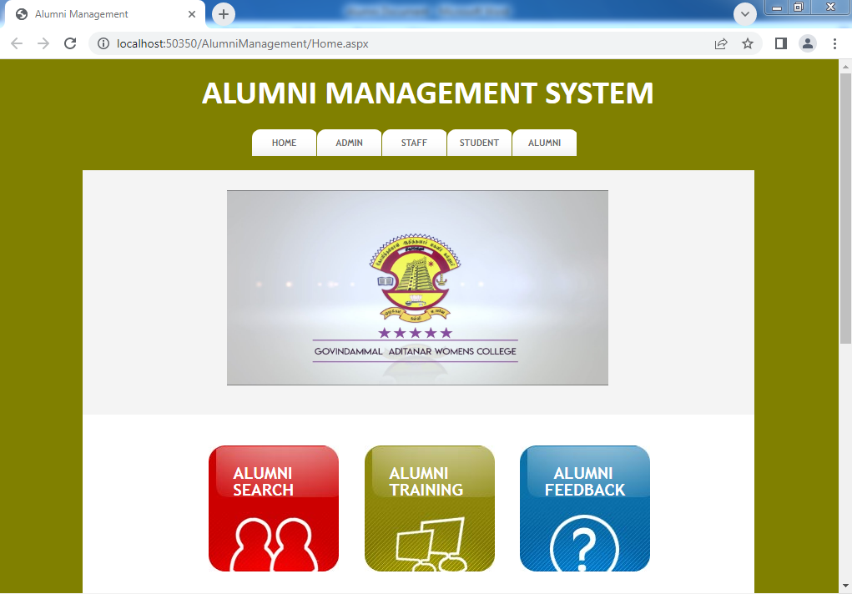

**ADMIN LOGIN PAGE**

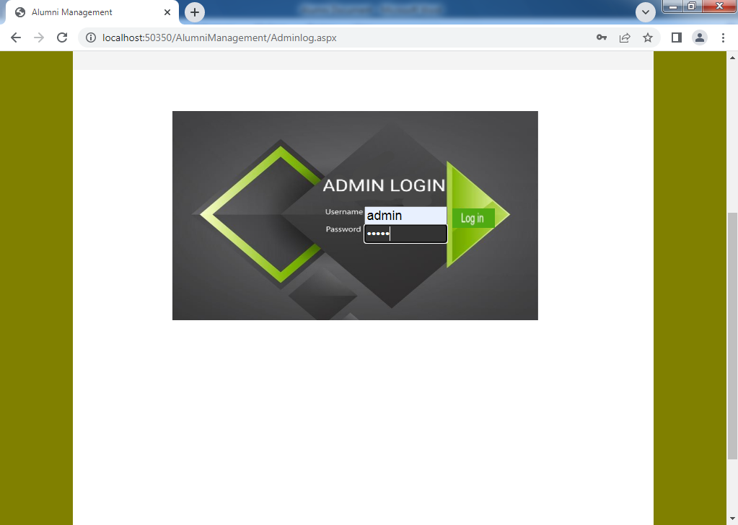

**STAFF REGISTER PAGE**

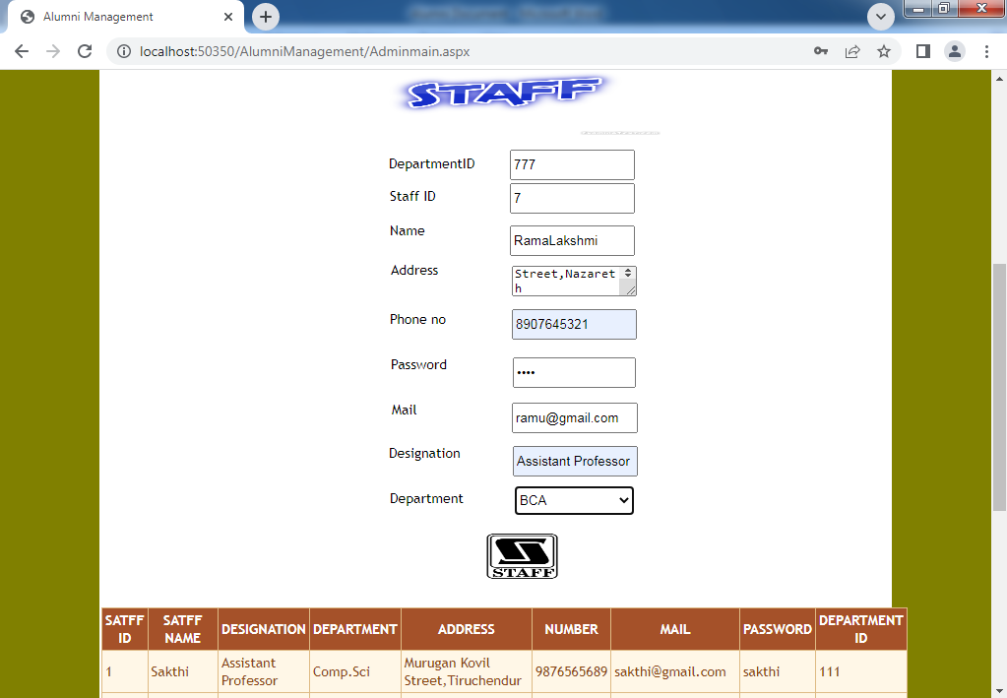

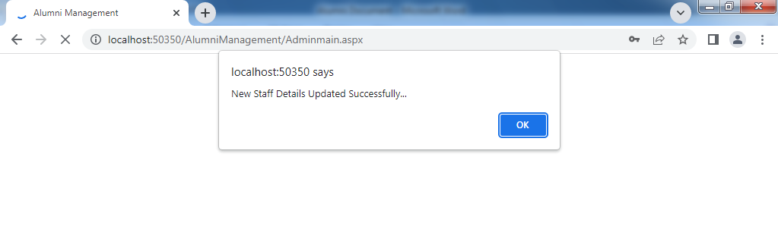

**VIEW STUDENT DETAILS**

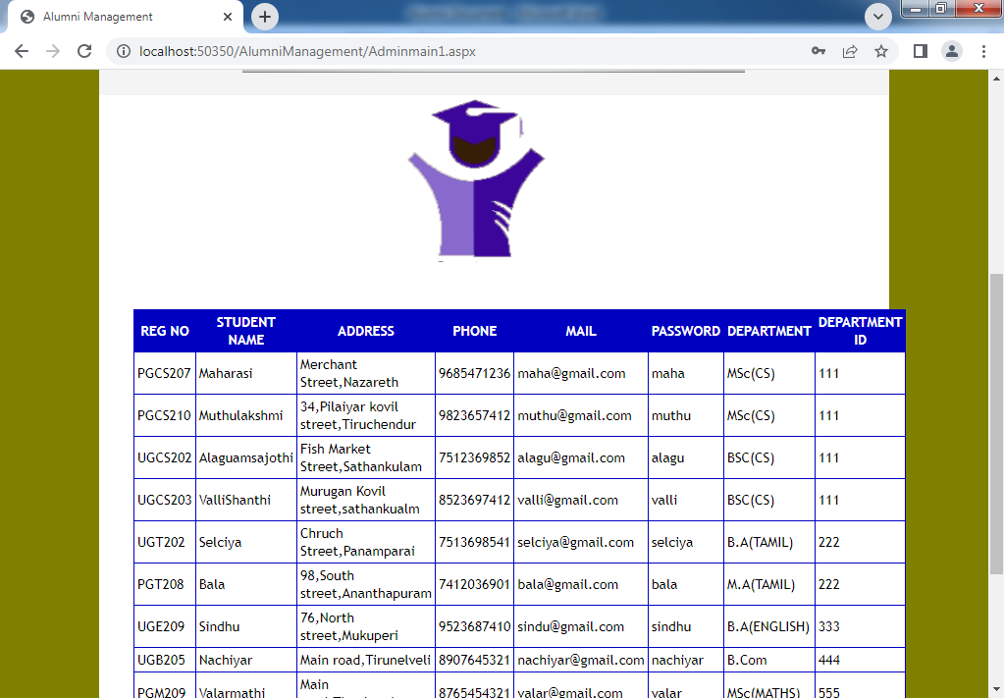

**VIEW ALUMNI DETAILS**

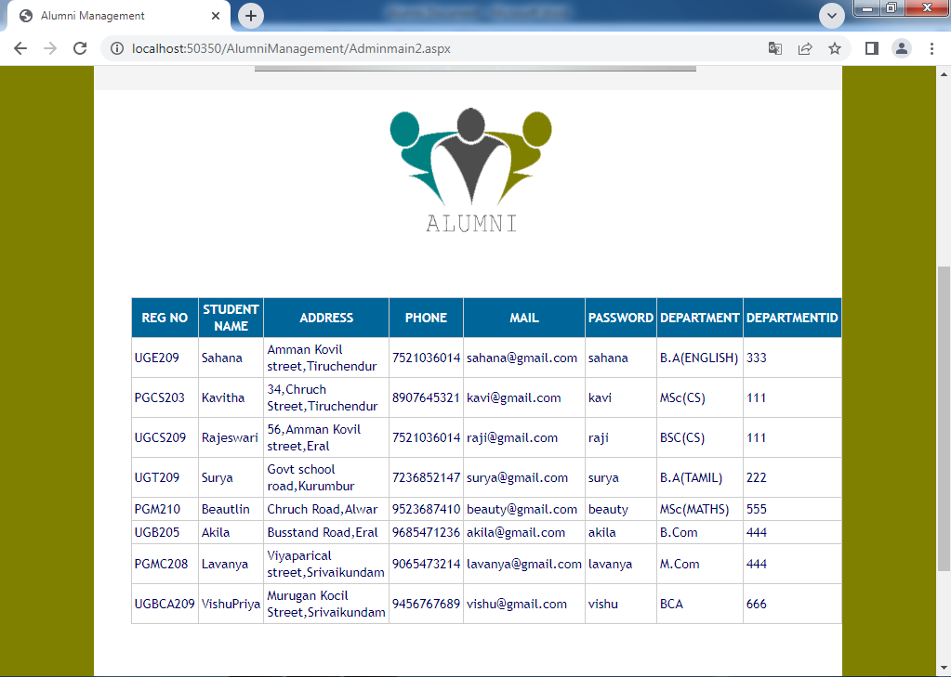

**VIEW ALUMNI MEETING DETAILS**

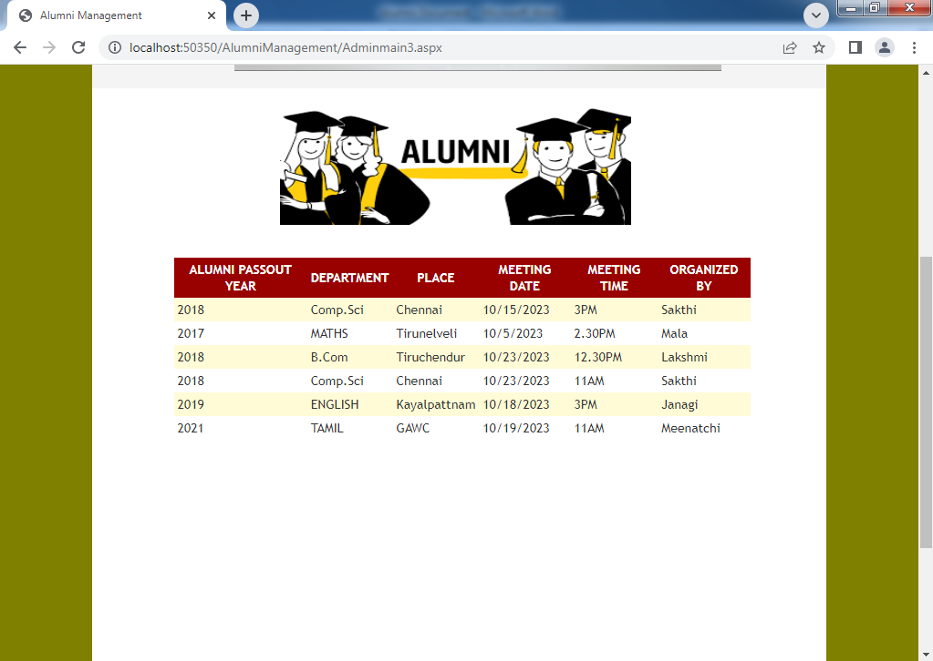

**VIEW ALUMNI SEMINAR DETAILS**

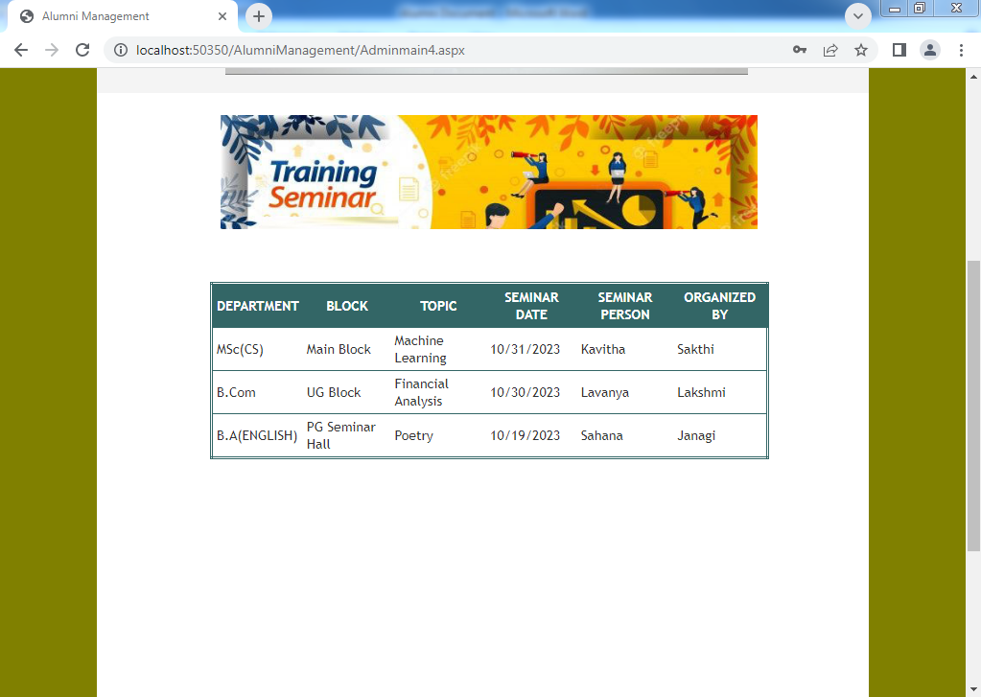

**VIEW FUND DETAILS**

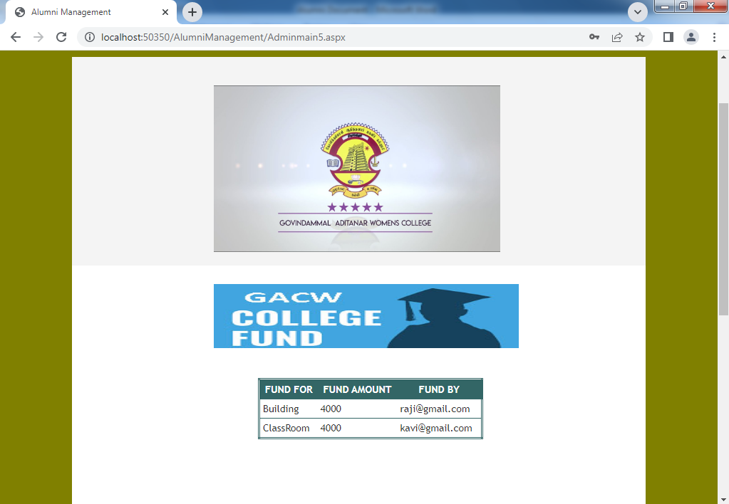

**STAFF LOGIN PAGE**

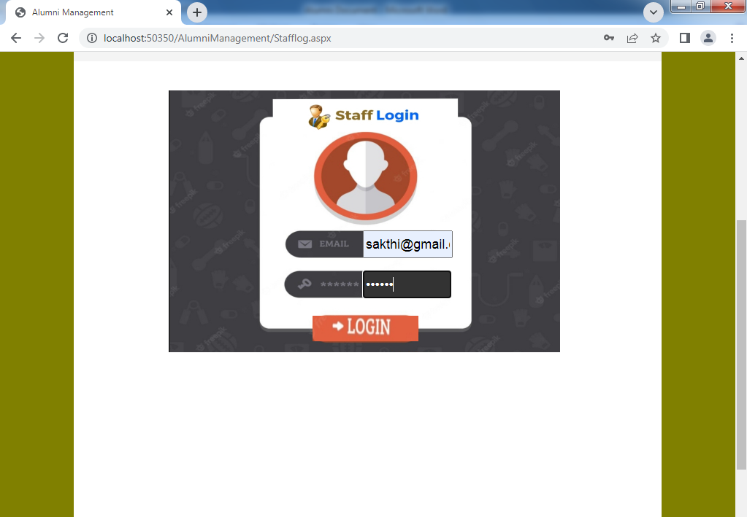

**UPLOAD ALUMNI MEETING**

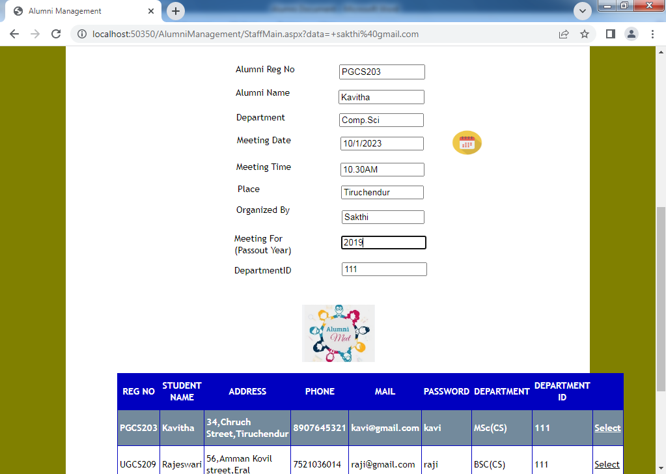

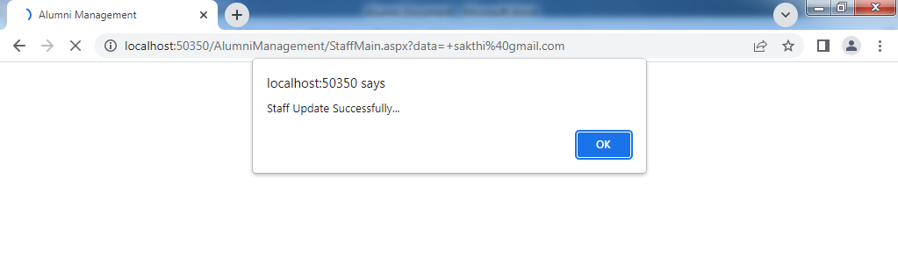

**UPLOAD ALUMNI SEMINAR**

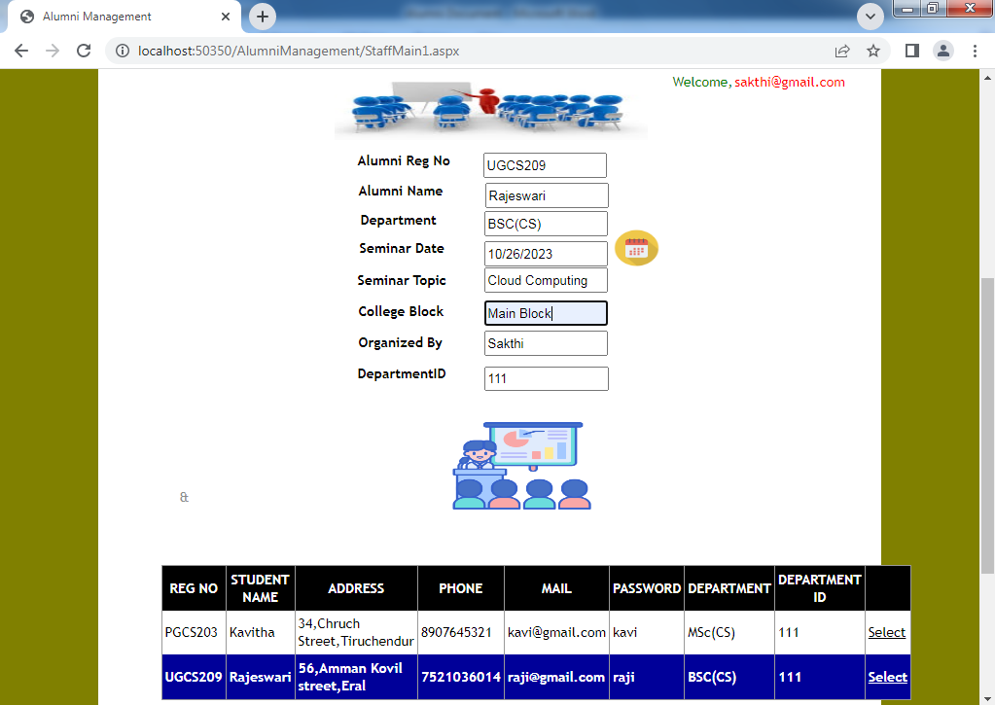

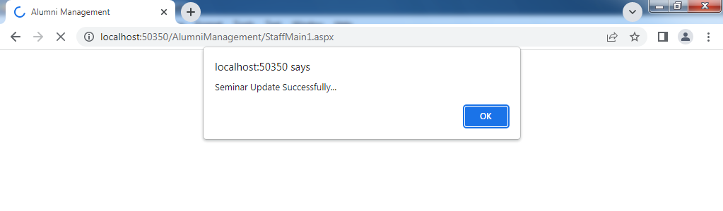

**STUDENT REGISTER PAGE**

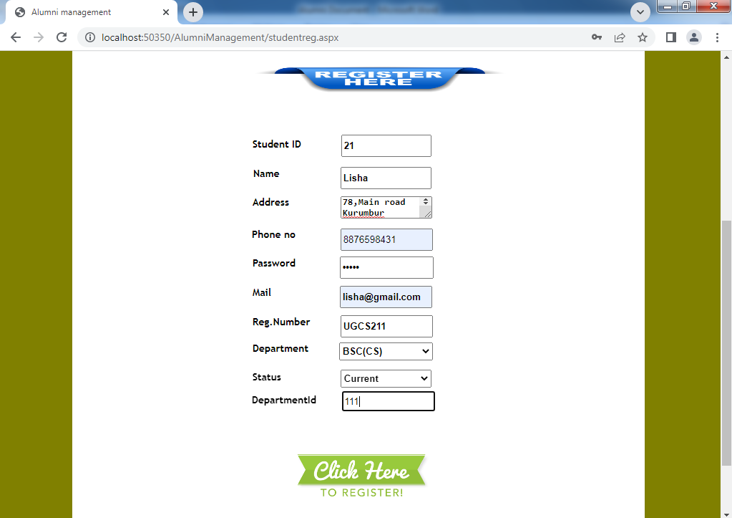

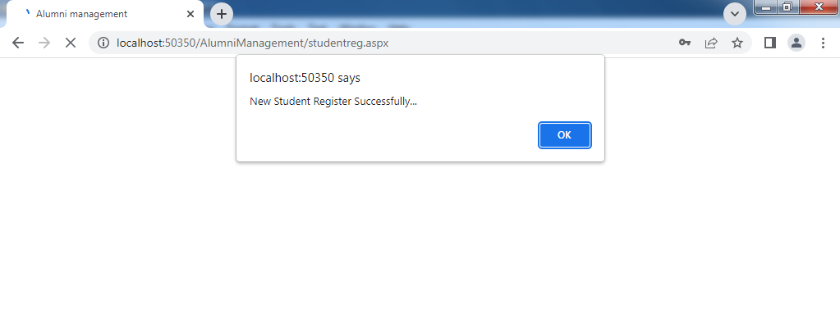

**STUDENT LOGIN PAGE**

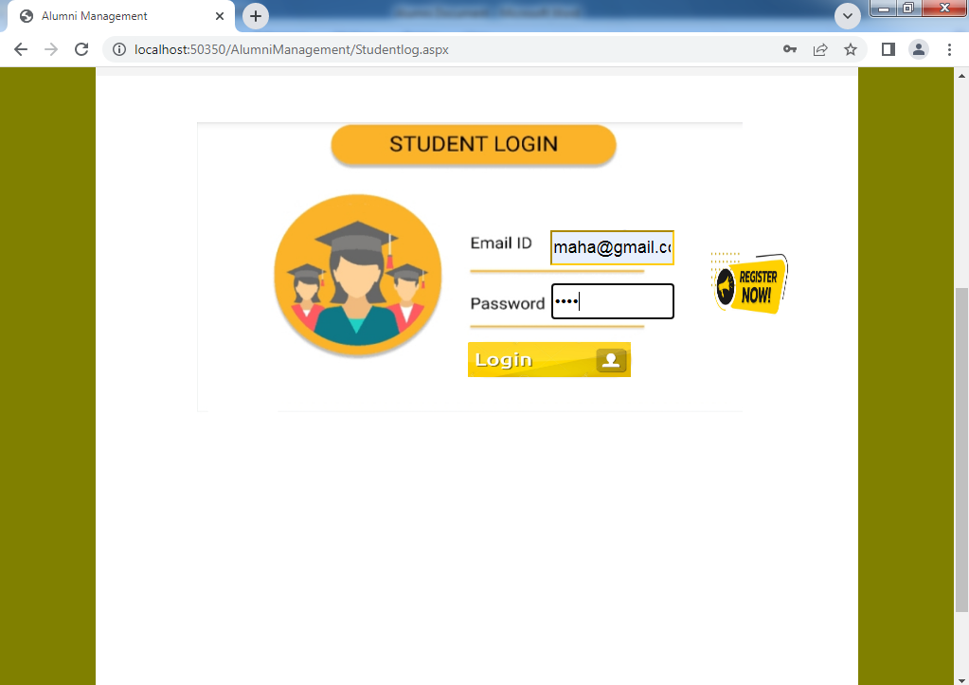

**VIEW JOB DETAILS**

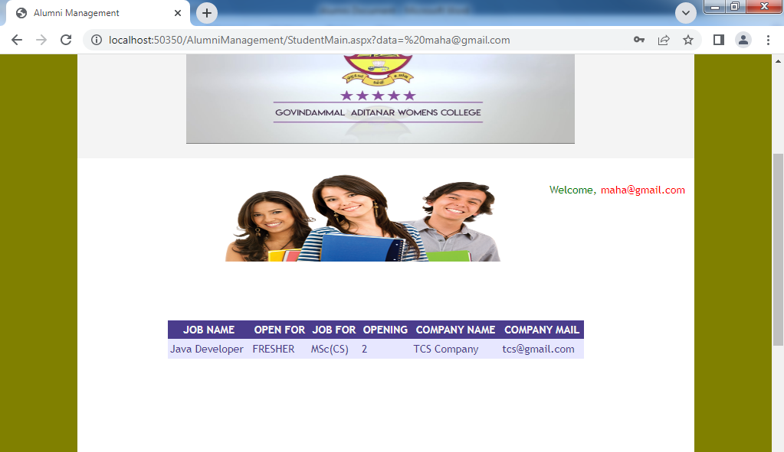

**VIEW SEMINAR DETAILS**

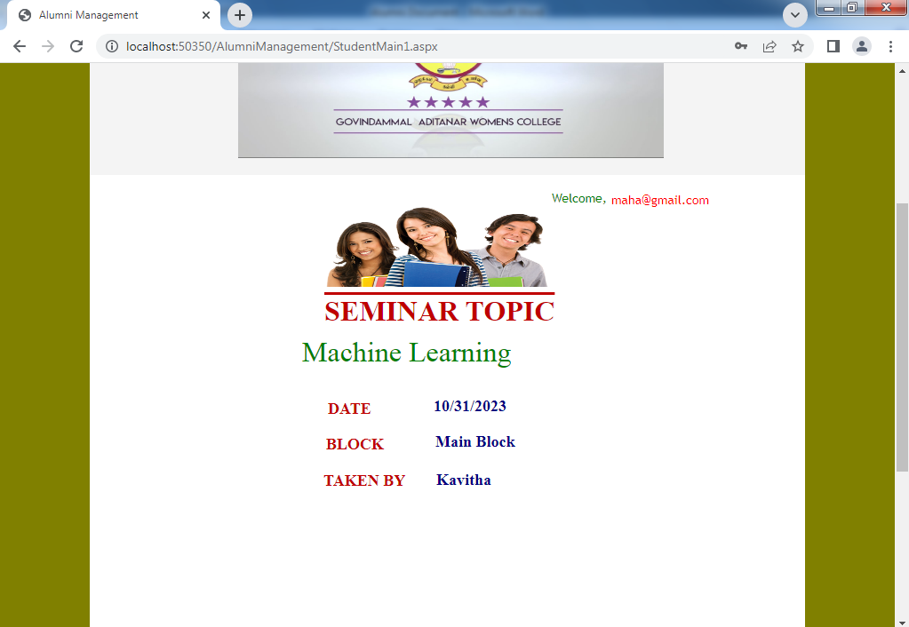

**ALUMNI LOGIN PAGE**

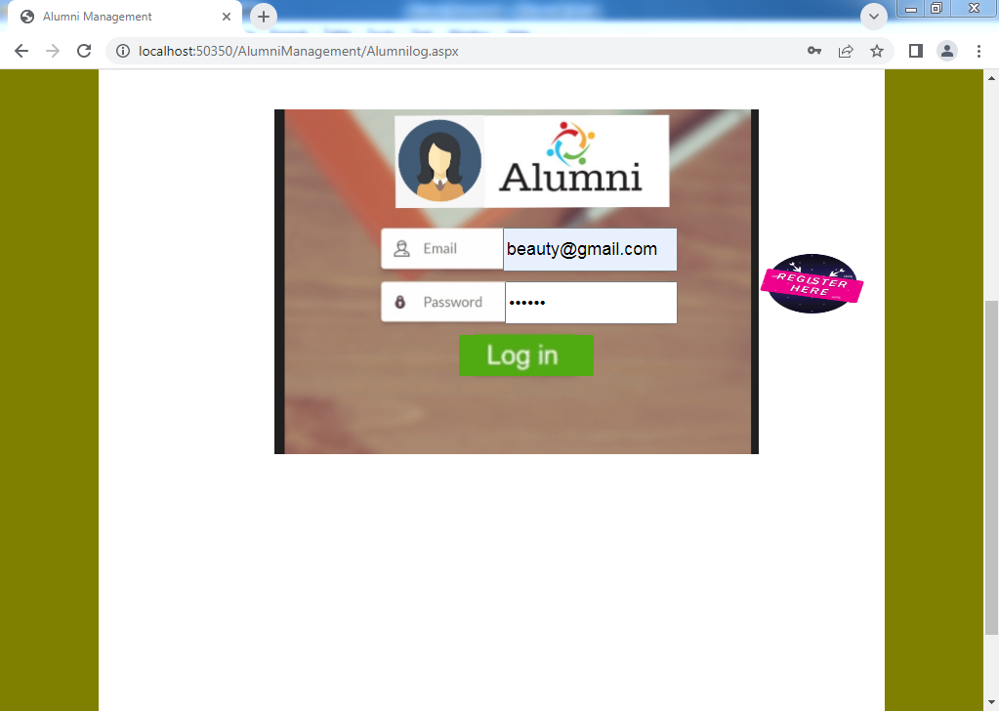

**ALUMNI UPLOAD THE DETAILS**

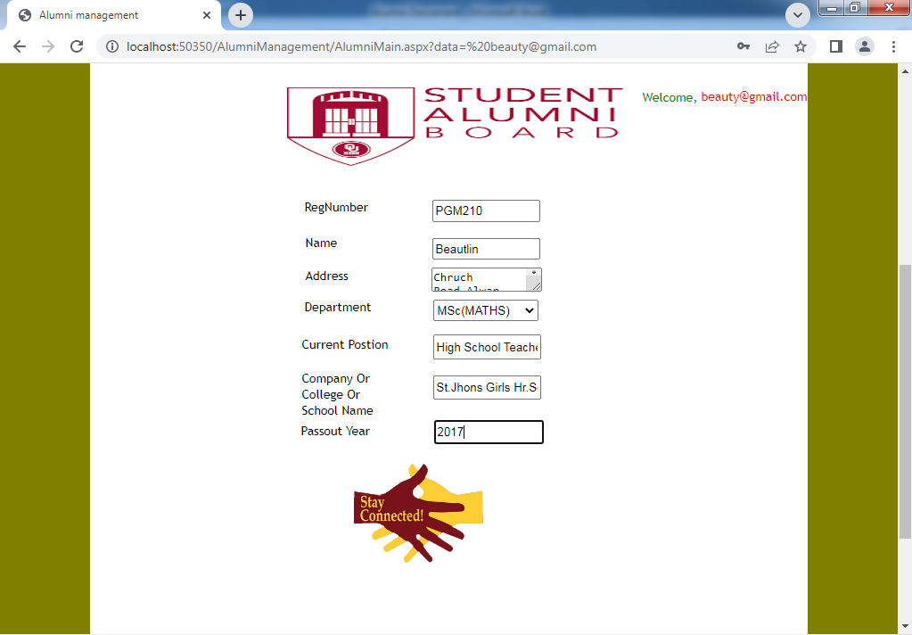

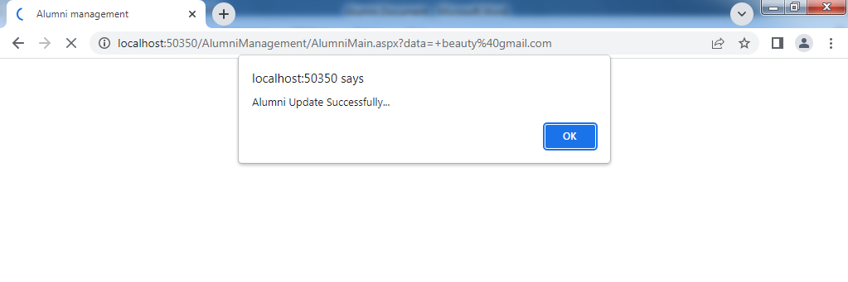

**ALUMNI POST A JOPS**

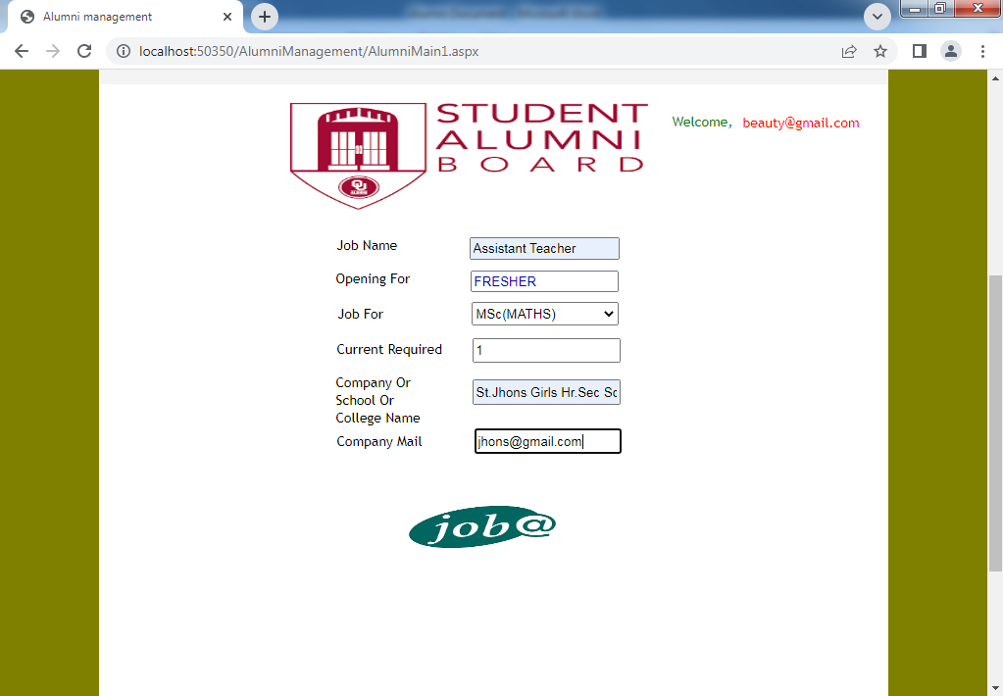

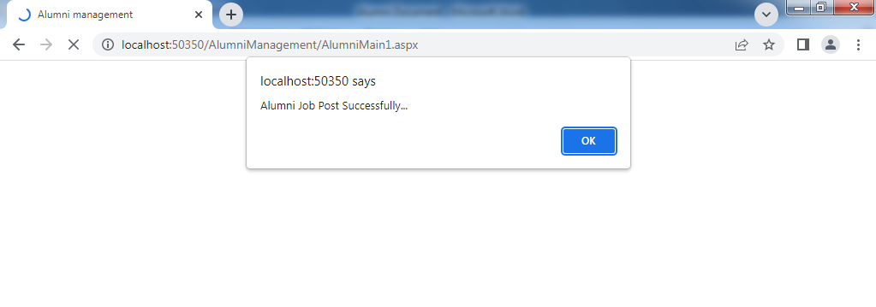

**VIEW MEETING DETAILS**

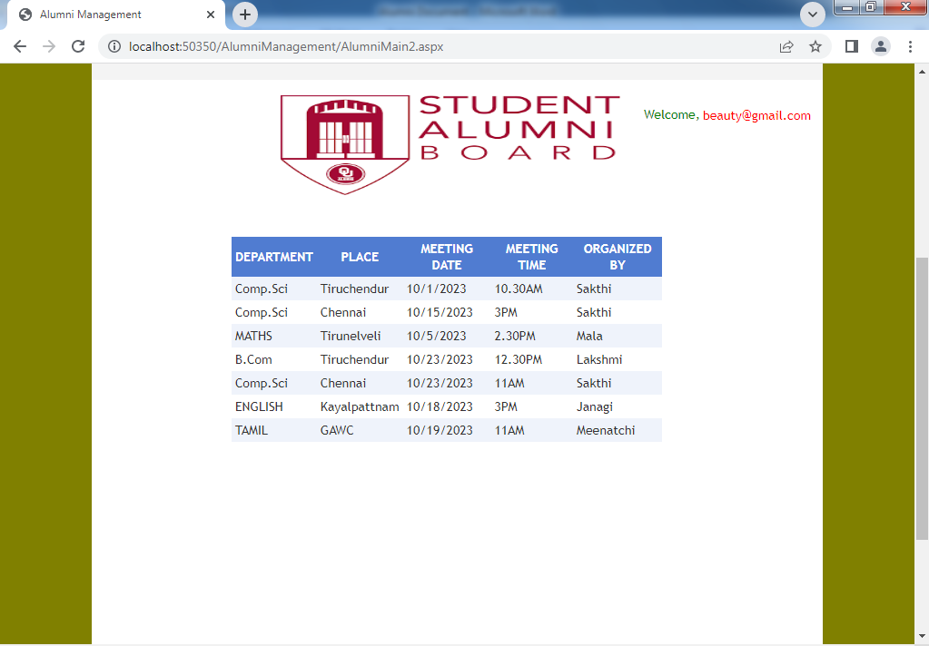**VIEW SEMINAR DETAILS**

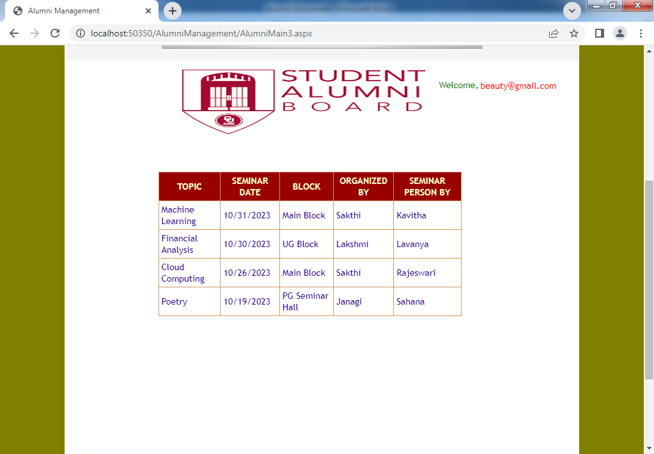

**UPLOAD THE FUND**

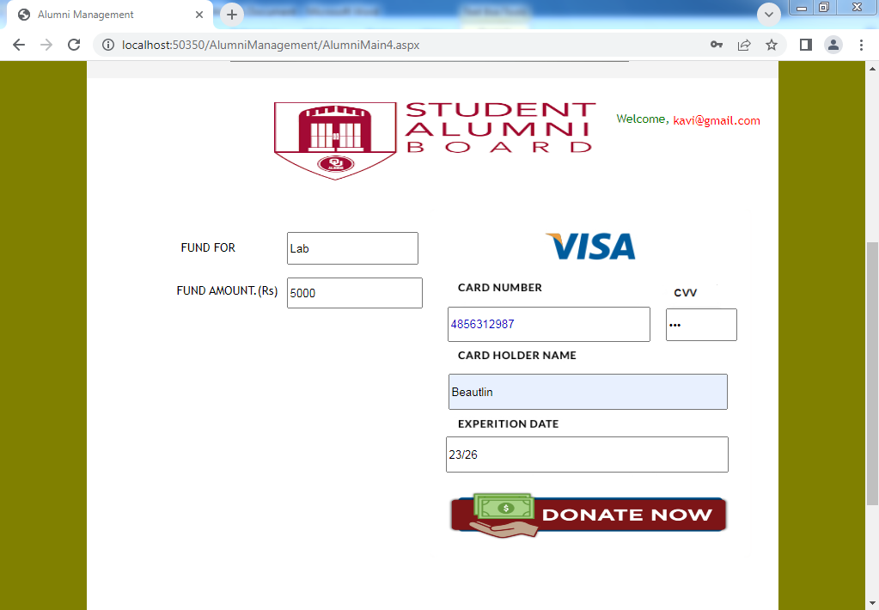

**VIEW ALUMNI DETAILS**

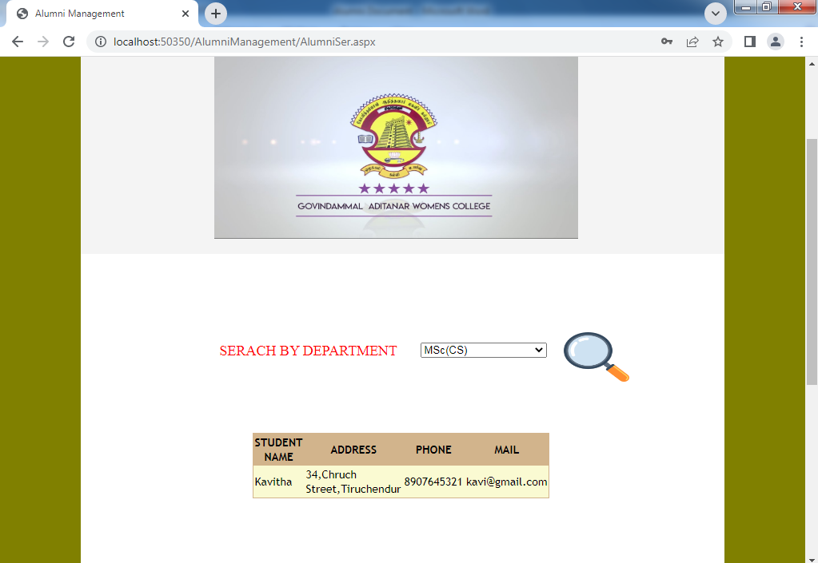

**VIEW SEMINAR DETAILS**

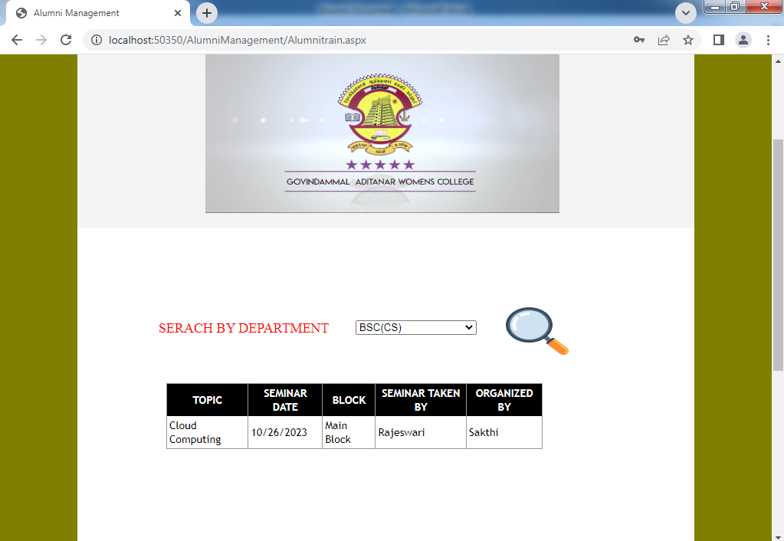

**UPLOAD THE FEEDBACK**

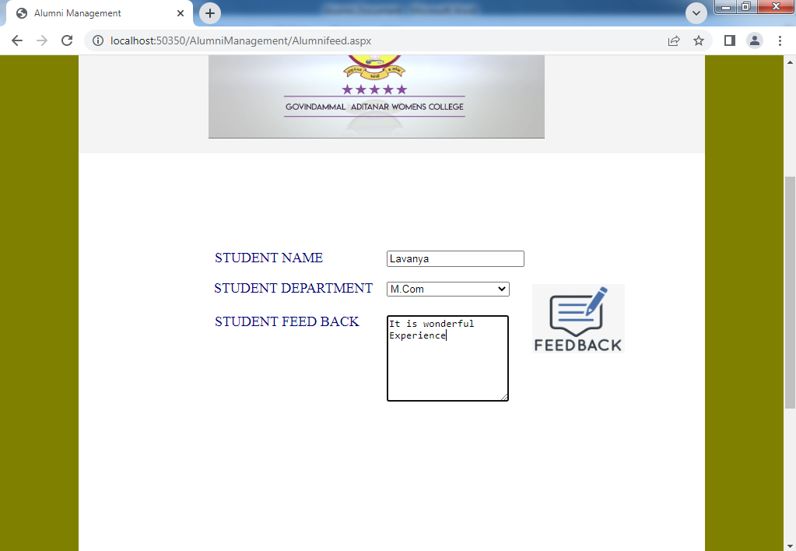

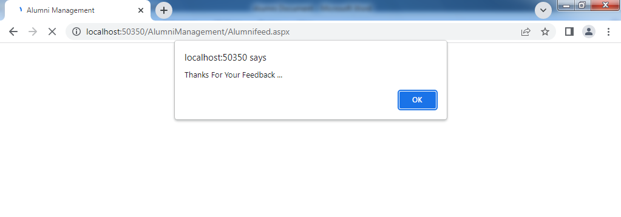

**10**. **CONCLUSION**

In conclusion, an online clothing store offers a convenient and accessible platform for customers to browse and purchase apparel from the comfort of their own homes,By incorporating user-friendly navigation,secure payment gateways,and responsive design,the store can provide a seamless shopping experience across devices.Coupled with strong product management,personalized user accounts,and efficient order fulfillment,the store can build customer loyalty and drive business growth,Ultimately, a well-executed online clothing store not only meets the needs of modern consumrs but also opens up new avenues for expanding market reach and enhancing brand presence in the competitive fashion industry.

**11**. **FUTURE ENHANCEMENT**

The Alumni Management System while comprehensive can user requirements keep changing as the system is being used. Some of the future enhancements that can be done this system are:

* + - As the technology emerges, it is possible to upgrade the system and can be adaptable to desire environment.
    - Because it is based on object-oriented design any further changes can be easily adaptable.
    - Based on the future security issues, securits can be imporved using emerging technologies.
    - Experience alumni can affer guidance and advice to current students based on their career interests.
    - Allowing alumni to connect with each other, share updates, and collaborate on projects.
    - Gallery module can be added.

**12**. **BIBLIOGRAPHY**

**BOOK REFERENCES**

* The Complete Reference ASP.NET by Matthew MacDonald - Tata

Mc Graw Hill Publishing

* Asp.Net – A Beginner’s Guide - David Mercer
* A Programming in C# E Balagurusamy - Tata Mc Graw Hill Publishing

**WEB REFERENCES**

* [www.msdn.microsoft.com](http://www.msdn.microsoft.com)
* [www.w3schools.com](http://www.w3schools.com)
* [www.aspfree.com](http://www.aspfree.com)